Koh Kood, Trat, Thailand
Thailand's best-kept secret — no high-rises, no traffic lights, no mass tourism. Just powdery sand, turquoise bays, and rainforest waterfalls the way they were meant to be.
⚓ Tender port (no cruise pier) · 🕒 Typical call: 7-9 hrs · 💵 Thai Baht (THB) — bring cash · 🗣️ Thai · 🏖️ Beach day destination
✍️ MY DAY IN PORT (FILL IN)
Ship / Date
In port | arrive ______ · all aboard ______
Booked excursion
Notes / meeting point
GETTING ASHORE
- Docking: Tender — ships anchor offshore; tender to beach or village jetty
- Walk to center: Nothing walkable from piers — transport required to beaches/waterfalls
- Best For: Beach relaxation, snorkeling, waterfall hikes, seafood villages
- Don't Miss: Khlong Chao Waterfall swim and fresh crab at Ao Yai stilt village
GETTING AROUND
- 📱 Rideshare: ❌ not available
TOP THINGS TO DO
- Khlong Chao Waterfall Hike & Swim — The island's most famous attraction — a 15-minute jungle walk leads to a multi-tier cascade with a deep, cool freshwater pool at…
- Bang Bao Beach Day — A horseshoe-shaped bay with calm, clear water, wooden piers stretching over turquoise shallows, and swaying coconut palms.
- Ao Yai Stilt Fishing Village — A traditional village built entirely on stilts over the water in the southeast.
- Snorkeling at Koh Rang National Marine Park — The best coral reefs in the archipelago lie around nearby Koh Rang — vibrant hard and soft corals, reef fish, and occasional rays.
- Kayaking the Khlong Chao River — Rent a kayak at Khlong Chao Beach and paddle upstream through quiet mangrove forest.
BEST WALKS
- Khlong Chao Beach to Waterfall: 2 km round trip · Easy · ~45 min walking — From the Khlong Chao Beach tender point, follow the river road north past bungalow cafes and kayak…
- Ao Salad Pier Village Stroll: Easy · 20–30 min · Flat — If tendered to Ao Salad, a short flat walk takes you through the local fishing village to Wat Ao…
WEATHER · DAYLIGHT · MONEY
Month | High °F | Low °F | Rainy days
May | 86 | 80 | 26
Jul | 83 | 78 | 30
Sep | 83 | 77 | 28
Daylight: May 5:46AM–6:25PM · Jul 5:53AM–6:37PM · Sep 5:59AM–6:10PM
cruiseports.org/koh-kut-kood-island-thailand · Confirm terminal & all-aboard time with your ship

Koh Kood, Trat, Thailand — Port Map
Red = walkable sights · Amber = excursions farther out · P = cruise terminal
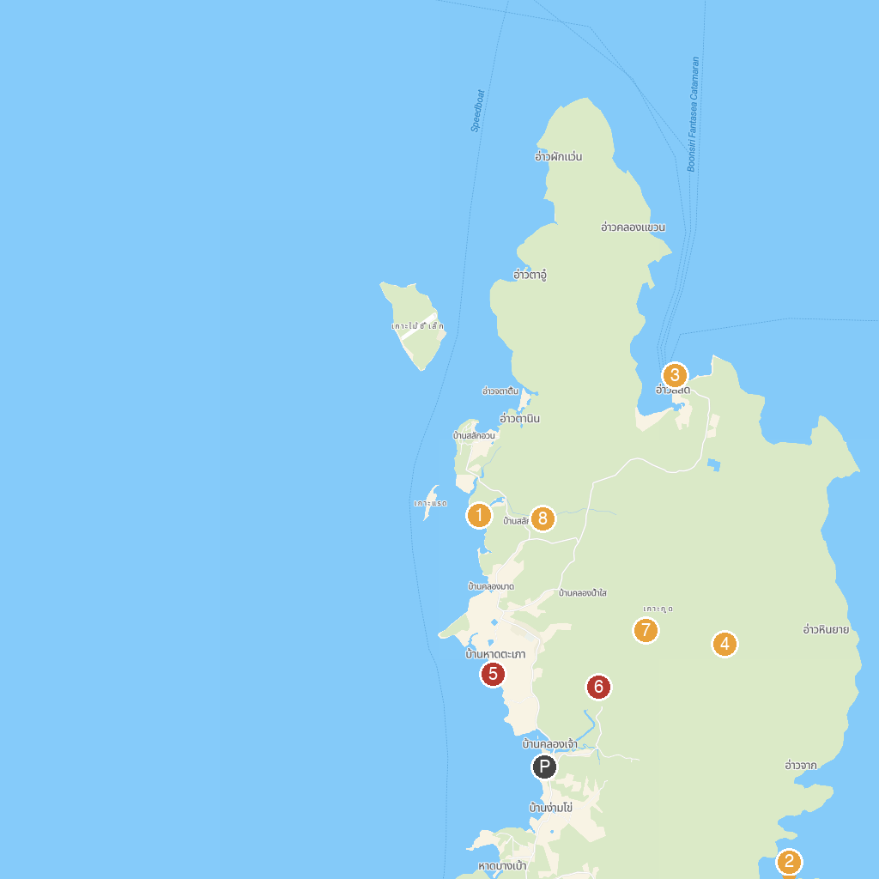
MAP KEY
1. Yai Kee Beach | 5. Ao Taphao Beach
2. laem ao yai | 6. Khlong Chao Waterfall
3. Wat Ao Salad | 7. Sai Yai - Big Chai Tree
4. Huang Nam Khiao Waterfall | 8. Khlong Yai Kee Waterfall
P. Cruise port / terminal
Map © MapTiler © OpenStreetMap contributors · cruiseports.org

