Kochi, Shikoku, Japan
The 'free spirit' of Shikoku — Kochi pairs one of Japan's last original castles with a raucous food-hall, pilgrimage temples, and the legend of samurai hero Sakamoto Ryoma.
⚓ Docked (Kochi New Port) · 🕒 Typical call: 8-10 hrs · 💴 Currency: Japanese Yen (JPY) · 🗣️ Language: Japanese
✍️ MY DAY IN PORT (FILL IN)
Ship / Date
In port | arrive ______ · all aboard ______
Booked excursion
Notes / meeting point
GETTING ASHORE
- Docking: Kochi New Port (~7 km south of city center); shuttle or taxi required
- Walk to center: Not walkable — take ship shuttle, taxi, or Tosaden tram
- Best For: Japanese castle, street food, Shikoku pilgrimage temples, coastal scenery
- Don't Miss: Kochi Castle keep + Hirome Market katsuo tataki lunch
GETTING AROUND
- 🚕 Taxi: ¥2,000–¥4,500 — Taxis available at the pier. Fare to Harimayabashi is roughly ¥2,000–¥3,000 (~10 min); to Kochi Castle is ¥3,000–¥4,500
- 📱 Rideshare: ✅ Uber, GO
- 🚌 Hop-on hop-off: ✅
TOP THINGS TO DO
- Kochi Castle & Castle Town — One of Japan's twelve surviving original castles, Kochi Castle retains its complete original wooden keep and turrets.
- Hirome Market & Katsuo Tataki — Kochi's legendary covered food hall is packed with stalls serving katsuo no tataki — straw-fire seared bonito tuna, Kochi's…
- Katsurahama Beach & Sakamoto Ryoma Museum — A scenic pine-backed shoreline south of the city, Katsurahama is famous for its bronze statue of Sakamoto Ryoma — the…
- Chikurin-ji Temple (Shikoku Pilgrimage No. 31) — A peaceful temple on Mount Godai, Chikurin-ji is one of 88 temples on the famous Shikoku pilgrimage circuit.
- Niyodo River Valley — About an hour from the port, the Niyodo River is celebrated for its impossibly clear cobalt-blue water.
BEST WALKS
- Castle to Hirome Market Loop: ~2 km | 45–60 min | Easy — Start at Kochi Castle, walk the castle grounds, then descend into the shopping arcade (Obiyamachi)…
- Sunday Joichi Market Stroll: ~1 km | 30 min | Very Easy (Sundays only) — Kochi's Sunday market along Otesuji Street is one of Japan's longest-running street markets (300+…
WEATHER · DAYLIGHT · MONEY
Month | High °F | Low °F | Rainy days
May | 73 | 56 | 12
Jul | 83 | 72 | 22
Sep | 81 | 69 | 19
Daylight: May 5:05AM–6:59PM · Jul 5:06AM–7:16PM · Sep 5:49AM–6:12PM
cruiseports.org/kochi-city · Confirm terminal & all-aboard time with your ship

Kochi, Shikoku, Japan — Port Map
Red = walkable sights · Amber = excursions farther out · P = cruise terminal
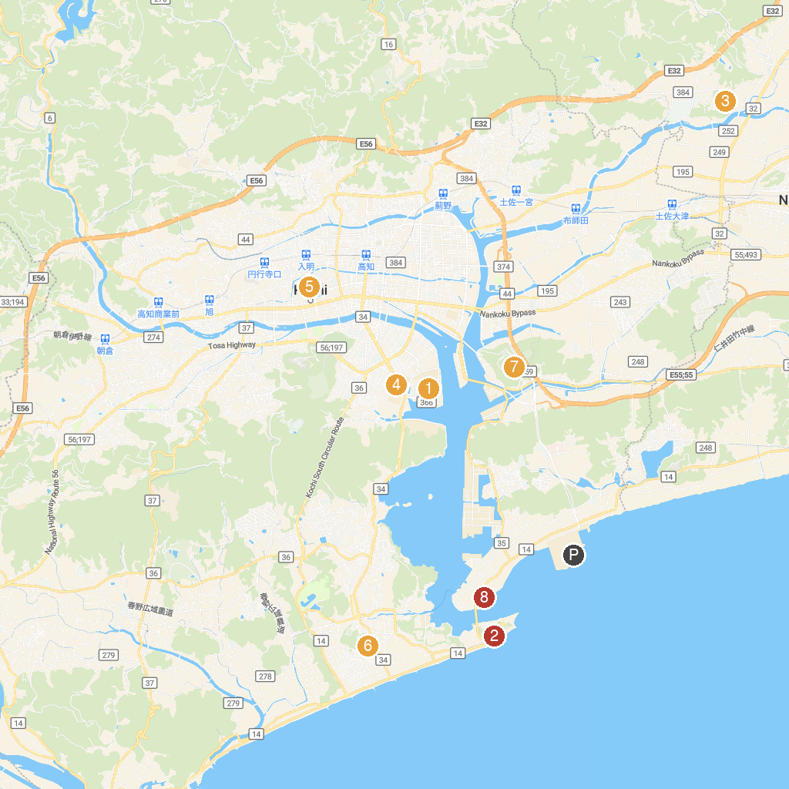
MAP KEY
1. わんぱーくこうちアニマルランド | 5. Kochi Park
2. The Sakamoto Ryoma Memorial Museum | 6. Wakamiya Hachiman-gu
3. Kochi Prefectural Museum of History | 7. Chikurin Temple
4. Kōchi People's and Liberty Museum | 8. Tanesakisensho Park
P. Cruise port / terminal
Map © MapTiler © OpenStreetMap contributors · cruiseports.org

