Kobe / Osaka, Kansai, Japan
Two great cities, one legendary region. Whether your ship ties up in Kobe's Harborland or Osaka's Tempozan Bay, the temples of Kyoto, deer parks of Nara, and Himeji Castle are all just a train ride away — and you haven't eaten Japan until you've had Kobe beef or Dotonbori street food.
⚓ Docked (pier berthing) · 🕒 Typical call: 8–10 hrs · 💴 Currency: Japanese Yen (¥) · 🗣️ Language: Japanese (English in tourist areas)
✍️ MY DAY IN PORT (FILL IN)
Ship / Date
In port | arrive ______ · all aboard ______
Booked excursion
Notes / meeting point
GETTING ASHORE
- Docking: Kobe: Shinko Pier No. 4 or Naka Pier (city-center, walk/Port Liner). Osaka: Tempozan Cruise Terminal (Bay Area, 8 km from Namba).
- Walk to Center: Kobe Naka Pier → Meriken Park: 2 min; Sannomiya: 20 min walk or short bus ride. Shinko Pier → Sannomiya: 5-min Port Liner. Osaka terminal → Osakako Metro: 5-min walk.
- Best For: Kyoto day trips, Kobe beef, sake breweries, Osaka street food, Himeji Castle, Nara deer park
- Don't Miss: A sit-down Kobe beef lunch in the Kita-no district or a bowl of takoyaki in Dotonbori
GETTING AROUND
- 🚕 Taxi: ¥1,500–¥1,900 (Kobe center) / ¥8,500–¥10,000 (Osaka Namba) — Taxis are abundant and metered. Short hop to Sannomiya from Kobe port is a few minutes; Osaka taxi fares are much higher
- 📱 Rideshare: ✅ Uber
- 🚌 Hop-on hop-off: ✅
TOP THINGS TO DO
- Kyoto Temples & Fushimi Inari — Japan's cultural capital is ~25–30 minutes by train from Osaka and ~50 minutes from Kobe.
- Himeji Castle — 45 minutes from Kobe, Himeji is Japan's finest surviving feudal castle — a UNESCO World Heritage Site nicknamed the White Heron…
- Nara Deer Park & Todai-ji Temple — Nara Park is home to 1,200 free-roaming sacred deer that bow for rice crackers sold at the gate.
- Kobe Beef Lunch in Kitano — Kobe is the birthplace of the world's most marbled beef.
- Osaka Castle & Dotonbori — Osaka Castle anchors a hilltop park with a modern museum inside.
BEST WALKS
- Kobe Waterfront Loop: 2.5 km · 45 min · Easy — From Naka Pier, stroll through Meriken Park past the Kobe Earthquake Memorial site and the striking…
- Kitano Ijinkan (Foreign Settlement): 1.5 km uphill · 30 min · Moderate — From Sannomiya, walk up through Kitano-cho to the well-preserved Meiji-era Western residences…
- Osaka: Tempozan Waterfront: 1 km · 20 min · Easy — If docked at Tempozan, the Osaka Aquarium Kaiyukan (one of Asia's largest, featuring a whale shark)…
WEATHER · DAYLIGHT · MONEY
Month | High °F | Low °F | Rainy days
May | 72 | 60 | 10
Jul | 84 | 75 | 16
Sep | 81 | 71 | 14
Daylight: May 4:56AM–6:54PM · Jul 4:57AM–7:12PM · Sep 5:42AM–6:06PM
cruiseports.org/kobe-osaka · Confirm terminal & all-aboard time with your ship

Kobe / Osaka, Kansai, Japan — Port Map
Red = walkable sights · Amber = excursions farther out · P = cruise terminal
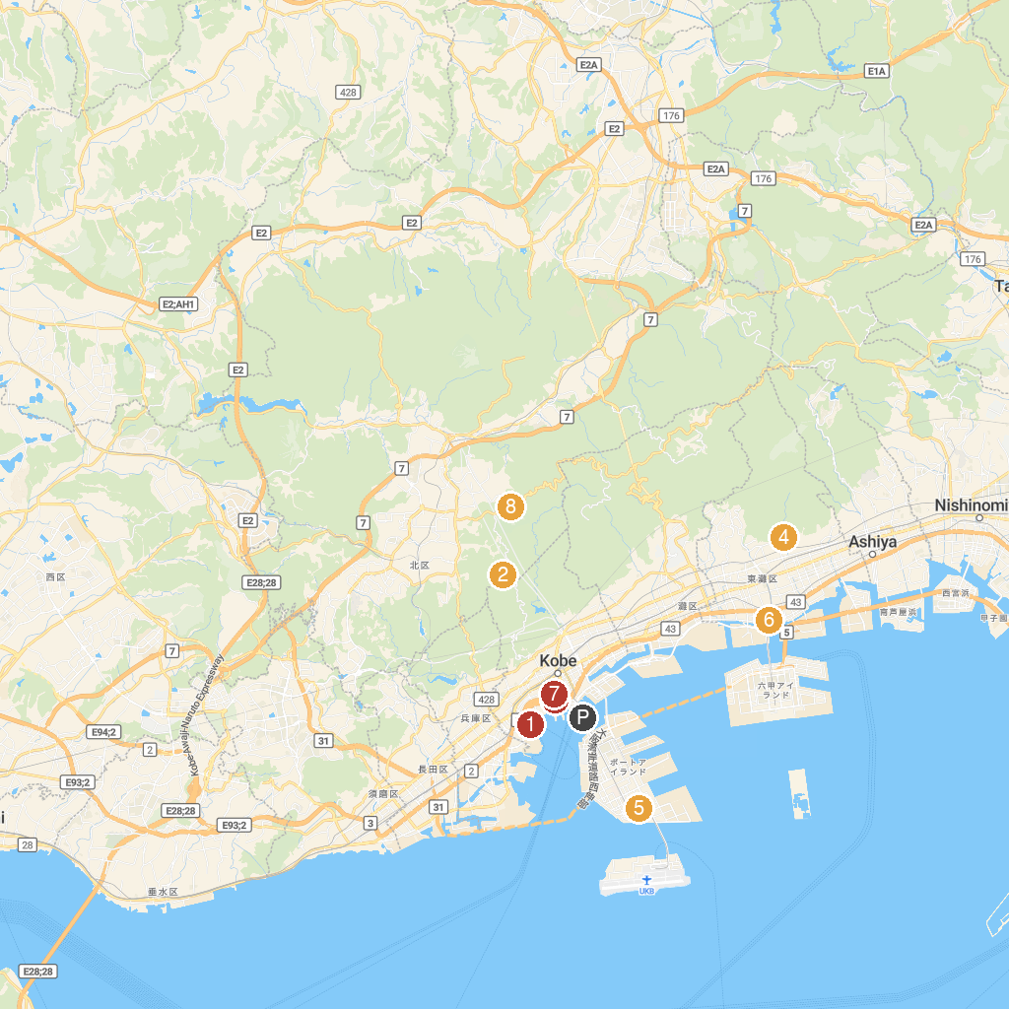
MAP KEY
1. Kōbe Anpanman Children’s Museum & Mall | 5. Kobe Animal Kingdom
2. Futatabi Park | 6. Kiku-Masamune Sake Brewery Museum
3. Kobe Naval Drills Office Trace Monument | 7. Kobe City Museum
4. Okamoto Park (Plum Garden) | 8. Kobe Municipal Arboretum
P. Cruise port / terminal
Map © MapTiler © OpenStreetMap contributors · cruiseports.org

