Klaipėda, Lithuania
Lithuania's only seaport — a half-timbered old town with a Germanic past, gateway to the soaring sand dunes and pine forests of the UNESCO-listed Curonian Spit.
⚓ Docked (near old town) · 🕒 Typical call: 8–10 hrs · 💶 Euro (EUR) · 🗣️ Lithuanian · English in tourism
✍️ MY DAY IN PORT (FILL IN)
Ship / Date
In port | arrive ______ · all aboard ______
Booked excursion
Notes / meeting point
GETTING ASHORE
- Docking: Cruise quay (central)
- Walk to old town: 10–15 min
- Best For: Dunes · Old town
- Don't Miss: Curonian Spit
GETTING AROUND
- 🚕 Taxi: €4–6 — Metered taxis are available at the terminal. The ride to Old Town is only 5 minutes; confirm the meter is running before
- 📱 Rideshare: ✅ Uber, Bolt
TOP THINGS TO DO
- Curonian Spit & Nida Dunes — The UNESCO-listed sandbar of shifting dunes, pine forest, and fishing villages — the great Parnidis Dune above Nida is a 'desert…
- Klaipėda Old Town — The half-timbered Fachwerk streets of the former Prussian city of Memel — Theatre Square, the Ännchen of Tharau statue, and the…
- Smiltynė & Sea Museum — Just across the ferry on the spit's north tip — the Lithuanian Sea Museum and aquarium in an old fort, plus quiet beaches and…
- Palanga & Amber Museum — The breezy seaside resort of Palanga to the north, with its famous Amber Museum in a palace park and a long sandy beach and pier.
BEST WALKS
- Old town & Theatre Square: ~2 km · 1.5 hrs · easy — Through the Fachwerk lanes to Theatre Square and the little Ännchen of Tharau fountain, hunting the…
- Danė riverfront: ~1.5 km · 1 hr · easy — Along the Danė River past moored tall ships and the chain ferry, a relaxed stroll linking the old…
- Sculpture Park: ~1.5 km · 1 hr · easy — A green former-cemetery park dotted with modern Lithuanian sculpture, a quiet contrast to the busy…
WEATHER · DAYLIGHT · MONEY
Month | High °F | Low °F | Rainy days
May | 60 | 47 | 10
Jul | 71 | 60 | 14
Sep | 64 | 54 | 10
Daylight: May 5:24AM–9:40PM · Jul 5:12AM–10:09PM · Sep 7:07AM–7:52PM
cruiseports.org/klaipeda · Confirm terminal & all-aboard time with your ship

Klaipėda, Lithuania — Port Map
Red = walkable sights · Amber = excursions farther out · P = cruise terminal
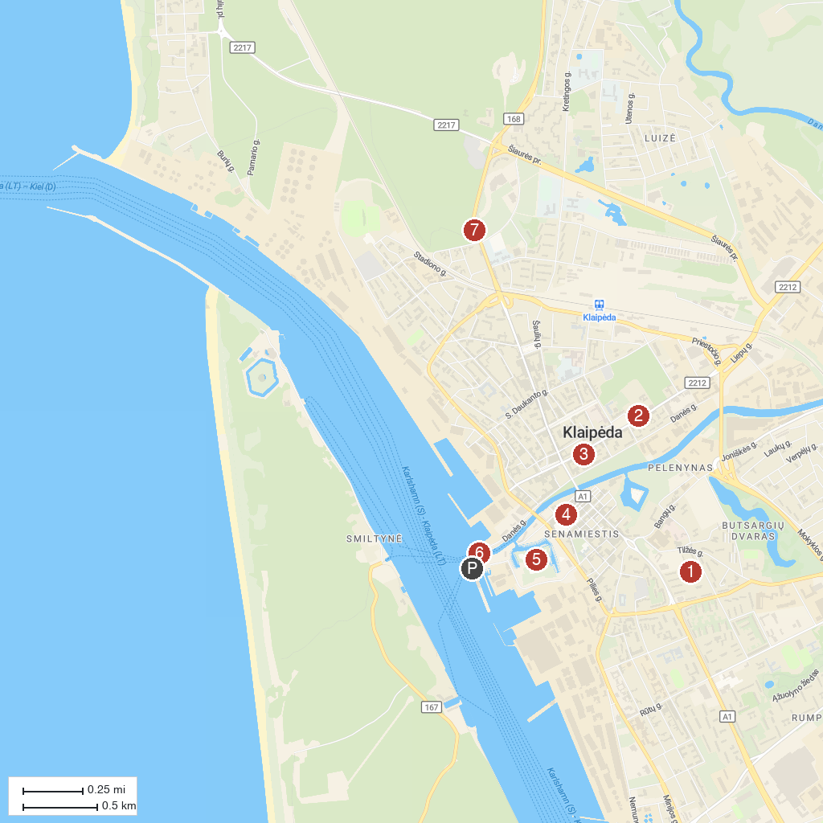
MAP KEY
1. Klaipėdos Marijos Taikos Karalienės bažnyčia | 5. The Castle Museum
2. Pranas Domšaitis Gallery | 6. Kiss
3. Museum of Clocks | 7. Minimelts park
4. The Magical Mouse
P. Cruise port / terminal
Map © MapTiler © OpenStreetMap contributors · cruiseports.org

