Kirkwall, Orkney, Scotland
Capital of the Orkney Islands and keeper of 5,000 years of history — from Neolithic stone circles older than the Pyramids to a Viking cathedral built in Norse red sandstone. This is Scotland like nowhere else in Scotland.
⚓ Pier — Hatston (2 miles from town) · 🕒 Typical call: 8-10 hrs · 💷 British Pounds (GBP) · 🗣️ English (with a Norse lilt)
✍️ MY DAY IN PORT (FILL IN)
Ship / Date
In port | arrive ______ · all aboard ______
Booked excursion
Notes / meeting point
GETTING ASHORE
- Docking: Hatston Pier, ~2 miles from town center — free shuttle provided
- Walk to center: Not walkable from Hatston; shuttle takes 7-10 min
- Best For: Prehistoric archaeology, Norse history, Scotch whisky
- Don't Miss: St Magnus Cathedral (free) and the Heart of Neolithic Orkney World Heritage Site
GETTING AROUND
- 🚕 Taxi: £8–11 to city center — Limited taxis available; pre-booking is essential on busy multi-ship days. Private island tours run ~£50–60/hr. Try Orkn
- 📱 Rideshare: ❌ not available
- 🚌 Hop-on hop-off: ✅
TOP THINGS TO DO
- Heart of Neolithic Orkney — The UNESCO World Heritage package: Skara Brae (5,000-year-old village preserved in sand), Maeshowe (Viking-inscribed Neolithic…
- St Magnus Cathedral & Kirkwall Old Town — The 12th-century Romanesque cathedral built by a Viking earl from striking red and yellow sandstone — admission is free.
- Highland Park Distillery Tour — The world's most northerly Scotch whisky distillery, making complex peaty-floral single malts since 1798.
- Scapa Flow & Italian Chapel — Scapa Flow — the great wartime anchorage where the German fleet scuttled itself in 1919 — is ringed by Churchill Barriers built…
- Orkney Coastal Walk & Scapa Beach — Scapa Beach — a sweeping sandy bay overlooking Scapa Flow — is about 1.5 miles south of town, reachable by the scenic Crantit…
BEST WALKS
- Kirkwall Town Center Loop: 1.5 miles · Easy · 45-60 min — From the shuttle drop at Kirkwall Travel Centre, walk down Broad Street to St Magnus Cathedral and…
- Cathedral to Highland Park Distillery: 1.2 miles each way · Easy · 40 min walk — A straightforward walk from the cathedral south along Holm Road to Highland Park Distillery at the…
WEATHER · DAYLIGHT · MONEY
Month | High °F | Low °F | Rainy days
May | 52 | 45 | 15
Jul | 59 | 52 | 18
Sep | 57 | 52 | 18
Daylight: May 4:41AM–9:36PM · Jul 4:25AM–10:09PM · Sep 6:41AM–7:31PM
cruiseports.org/kirkwall · Confirm terminal & all-aboard time with your ship

Kirkwall, Orkney, Scotland — Port Map
Red = walkable sights · Amber = excursions farther out · P = cruise terminal
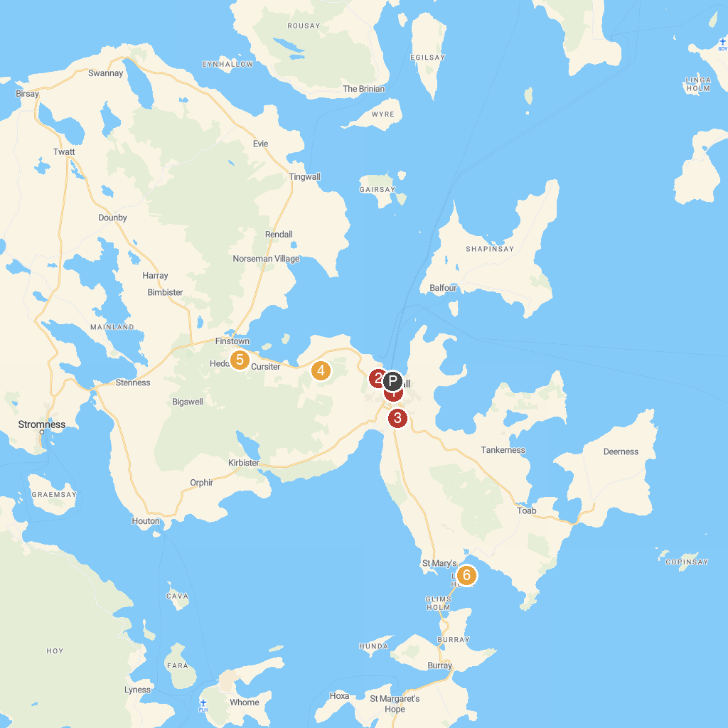
MAP KEY
1. St Magnus Cathedral | 5. Cuween Hill Chambered Cairn
2. Grain Earth House | 6. Italian Chapel | Orkney
3. Highland Park Whisky Distillery | 7. Barnhouse Settlement
4. Wideford Hill Cairn | 8. Maeshowe Visitor Centre
P. Cruise port / terminal
Map © MapTiler © OpenStreetMap contributors · cruiseports.org

