Kirkenes, Finnmark, Norway
At 69°N and just a few kilometers from Russia, Kirkenes is the end of the line on the Norwegian Coastal Express — and the starting point for some of the Arctic's most memorable experiences, from hauling king crabs out of icy fjords to peering across the last land border in Schengen Europe.
⚓ Docked (cruise pier) · 🕒 Typical call: 6-8 hrs · 💵 Norwegian Krone (NOK) — cashless society · 🗣️ Norwegian / English widely spoken · 🦀 Famous for king crab
✍️ MY DAY IN PORT (FILL IN)
Ship / Date
In port | arrive ______ · all aboard ______
Booked excursion
Notes / meeting point
GETTING ASHORE
- Docking: Cruise ships dock at Dypvannskaia or Hurtigrutekaia — both within ~1 km of town center
- Walk to center: ~10–15 min on foot from the cruise dock to Kirkenes town center
- Best For: King crab safaris, Arctic wilderness, Russian border sightseeing, WWII history
- Don't Miss: King Crab Safari on the Varangerfjord — a genuinely unique Arctic experience
GETTING AROUND
- 🚕 Taxi: 75–95 NOK (~$7–9 USD) — Local taxis are available at the Hurtigruten pier. The city center is about 2 km away — a 2–3 minute ride.
- 📱 Rideshare: ❌ not available
TOP THINGS TO DO
- King Crab Safari — The signature Kirkenes experience.
- Snow Resort Kirkenes (Snowhotel 365) — The world-famous Snowhotel is open year-round.
- Russian Border at Storskog — Drive to Storskog — Norway's only land border crossing with Russia and the easternmost point of the Schengen area.
- Andersgrotten WWII Bomb Shelter — Kirkenes was one of the most heavily bombed towns in Norway during WWII.
- Grenselandmuseet (Borderlands Museum) — Kirkenes's main museum covers the history of this unique border region — including Sámi culture, the WWII occupation, the Soviet…
BEST WALKS
- Pier to Town Center Walk: 1.2 km · ~15 min · Flat — A simple walk from the cruise dock along Johan Knudtzens Gate into the Kirkenes town center.
- Town Center Sights Loop: 1.5 km · ~25 min · Flat — A short loop taking in the key landmarks of central Kirkenes: the Soviet Liberation Monument (a…
WEATHER · DAYLIGHT · MONEY
Month | High °F | Low °F | Rainy days
May | 46 | 33 | 13
Jul | 62 | 50 | 12
Sep | 50 | 42 | 12
Daylight: Sep 5:13AM–6:33PM
cruiseports.org/kirkenes · Confirm terminal & all-aboard time with your ship

Kirkenes, Finnmark, Norway — Port Map
Red = walkable sights · Amber = excursions farther out · P = cruise terminal
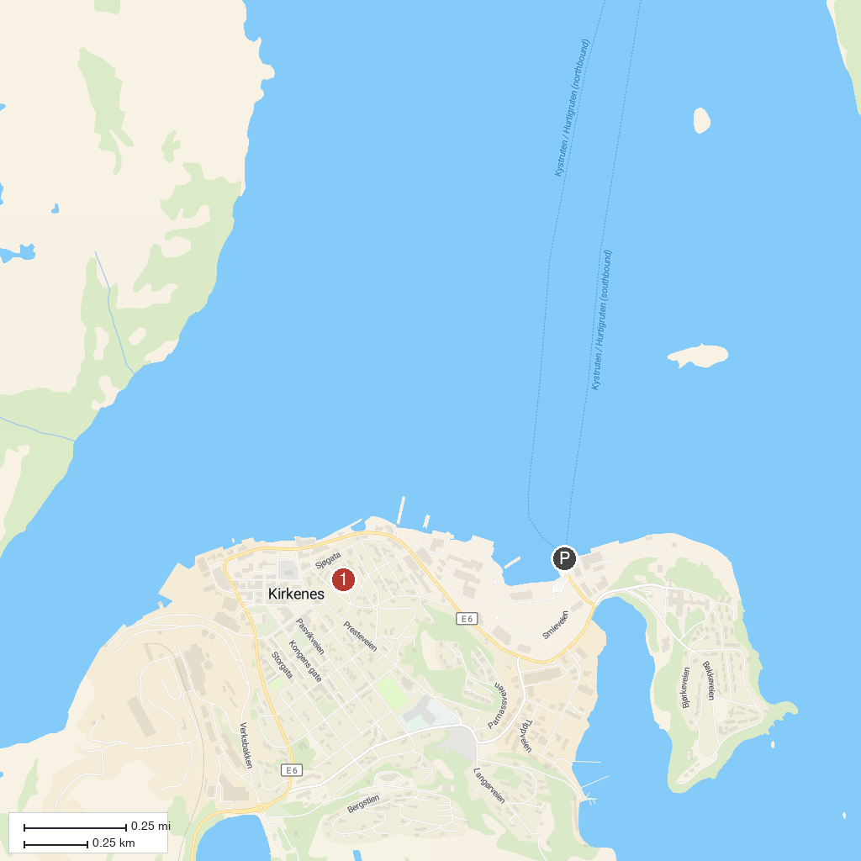
MAP KEY
1. Monument in honor of the Soviet Liberation | 3. Grense Jakobselv
2. Skoltefossen Waterfall
P. Cruise port / terminal
Map © MapTiler © OpenStreetMap contributors · cruiseports.org

