Kingston, Ontario, Canada
Canada's limestone city sits at the gateway to the Thousand Islands — dock steps from 19th-century fortresses, notorious prison tours, and a waterfront packed with local character.
⚓ Pier (Crawford Wharf) · 🕒 Typical call: 6-8 hrs · 💵 Canadian Dollar (CAD) · 🗣️ English
✍️ MY DAY IN PORT (FILL IN)
Ship / Date
In port | arrive ______ · all aboard ______
Booked excursion
Notes / meeting point
GETTING ASHORE
- Docking: Pier — Crawford Wharf, 1 Brock St, directly downtown
- Walk to centre: 0 min — City Hall is immediately adjacent to the dock
- Best For: History buffs, dark tourism, 1000 Islands scenery, walkable foodie streets
- Don't Miss: Kingston Penitentiary tour (book ahead; ~3.5 km west of downtown) and Fort Henry National Historic Site
GETTING AROUND
- 🚕 Taxi: ~CAD $10–$15 from Coal Dock — Ships using the Coal Dock (west of downtown) are about 3–5 km from the city center. Taxis are readily available; expect
- 📱 Rideshare: ✅ Uber
- 🚌 Hop-on hop-off: ✅ Kingston Trolley Tours
TOP THINGS TO DO
- Kingston Penitentiary Tour — Canada's most notorious maximum-security prison closed in 2013 and opened to the public.
- Fort Henry National Historic Site — A UNESCO World Heritage Site crowning Henry Hill, this massive 19th-century British fort offers military drills, artillery demos…
- 1000 Islands Sightseeing Cruise — Board a local sightseeing vessel from the wharf beside your ship and weave through granite islands dotted with castles…
- Kingston Limestone Walking Tour — Stroll a cityscape unlike any other in Ontario — 19th-century bylaws mandated local grey limestone for all major buildings…
- Canada's Penitentiary Museum — Located in the former Warden's residence across from KP (about 3.5 km west of downtown), this small but absorbing museum covers…
BEST WALKS
- Waterfront & Historic Core Loop: 2.5 km · ~45 min · Flat & easy — From the dock, cross into Confederation Park past Shoal Tower standing in the harbour.
- Queen's University & Agnes Art Centre: 3 km · ~50 min · Flat — Head west from City Hall along King Street through the limestone downtown to Queen's University…
WEATHER · DAYLIGHT · MONEY
Month | High °F | Low °F | Rainy days
May | 63 | 45 | 11
Jul | 77 | 59 | 9
Sep | 69 | 51 | 10
Daylight: May 5:40AM–8:27PM · Jul 5:32AM–8:42PM · Sep 6:44AM–7:10PM
cruiseports.org/kingston-on · Confirm terminal & all-aboard time with your ship

Kingston, Ontario, Canada — Port Map
Red = walkable sights · Amber = excursions farther out · P = cruise terminal
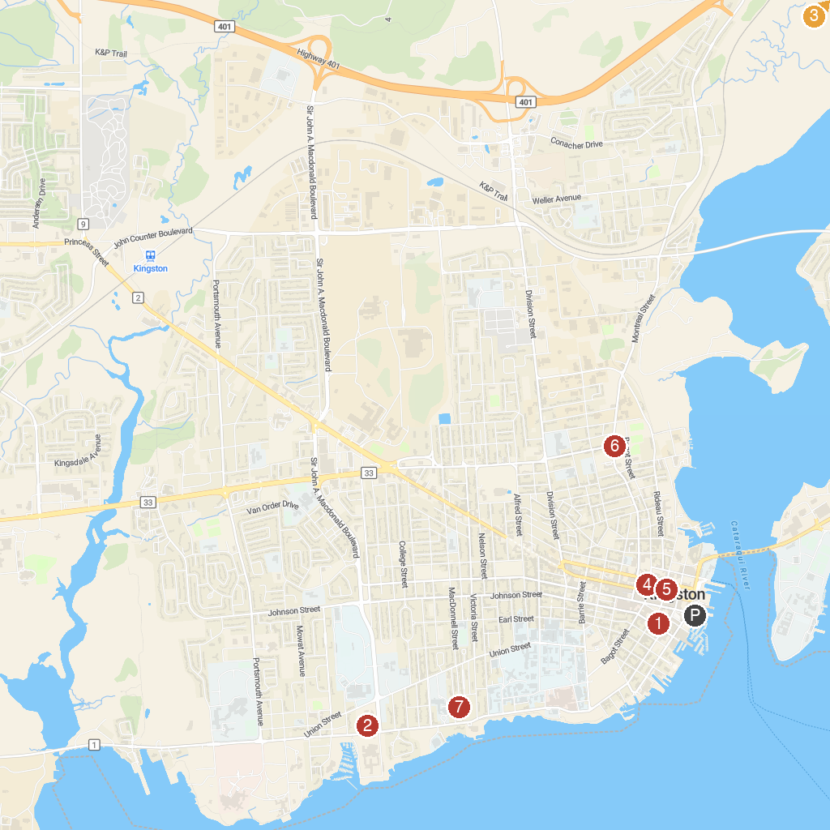
MAP KEY
1. St. George's Cathedral | 5. Martello Alley
2. Canada's Penitentiary Museum (Correctional Service of Canada Museum) | 6. Megaffin Park
3. Rideau Canal, Locks 46 - 49 - Kingston Mills | 7. Bellevue House National Historic Site
4. Sherlock's Escapes
P. Cruise port / terminal
Map © MapTiler © OpenStreetMap contributors · cruiseports.org

