Kingston, New York, USA
New York's first capital hugs the Hudson's Rondout Creek with 17th-century stone streets, a lively maritime waterfront, and a Hudson Valley food scene that punches well above the city's size.
⚓ Docked (pier) · 🕒 Typical call: 6–8 hrs · 💵 US Dollar · 🗣️ English
✍️ MY DAY IN PORT (FILL IN)
Ship / Date
In port | arrive ______ · all aboard ______
Booked excursion
Notes / meeting point
GETTING ASHORE
- Docking: Pier — ships tie up at Rondout waterfront, no tender needed
- Walk to center: Rondout district: steps from ship; Stockade Uptown: 2.5 mi (shuttle recommended)
- Best For: Colonial history, Hudson Valley food & wine, maritime museums
- Don't Miss: The four-corners stone houses of the Stockade District & Rondout Lighthouse boat tour
GETTING AROUND
- 🚕 Taxi: $15–$25 — KPLS Rides provides local taxi service from the Rondout waterfront to Uptown Kingston or Midtown. Price varies by time o
- 📱 Rideshare: ✅ Uber, Lyft
TOP THINGS TO DO
- Stockade District Walking Tour — America's densest concentration of pre-Revolutionary stone houses fills a four-block grid Uptown.
- Rondout Lighthouse Boat Tour — Board the solar-powered vessel Solaris at the Hudson River Maritime Museum for a short cruise out to the 1915 Rondout Lighthouse.
- Hudson River Maritime Museum — Steps from the dock, this museum covers the Hudson's commercial history — ice harvesting, canal trade, and boat building.
- Trolley Museum of New York — Vintage subway cars and trolleys plus a scenic 1.5-mile trolley ride along the Hudson to Kingston Point Park.
- Hudson Valley Farm-to-Table Lunch — Kingston is a genuine food destination.
BEST WALKS
- Rondout Waterfront Loop: 1–1.5 miles · Easy · 30–45 min — From the dock, head east along the Rondout Riverfront Walk past the Maritime Museum and Trolley…
- Stockade District Four Corners Walk: 0.5 miles · Easy · 45–60 min — Take the shuttle Uptown.
WEATHER · DAYLIGHT · MONEY
Month | High °F | Low °F | Rainy days
May | 72 | 49 | 12
Jul | 84 | 63 | 11
Sep | 74 | 53 | 9
Daylight: May 5:36AM–8:08PM · Jul 5:33AM–8:31PM · Sep 6:35AM–7:08PM
cruiseports.org/kingston-ny · Confirm terminal & all-aboard time with your ship

Kingston, New York, USA — Port Map
Red = walkable sights · Amber = excursions farther out · P = cruise terminal
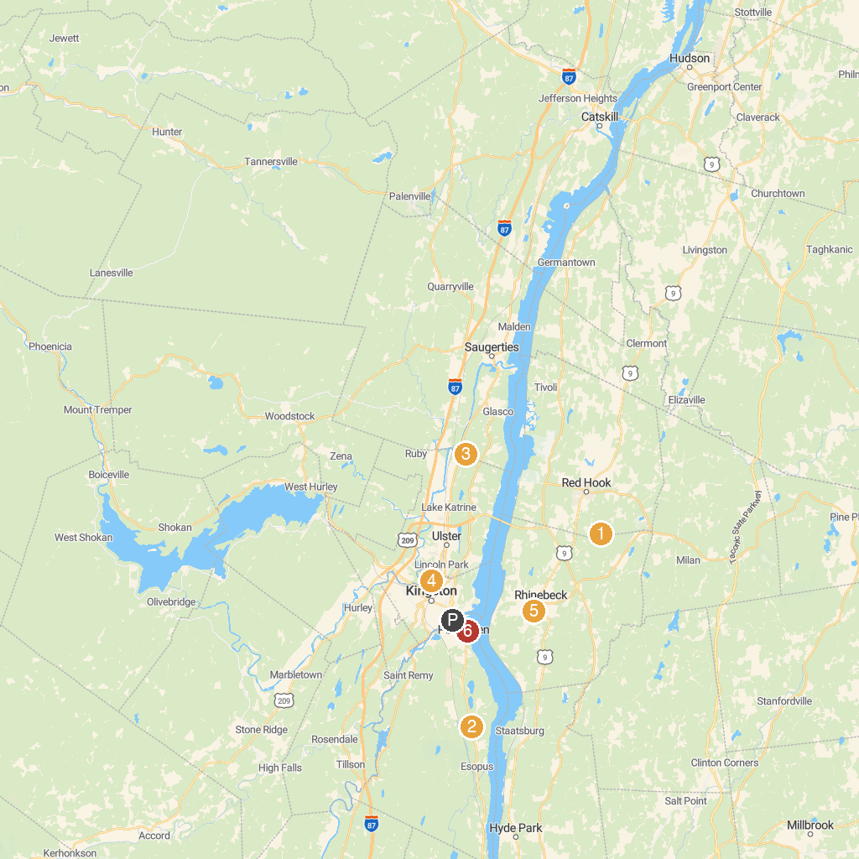
MAP KEY
1. Vanderbilt Mansion National Historic Site | 5. Omega Institute for Holistic Studies
2. Old Rhinebeck Aerodrome | 6. Loughran Park
3. Headless Horseman Hayrides and Haunted Attractions | 7. Thompson-Mazzarella Park
4. Catskill Animal Sanctuary | 8. George H. Freer Memorial Beach
P. Cruise port / terminal
Map © MapTiler © OpenStreetMap contributors · cruiseports.org

