Kingston (Port Royal), Jamaica
Once the wickedest city on earth, Port Royal is now your gateway to Kingston's reggae soul, pirate ruins, and the Caribbean's most authentic urban culture.
⚓ SeaWalk floating pier · 🕒 Typical call: 8-10 hrs · 💵 USD accepted / JMD local · 🗣️ English · 🎵 Reggae capital of the world
✍️ MY DAY IN PORT (FILL IN)
Ship / Date
In port | arrive ______ · all aboard ______
Booked excursion
Notes / meeting point
GETTING ASHORE
- Docking: SeaWalk articulating floating pier at Port Royal — ship secures alongside the pier (walk off, no ship's tender)
- Walk to center: Port Royal village: 5 min on foot. Downtown Kingston: ~16 miles by taxi or ferry
- Best For: Music history, pirate lore, authentic Jamaican food, beach day at Lime Cay
- Don't Miss: Gloria's Seafood for escovitch fish, Fort Charles & the Giddy House
GETTING AROUND
- 🚕 Taxi: $35–45 USD — Official taxis are available at the port. Agree on the fare before departure — meters are not always used. Journey to do
- 📱 Rideshare: ✅ Uber
- 🚌 Hop-on hop-off: ✅
TOP THINGS TO DO
- Fort Charles & the Giddy House — Built in 1655, Fort Charles is Jamaica's oldest fort and the heart of pirate-era Port Royal.
- Bob Marley Museum — Marley's former home and recording studio at 56 Hope Road in Kingston.
- Lime Cay Beach Day — A short water taxi from Port Royal takes you to Lime Cay — a deserted white-sand cay with clear water and good snorkeling.
- Port Royal Walking Tour — Explore the sleepy fishing village where 17th-century pirates once ruled.
- Kingston Food & Culture Tour — Devon House ice cream (one of the world's best), Chelsea Jerk Centre for authentic jerk chicken, and street-level Kingston…
BEST WALKS
- Port Royal Heritage Walk: 1.5 km · 30-45 min · Easy — From the cruise pier, walk through the Port Royal Cruise Village into the old town.
WEATHER · DAYLIGHT · MONEY
Month | High °F | Low °F | Rainy days
May | 86 | 75 | 12
Jul | 90 | 77 | 5
Sep | 89 | 77 | 12
Daylight: May 5:38AM–6:29PM · Jul 5:44AM–6:42PM · Sep 5:59AM–6:05PM
cruiseports.org/kingston-jamaica · Confirm terminal & all-aboard time with your ship

Kingston (Port Royal), Jamaica — Port Map
Red = walkable sights · Amber = excursions farther out · P = cruise terminal
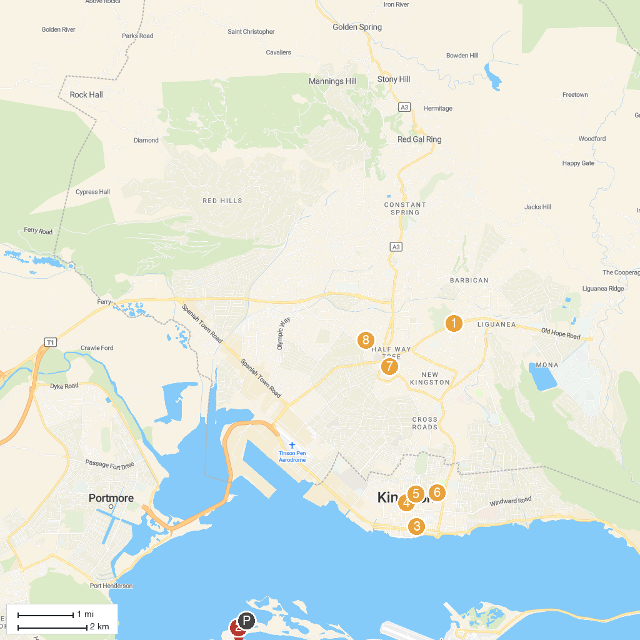
MAP KEY
1. Bob Marley Museum | 5. Shaare Shalom Synagogue
2. Loose Cannon Tours | 6. Holy Trinity Cathedral
3. National Museum Jamaica | 7. Holy Cross Catholic Church
4. Liberty Hall: The Legacy of Marcus Garvey | 8. Nanook
P. Cruise port / terminal
Map © MapTiler © OpenStreetMap contributors · cruiseports.org

