Kings Wharf, Bermuda
Bermuda's flagship cruise port sits inside a restored 19th-century British naval fortress — step off the ship into working studios, a world-class maritime museum, and a fast ferry to the pastel capital.
⚓ Docked (pier) · 🕒 Typical call: 8–10 hrs (often overnight) · 💵 USD & BMD accepted 1:1 · 🗣️ English
✍️ MY DAY IN PORT (FILL IN)
Ship / Date
In port | arrive ______ · all aboard ______
Booked excursion
Notes / meeting point
GETTING ASHORE
- Docking: King's Wharf or Heritage Wharf — large ships dock directly, no tender
- Walk to centre: Dockyard shops & museum within 5–10 min on foot; Hamilton 20 min by ferry
- Best For: History, pink-sand beaches, snorkelling, day-trip to Hamilton
- Don't Miss: National Museum of Bermuda in Commissioner's House, Horseshoe Bay Beach
GETTING AROUND
- 🚕 Taxi: $34–$45 to Hamilton — Government-fixed metered rates: ~$3.25/mile for up to 4 passengers. From Dockyard to Hamilton (~7.8 miles) expect roughl
- 📱 Rideshare: ❌ not available
TOP THINGS TO DO
- National Museum of Bermuda — Housed in the restored Commissioner's House — one of the world's oldest buildings with a prefabricated cast-iron frame (assembled…
- Horseshoe Bay Beach — Bermuda's most famous beach, with soft pink sand and turquoise water on the South Shore.
- Crystal Caves — Underground cathedral of stalactites and crystal-clear flooded caverns in Hamilton Parish.
- St. George's UNESCO Town — One of the oldest English-founded towns in the New World, with 17th-century forts, cobblestone alleys, and the Unfinished Church.
- Snorkelling & Shipwreck Catamaran — Bermuda has some of the Atlantic's best accessible wrecks and reefs.
BEST WALKS
- Dockyard Loop: 1.5 km · 30 min · Easy — A relaxed circuit of the entire Dockyard grounds, taking in Clocktower Mall, Bermuda Arts Centre…
- Hamilton Waterfront Stroll: 1 km in Hamilton · Easy · Ferry required — Catch the Blue Route ferry to Hamilton and walk along Front Street — pastel colonial buildings…
WEATHER · DAYLIGHT · MONEY
Month | High °F | Low °F | Rainy days
May | 72 | 70 | 11
Jul | 81 | 78 | 16
Sep | 81 | 78 | 15
Daylight: May 6:21AM–8:10PM · Jul 6:23AM–8:26PM · Sep 7:03AM–7:24PM
cruiseports.org/kings-wharf · Confirm terminal & all-aboard time with your ship

Kings Wharf, Bermuda — Port Map
Red = walkable sights · Amber = excursions farther out · P = cruise terminal
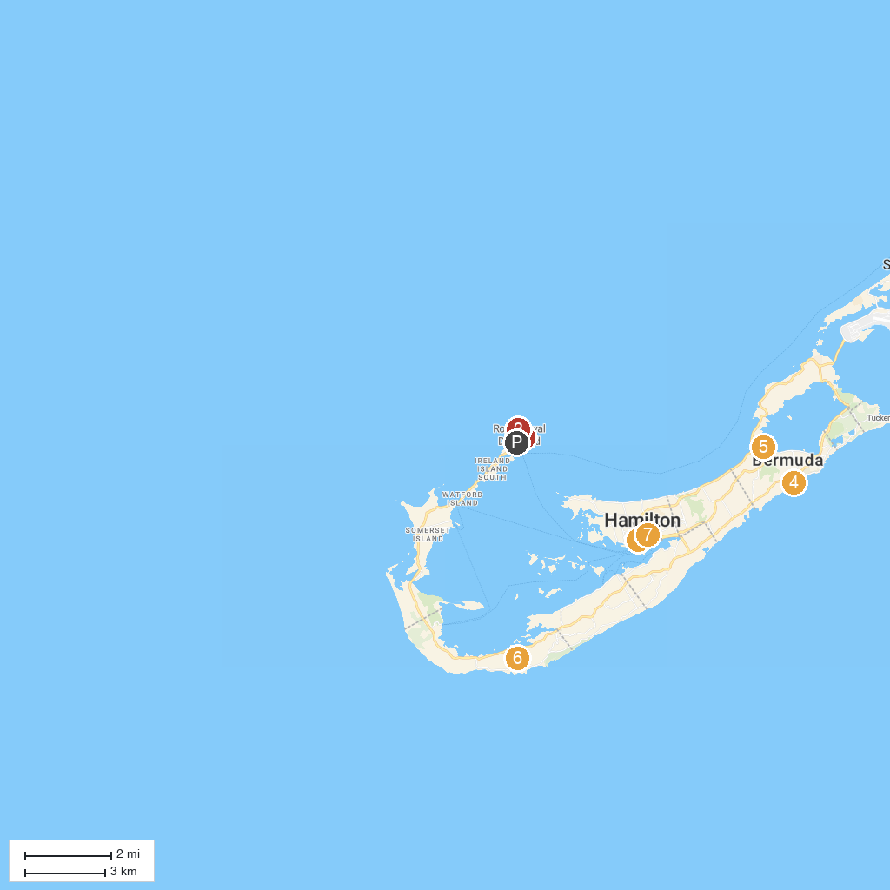
MAP KEY
1. Queen Elizabeth Par-La-Ville Sculpture Park | 5. Bermuda Aquarium, Museum & Zoo
2. Hartley's Helmet Diving | 6. Gibb's Hill Lighthouse
3. Snorkel Park | 7. Crystal and Fantasy Caves
4. Spittal Pond | 8. The Cathedral of the Most Holy Trinity
P. Cruise port / terminal
Map © MapTiler © OpenStreetMap contributors · cruiseports.org

