Kinderdijk, South Holland, Netherlands
Nineteen 18th-century windmills line the canal banks where the Lek and Noord rivers meet — a living drainage system and the most iconic windmill landscape in the Netherlands, now a UNESCO World Heritage Site.
⚓ River pier (direct dock) · 🕒 Typical call: 3-5 hrs · 💶 Euro (€) — largely cashless · 🗣️ Dutch (English widely spoken)
✍️ MY DAY IN PORT (FILL IN)
Ship / Date
In port | arrive ______ · all aboard ______
Booked excursion
Notes / meeting point
GETTING ASHORE
- Docking: River cruise ships berth on the Lek riverbank, steps from the windmill site entrance
- Walk to windmills: 2–5 min from the pier to the Visitor Center
- Best For: Photography, Dutch history, easy flat walking, canal boat tours
- Don't Miss: Interior of Museum Windmill Nederwaard and the 30-min canal cruiser tour
GETTING AROUND
- 🚕 Taxi: €80–95 from Rotterdam — Private taxi from Rotterdam city center or cruise terminal to Kinderdijk takes ~22–30 minutes depending on traffic. Fare
- 📱 Rideshare: ✅ Uber, Bolt
TOP THINGS TO DO
- Museum Windmill Nederwaard — Step inside a working 1738 ground-sailer windmill to see how a family of 15 once lived and worked in cramped quarters alongside…
- Canal Cruiser Boat Tour — A 30-minute guided canal ride past all 19 windmills from the water — the best angle for photos and ideal for those who prefer not…
- Wisboom Pumping Station — Explore the 19th-century steam pumping station — now electric — with interactive displays explaining the Dutch polder…
- Cycling the Windmill Route — Rent a bike at the entrance and cycle the full length of the polder canal — the most Dutch way to see all 19 mills and reach the…
- Rotterdam Day Extension — Combine Kinderdijk with Rotterdam's striking modern architecture — the Cube Houses, Markthal, and Erasmus Bridge are 30 minutes…
BEST WALKS
- Main Windmill Canal Walk: 2 km one-way · Flat paved path · 30–45 min each way — Follow the canal towpath from the Visitor Center past all 19 windmills to the far end of the polder.
- Village & River Levee Loop: ~1.5 km · Flat · 20–30 min — From the pier, walk the Lek riverbank levee path north and loop back through the small village…
WEATHER · DAYLIGHT · MONEY
Month | High °F | Low °F | Rainy days
May | 63 | 48 | 12
Jul | 72 | 58 | 15
Sep | 67 | 54 | 10
Daylight: May 5:48AM–9:28PM · Jul 5:40AM–9:53PM · Sep 7:16AM–7:55PM
cruiseports.org/kinderdijk · Confirm terminal & all-aboard time with your ship

Kinderdijk, South Holland, Netherlands — Port Map
Red = walkable sights · Amber = excursions farther out · P = cruise terminal
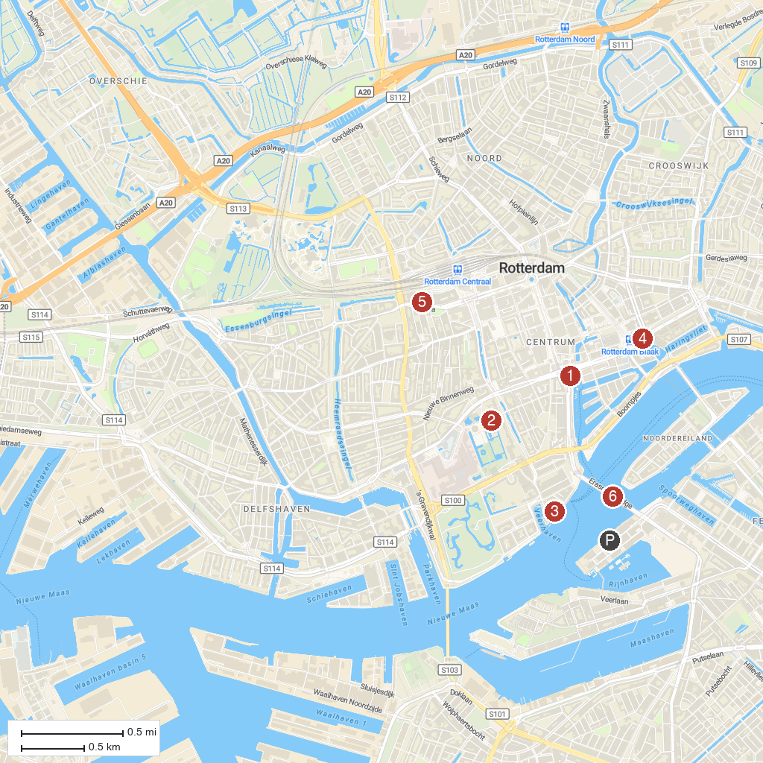
MAP KEY
1. Hoge Bergse Bos | 5. Plaswijckpark
2. Maritime Museum | 6. Kijk-Kubus Museum-house
3. Museum Boijmans Van Beuningen | 7. Miniworld Rotterdam
4. Wereldmuseum Rotterdam | 8. Erasmusbrug
P. Cruise port / terminal
Map © MapTiler © OpenStreetMap contributors · cruiseports.org

