Kimberley Coast, Western Australia, Australia
A vast ancient coastline of red cliffs, horizontal waterfalls, and 40,000-year-old rock art — accessible only by expedition ship. No cruise terminals, no tourist strips. Just raw wilderness.
⚓ Tender/Zodiac (no pier on coast) · 🕒 Typical call: multi-day expedition · 💵 AUD · 🗣️ English · 🌿 Season: April–October
✍️ MY DAY IN PORT (FILL IN)
Ship / Date
In port | arrive ______ · all aboard ______
Booked excursion
Notes / meeting point
GETTING ASHORE
- Docking: Anchor & Zodiac landings; no pier on coast. Broome & Wyndham have deepwater docks.
- Best For: Expedition-style wilderness cruising, ancient Aboriginal culture, wildlife, waterfalls
- Don't Miss: Horizontal Falls, Montgomery Reef, King George Falls, ancient Gwion Gwion (Bradshaw) rock art
- Key Warning: No swimming on coast — saltwater crocodiles and box jellyfish. Cable Beach (Broome) only.
GETTING AROUND
- 🚕 Taxi: AUD 18–25 for short trips — Taxis operate in Broome, the main embarkation/disembarkation port. Base fare ~AUD 4.60 + ~AUD 2.80/km; a 5 km trip runs
TOP THINGS TO DO
- Montgomery Reef — Watch a 150-square-mile coral reef appear to 'rise' from the sea as the tide falls, creating cascading waterfalls in the middle…
- Horizontal Falls — Fast-Boat Ride — Tidal forces push water through two narrow mountain gorges in Talbot Bay, creating a 'horizontal waterfall.' A fast-boat ride…
- King George Falls — Twin waterfalls plunge 80 metres down red sandstone cliffs into the ocean.
- Ancient Rock Art (Bradshaw Figures & Wandjina) — Among the oldest rock art on Earth — Gwion Gwion (Bradshaw) figures dated to roughly 12,000 years, with some Kimberley motifs…
- Mitchell Falls Helicopter Flight — A scenic helicopter flight over the four-tiered Mitchell Falls, deep in the Mitchell Plateau.
BEST WALKS
- Jar Island Rock Art Walk: 1-2 km | Easy | 45-90 min — Guided walk from Zodiac landing to Gwion Gwion (Bradshaw) figure rock art panels — extraordinary…
- Cable Beach Stroll (Broome): Up to 22 km | Easy | Any length — The only beach on the Kimberley cruise where swimming is safe (in season).
WEATHER · DAYLIGHT · MONEY
Month | High °F | Low °F | Rainy days
May | 90 | 71 | 1
Jul | 85 | 64 | 0
Sep | 90 | 71 | 0
Daylight: May 6:09AM–5:25PM · Jul 6:22AM–5:31PM · Sep 5:47AM–5:45PM
cruiseports.org/kimberley-coast · Confirm terminal & all-aboard time with your ship

Kimberley Coast, Western Australia, Australia — Port Map
Red = walkable sights · Amber = excursions farther out · P = cruise terminal
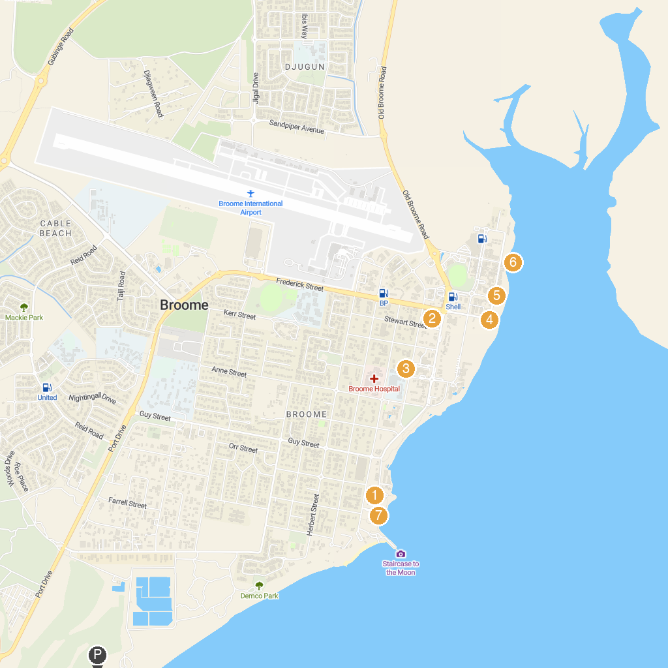
MAP KEY
1. Broome Historical Museum | 5. Pearl Luggers Broome
2. Broome Courthouse Markets | 6. Streeter's Jetty Broome
3. Our Lady Queen of Peace Cathedral | 7. Town Beach
4. Roebuck Bay Lookout
P. Cruise port / terminal
Map © MapTiler © OpenStreetMap contributors · cruiseports.org

