Killybegs, County Donegal, Ireland
Ireland's busiest fishing port punches well above its size — it's the launchpad for jaw-dropping Slieve League, the Wild Atlantic Way's wildest coastline, and some of the freshest seafood you'll eat on any cruise.
⚓ Pier (deep-water berth) · 🕒 Typical call: 7-9 hrs · 💶 Currency: Euro (€) · 🗣️ Language: English (Irish Gaeltacht nearby) · 🐟 Ireland's top fishing port
✍️ MY DAY IN PORT (FILL IN)
Ship / Date
In port | arrive ______ · all aboard ______
Booked excursion
Notes / meeting point
GETTING ASHORE
- Docking: Deep-water pier at Smooth Point — no tender
- Walk to centre: ~1.5 km / 15-20 min flat walk (shuttle often provided)
- Best For: Slieve League cliffs, coastal drives, seafood
- Don't Miss: Fresh chowder at the harbour; Slieve League cliffs views
GETTING AROUND
- 🚕 Taxi: €10–€15 — Local taxis can transfer you to the town centre or nearby attractions. Demand spikes on cruise days, so pre-booking is s
- 📱 Rideshare: ✅ Uber, Bolt
TOP THINGS TO DO
- Slieve League Cliffs — At 601 m, these Atlantic sea cliffs are nearly three times the height of the Cliffs of Moher — and far less crowded.
- Slieve League Boat Trip — View the towering cliffs from the water on a RIB or small boat out of nearby Teelin Pier.
- Donegal Town & Castle — The county town is about 27 km east and packs a full cultural day: Donegal Castle (15th-century O'Donnell stronghold), the ruins…
- Killybegs Carpet & Maritime Centre — Killybegs was home to Donegal Carpets, whose hand-knotted work graced the White House, Buckingham Palace, and the Vatican.
- Harbour Seafood & Local Food Trail — Killybegs lands some of Ireland's best fish — mackerel, cod, haddock, and shellfish.
BEST WALKS
- Killybegs Heritage Harbour Walk: 3.5 km | 45-60 min | Easy | Self-guided — Follow the bronze pavement plaques around the inner harbour past the fish-processing quays, St.
- Fintra Bay Walk: 3 km from town | Easy coastal path | Blue Flag beach — Head west along the coast road from town to reach Fintra Beach (also spelled Fintragh), a sheltered…
WEATHER · DAYLIGHT · MONEY
Month | High °F | Low °F | Rainy days
May | 58 | 47 | 17
Jul | 63 | 54 | 21
Sep | 60 | 52 | 19
Daylight: May 5:28AM–9:33PM · Jul 5:17AM–10:00PM · Sep 7:07AM–7:49PM
cruiseports.org/killybegs · Confirm terminal & all-aboard time with your ship

Killybegs, County Donegal, Ireland — Port Map
Red = walkable sights · Amber = excursions farther out · P = cruise terminal
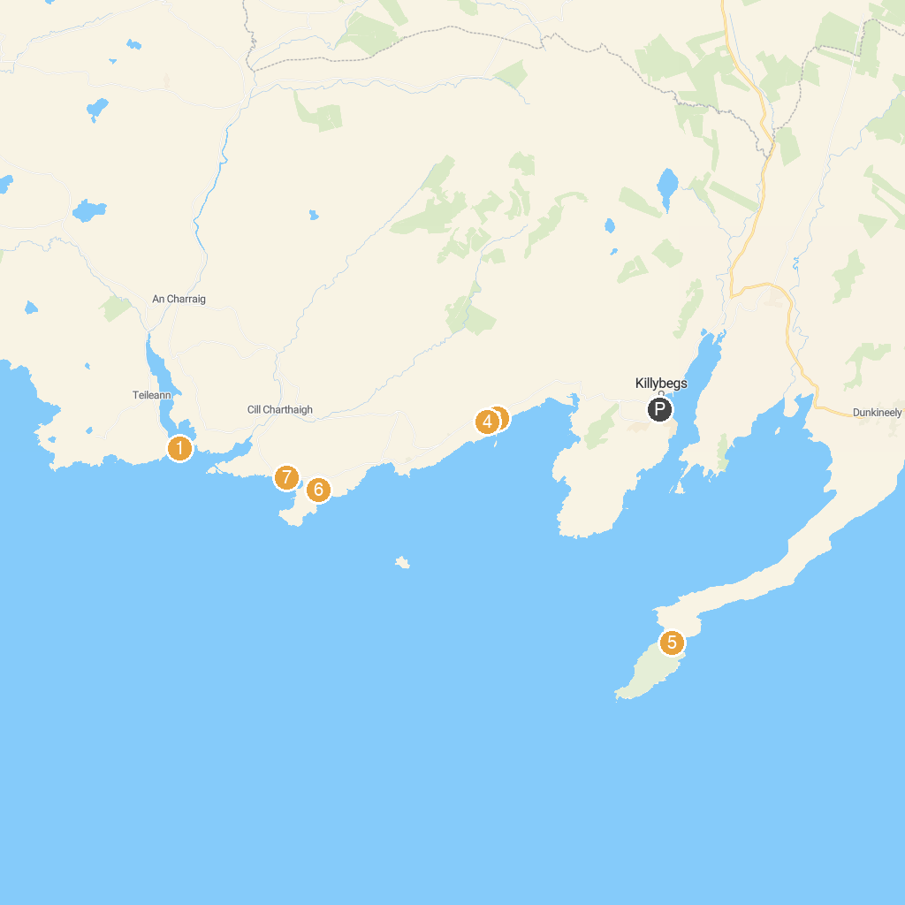
MAP KEY
1. Sliabh Liag Boat Trips | 5. St John's Point Beach
2. Atlantic Coastal Cruises | 6. Trá Bán Beach
3. Secret Waterfall | 7. Wild Atlantic Way Discovery Point @Muckross Head
4. Largy Viewpoint | 8. Sliabh Liag Tours
P. Cruise port / terminal
Map © MapTiler © OpenStreetMap contributors · cruiseports.org

