Killarney, Ontario, Canada
Ontario's oldest north-shore village perches where pink granite meets sapphire Georgian Bay. The Group of Seven painted here; expedition ships tender passengers into a landscape that still looks like living Canadian art.
⚓ Tender port · 🕒 Typical call: 6–8 hrs · 💵 Canadian Dollar (CAD) · 🗣️ English · 🌲 Wilderness / nature focus
✍️ MY DAY IN PORT (FILL IN)
Ship / Date
In port | arrive ______ · all aboard ______
Booked excursion
Notes / meeting point
GETTING ASHORE
- Docking: Tender — no large cruise pier; tenders use marina docks
- Walk to village: Steps from tender dock; village is very compact (~5 min on foot)
- Best For: Hiking, wilderness scenery, Canadian history, nature photography
- Don't Miss: Herbert's Fisheries fish & chips and views from Killarney East Lighthouse
GETTING AROUND
- 🚕 Taxi: Varies by destination — Killarney On The Water and Killarney Outfitters offer water taxis to Collins Inlet, Baie Fine, and Philip Edward Island
TOP THINGS TO DO
- The Crack Hike, Killarney Provincial Park — The park's signature day hike climbs a dramatic quartzite fissure to jaw-dropping views over the La Cloche Mountains and Georgian…
- Kayak or Canoe on Georgian Bay — Killarney Outfitters rents canoes and kayaks for exploring the sheltered inlets and islands along the bay's north shore.
- Village Walk & Killarney Museum — Ontario's oldest north-shore settlement was founded in 1820 as a fur trading post.
- Floatplane Scenic Flight — Local floatplane operators offer scenic flights over the La Cloche Mountains, Georgian Bay islands, and the white quartzite…
- Killarney Lighthouse Trail — A 4.5 km return trail along the Georgian Bay shoreline to the historic Killarney East Lighthouse with panoramic bay views.
BEST WALKS
- Village & Waterfront Stroll: 1 km · 20 min · Easy · Flat — From the marina tender dock, stroll past Herbert's Fisheries, the Killarney Museum, and along the…
- Killarney Lighthouse Trail: 4.5 km return · 1.5 hrs · Moderate · Rocky shoreline — Head east from the village along the Georgian Bay shore to the Killarney East Lighthouse.
WEATHER · DAYLIGHT · MONEY
Month | High °F | Low °F | Rainy days
May | 63 | 44 | 9
Jul | 77 | 58 | 9
Sep | 68 | 50 | 10
Daylight: May 5:25AM–8:45PM · Jul 5:25AM–9:10PM · Sep 6:40AM–7:35PM
cruiseports.org/killarney-on · Confirm terminal & all-aboard time with your ship

Killarney, Ontario, Canada — Port Map
Red = walkable sights · Amber = excursions farther out · P = cruise terminal
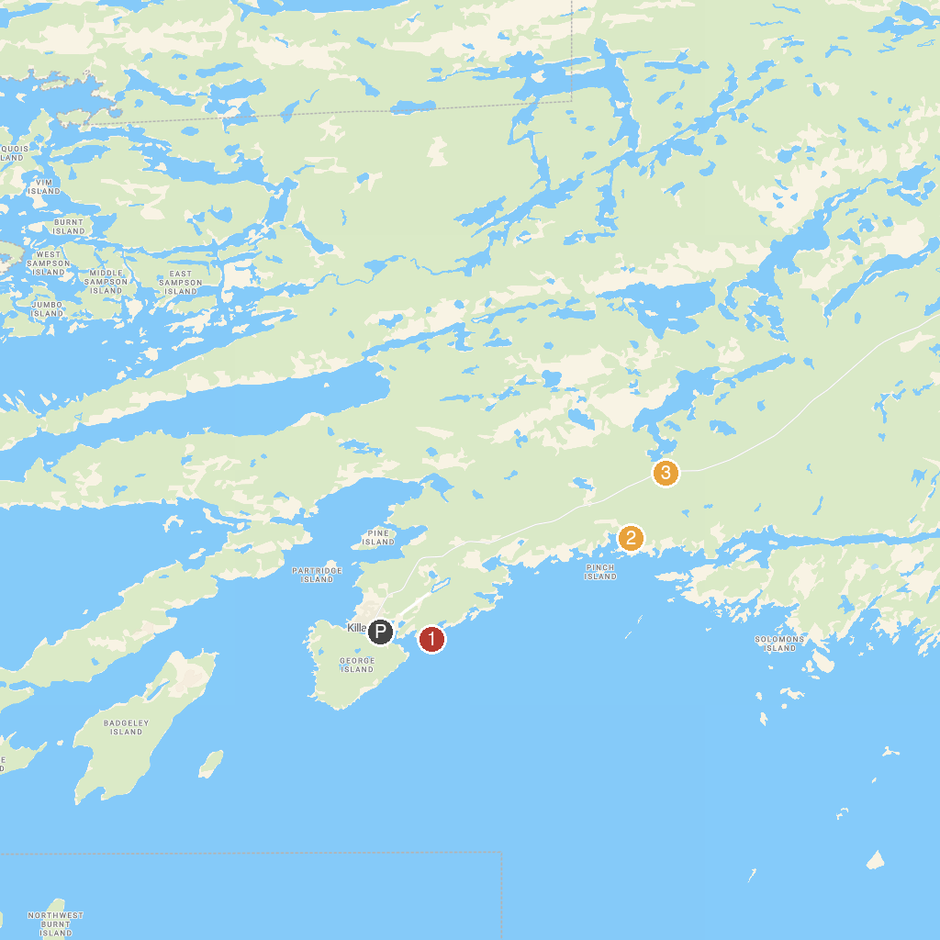
MAP KEY
1. Killarney East Lighthouse | 3. Granite Ridge Trail
2. Chikanishing Trail
P. Cruise port / terminal
Map © MapTiler © OpenStreetMap contributors · cruiseports.org

