Kiel, Germany
Germany's sailing capital at the head of the Kiel Fjord — a maritime city beside the world's busiest artificial waterway, and a gateway to the Hanseatic jewel of Lübeck.
⚓ Docked (city center) · 🕒 Typical call: 8–10 hrs · 💶 Euro (EUR) · 🗣️ German · some English
✍️ MY DAY IN PORT (FILL IN)
Ship / Date
In port | arrive ______ · all aboard ______
Booked excursion
Notes / meeting point
GETTING ASHORE
- Docking: Ostseekai terminal
- Walk to center: 5 min
- Best For: Lübeck · Maritime
- Don't Miss: Kiel Canal locks
GETTING AROUND
- 🚕 Taxi: €8–€20 — Taxis queue at all terminals. Central terminals run €8–€15; the more distant Ostuferhafen terminal is around €20 to city
- 📱 Rideshare: ✅ Uber, Bolt
- 🚌 Hop-on hop-off: ✅
TOP THINGS TO DO
- Medieval Lübeck — The UNESCO-listed Hanseatic old town on its island — the brick Holstentor gate, marzipan shops, and seven church spires.
- Hamburg Day Trip — Germany's great port city — the Speicherstadt warehouse district, the Elbphilharmonie, and the Reeperbahn, ~1.25 hours away by…
- Kiel Canal & Holtenau Locks — Watch ocean ships transit the locks where the world's busiest artificial waterway meets the Baltic — a maritime engineering…
- Laboe Naval Memorial & Beach — Across the fjord, the towering Laboe Memorial and U-995 submarine, paired with a Baltic beach — reached by a scenic fjord ferry…
BEST WALKS
- Kiellinie waterfront promenade: ~3 km · 1.5 hrs · easy — The pleasant fjord-side promenade from the city center, lined with sailing yachts, cafés, and views…
- Holstenstraße & old market: ~1.5 km · 1 hr · easy — Kiel's pedestrian shopping street up to the Alter Markt, the Nikolaikirche, and Barlach's 'Spirit…
- Schwentine fjord ferry ride: short ferry · 1–2 hrs · easy — Hop a fjord ferry from the city pier for a cheap mini-cruise across the harbour — a local's way to…
WEATHER · DAYLIGHT · MONEY
Month | High °F | Low °F | Rainy days
May | 61 | 46 | 11
Jul | 71 | 57 | 14
Sep | 66 | 53 | 11
Daylight: May 5:15AM–9:17PM · Jul 5:05AM–9:44PM · Sep 6:52AM–7:35PM
cruiseports.org/kiel · Confirm terminal & all-aboard time with your ship

Kiel, Germany — Port Map
Red = walkable sights · Amber = excursions farther out · P = cruise terminal
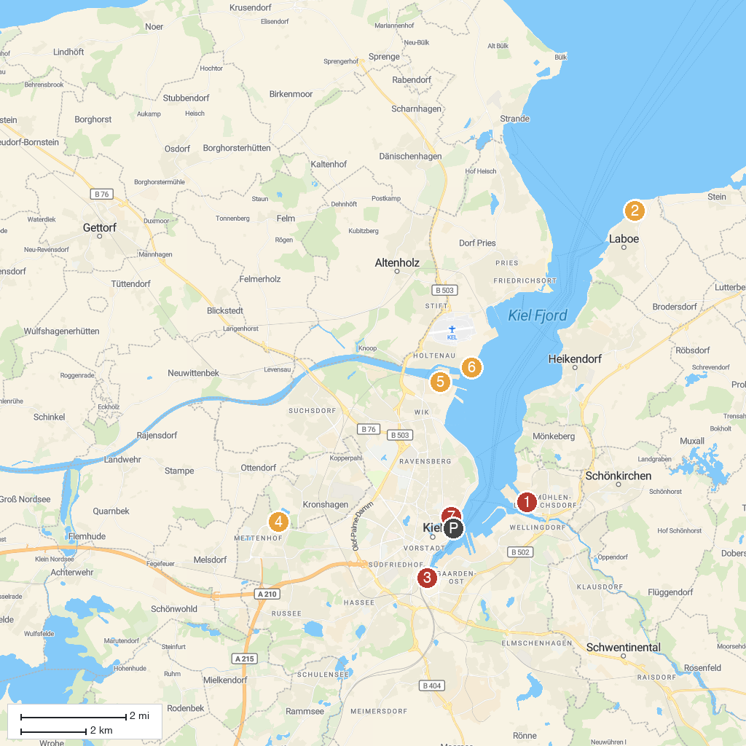
MAP KEY
1. Computermuseum der Fachhochschule Kiel | 5. Aussichtsplattform Schleuse
2. Naval Memorial | 6. Leuchtturm Kiel-Holtenau
3. Hörn | 7. Marine Biology Station Laboe
4. LaserZone LaserTag Kiel | 8. Zoological Museum of Kiel University
P. Cruise port / terminal
Map © MapTiler © OpenStreetMap contributors · cruiseports.org

