Khasab, Musandam Governorate, Oman
Khasab is Oman's Musandam outpost, where bare Hajar mountains plunge into blue khors and traditional dhows head for dolphin waters. It is a small, practical port day: book the fjords, use shuttles or taxis, and do not expect a big-city cruise terminal.
⚓ Docked (commercial port) · 🕒 Typical call: 7-9 hrs · 💵 Omani Rial (OMR) · 🗣️ Arabic (English in tours) · ☀️ Hot, exposed port
✍️ MY DAY IN PORT (FILL IN)
Ship / Date
In port | arrive ______ · all aboard ______
Booked excursion
Notes / meeting point
GETTING ASHORE
- Docking: Usually alongside at Khasab's commercial port; terminal facilities are limited and older guides may still mention tendering.
- Walk to center: About 3-5 km to Khasab town and souq depending on drop-off; take the shuttle, taxi, or tour pickup in the heat.
- Best For: Dhow cruises, dolphins, desert-fjord scenery, 4x4 mountain views, low-key Omani culture.
- Don't Miss: A Khor Sham dhow cruise to Telegraph Island and the Musandam fjords.
GETTING AROUND
- 🚕 Taxi: Negotiated fare — Local taxis are available at the port. Fares are negotiated; USD, EUR, and AED are often accepted alongside Omani Rials
- 📱 Rideshare: ❌ not available
TOP THINGS TO DO
- Khor Sham Dhow Cruise — Board a traditional wooden dhow for the classic Musandam fjords day: steep limestone walls, small fishing villages, tea and dates…
- Dolphin Watching in the Fjords — Many dhow trips include a good chance of seeing dolphins riding the bow wave in the sheltered khors.
- Khasab Fort — A restored 17th-century Omani fort with exhibits on Musandam life, boats, crafts, palm houses, weapons, and local history.
- Jebel Harim 4x4 Safari — Head into the Musandam mountains by 4x4 for high viewpoints, rough tracks, fossils, and ancient rock carvings near Tawi.
- Bassa Beach — Khasab's main public beach sits north of town with mountain views and basic shade.
BEST WALKS
- Khasab Fort & Souq Stroll: 1.5-2 km · 1-2 hrs · Easy once in town — Take the shuttle or taxi into Khasab, visit Khasab Fort, then continue toward the small souq area…
- Bassa Beach Stop: Short beach visit · Taxi required · Easy — Use a taxi for a simple beach break at Bassa Beach, then return to town or directly to the port.
WEATHER · DAYLIGHT · MONEY
Month | High °F | Low °F | Rainy days
May | 98 | 85 | 0
Jul | 102 | 90 | 0
Sep | 99 | 86 | 0
Daylight: May 5:28AM–6:54PM · Jul 5:32AM–7:09PM · Sep 6:00AM–6:19PM
cruiseports.org/khasab · Confirm terminal & all-aboard time with your ship

Khasab, Musandam Governorate, Oman — Port Map
Red = walkable sights · Amber = excursions farther out · P = cruise terminal
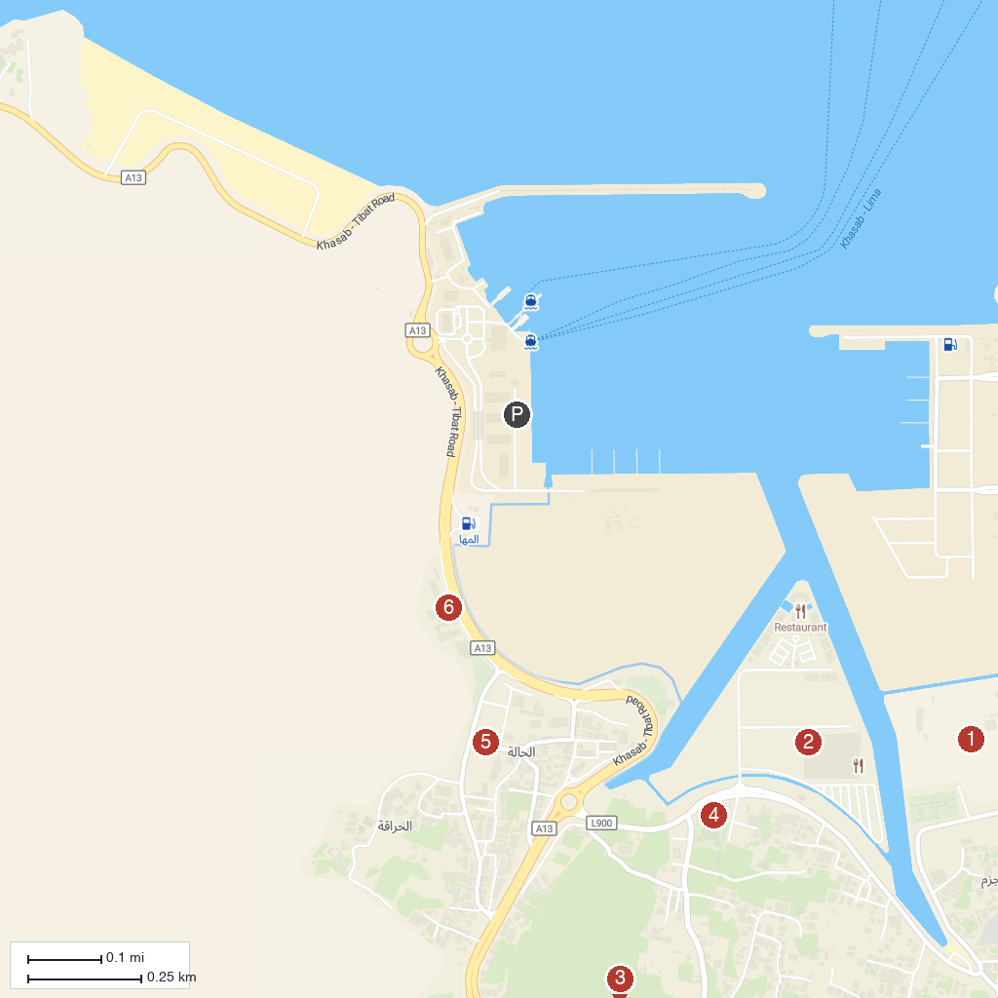
MAP KEY
1. Khasab Sea Tours | 4. Khasab Castle
2. DOLPHIN KHASAB TOURS | 5. AHLAM MUSANDAM TOURS, KHASAB
3. Sultan Qaboos Mosque | 6. Khasab Sands Tours
P. Cruise port / terminal
Map © MapTiler © OpenStreetMap contributors · cruiseports.org

