Key Biscayne, Florida, USA
A lush barrier island just off Miami, Key Biscayne delivers world-class beaches, a 200-year-old lighthouse, and the famous Stiltsville silhouette — without the South Beach crowds.
⚓ Small ships / tender landing · 🕒 Typical call: 6–8 hrs · 💵 USD · 🗣️ English · 🌴 Beach & nature day
✍️ MY DAY IN PORT (FILL IN)
Ship / Date
In port | arrive ______ · all aboard ______
Booked excursion
Notes / meeting point
GETTING ASHORE
- Docking: Tender or marina dock (American Cruise Lines; small vessels only)
- Walk to center: Village shops & dining within 5–10 min of Crandon Park Marina
- Best For: Beaches, cycling, nature parks, Miami skyline views
- Don't Miss: Bill Baggs Cape Florida State Park & the 1825 lighthouse
GETTING AROUND
- 🚕 Taxi: $30–$45 — Taxis are available near the dock and along Crandon Boulevard. Expect $30–$45 for a ride to Downtown Miami or Brickell;
- 📱 Rideshare: ✅ Uber, Lyft
TOP THINGS TO DO
- Bill Baggs Cape Florida State Park — Consistently ranked among America's top beaches, this wild southern-tip park wraps around the 1825 Cape Florida Lighthouse with…
- Cape Florida Lighthouse — Florida's oldest standing structure (1825), the lighthouse offers free guided tours Thu–Mon at 10 AM and 1 PM inside Bill Baggs…
- Crandon Park Beach — Two miles of powder-white sand with a sheltered sandbar that creates shallow, calm water ideal for families.
- Village of Key Biscayne — Stroll the compact village for Cuban pastries at Donut Gallery Diner (a local institution since 1971), boutique shops, and café…
- Stiltsville & Biscayne Bay Views — From the southern tip of Bill Baggs, spot the ghostly cluster of 1930s-era wooden homes perched on stilts in Biscayne Bay.
BEST WALKS
- Village to Crandon Park Beach: 1.5 miles each way · Flat · 25–30 min walk — An easy stroll or quick bike ride north from the village center along Crandon Boulevard to the…
- Cape Florida Lighthouse Loop: ~1 mile inside park · Easy · 45–60 min — From the Bill Baggs State Park entrance, follow the trail past the keeper's cottage to the…
WEATHER · DAYLIGHT · MONEY
Month | High °F | Low °F | Rainy days
May | 83 | 74 | 16
Jul | 87 | 78 | 22
Sep | 86 | 77 | 24
Daylight: May 6:35AM–7:59PM · Jul 6:39AM–8:13PM · Sep 7:06AM–7:24PM
cruiseports.org/key-biscayne-fl · Confirm terminal & all-aboard time with your ship

Key Biscayne, Florida, USA — Port Map
Red = walkable sights · Amber = excursions farther out · P = cruise terminal
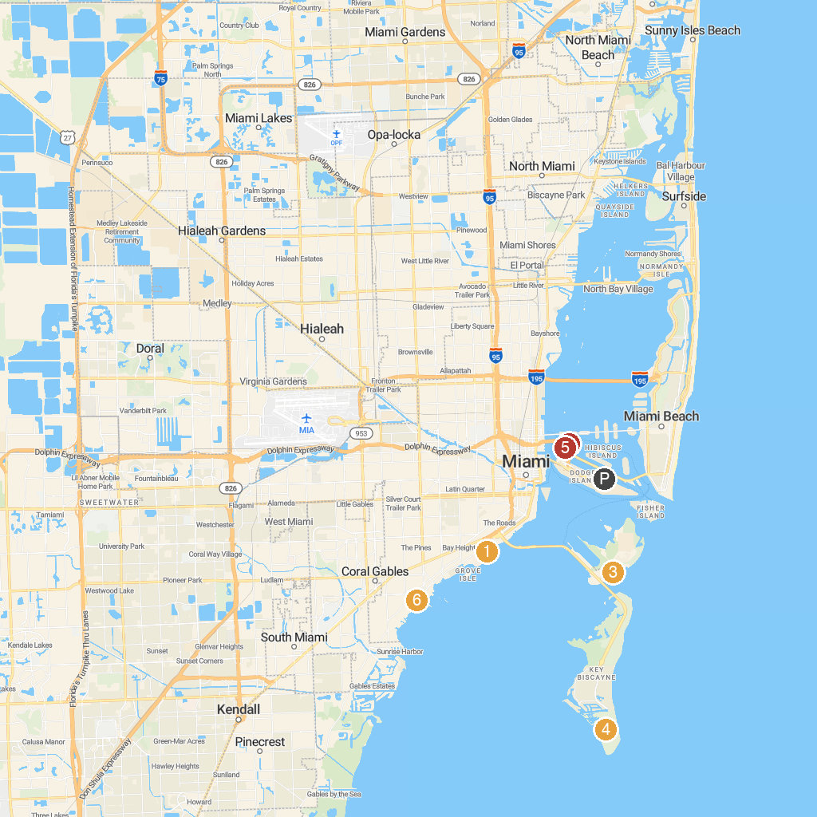
MAP KEY
1. Vizcaya Museum & Gardens | 5. Venetian Pool
2. Jungle Island | 6. Miami Children's Museum
3. Historic Virginia Key Beach Park | 7. Magic City Casino
4. Bill Baggs Cape Florida State Park | 8. Peacock Park
P. Cruise port / terminal
Map © MapTiler © OpenStreetMap contributors · cruiseports.org

