Ketchikan, Alaska, USA
Alaska's 'First City' and totem-pole capital — a rainy rainforest port where Creek Street's historic boardwalk, floatplane wilderness, world-class salmon fishing, and Tlingit heritage all sit minutes from the dock.
⚓ Docked (4 downtown berths + Ward Cove) · 🕓 Typical call: 7–10 hrs · 💵 US Dollar (USD) · 🌧️ Rainforest climate — waterproof everything
✍️ MY DAY IN PORT (FILL IN)
Ship / Date
In port | arrive ______ · all aboard ______
Booked excursion
Notes / meeting point
GETTING ASHORE
- Docking: Up to 5 berths (4 downtown, 1 at Ward Cove)
- Walk to center: 0–10 min (downtown berths); free shuttle from Ward Cove
- Best For: Totems · Flightseeing · Salmon fishing
- Don't Miss: Creek Street boardwalk & Misty Fjords flightseeing
GETTING AROUND
- 🚕 Taxi: .50 drop + ~/mile — Taxis are available but limited; pre-arranging is recommended. A typical downtown trip runs –.
- 📱 Rideshare: ✅ Uber, Lyft
TOP THINGS TO DO
- Misty Fjords Flightseeing — A floatplane soars over 3,000-ft granite cliffs, cascading waterfalls, and the volcanic spire of New Eddystone Rock before…
- Saxman Village & Totem Bight — Saxman is a living Tlingit village 2 miles south of town — two dozen totem poles, an active carving shed, and clan house dances.
- Misty Fjords Catamaran Cruise — A high-speed catamaran threads the same fjord at water level — glacially carved cliffs towering overhead, naturalists spotting…
- Salmon & Halibut Fishing Charter — Ketchikan earns its 'Salmon Capital of the World' title.
- Herring Cove Bear Viewing — Late July through September, black bears crowd the Herring Cove creek mouth to intercept spawning salmon.
BEST WALKS
- Creek Street Boardwalk: ~1 km · 30–45 min · easy · free — The iconic stilted walkway built over Ketchikan Creek — former red-light district, now galleries…
- Downtown Totem & History Loop: ~2 km · 1–1.5 hrs · easy — Start at the Ketchikan Visitor Center, detour to the Tongass Historical Museum, continue to the…
- Deer Mountain Trail: ~8 km out-and-back · 4–5 hrs · strenuous — Switchbacks climb from near City Park through old-growth spruce into alpine terrain with sweeping…
WEATHER · DAYLIGHT · MONEY
Month | High °F | Low °F | Rainy days
May | 58 | 45 | 14
Jul | 65 | 55 | 17
Sep | 59 | 50 | 19
Daylight: May 4:36AM–8:50PM · Jul 4:26AM–9:17PM · Sep 6:20AM–7:01PM
cruiseports.org/ketchikan · Confirm terminal & all-aboard time with your ship

Ketchikan, Alaska, USA — Port Map
Red = walkable sights · Amber = excursions farther out · P = cruise terminal
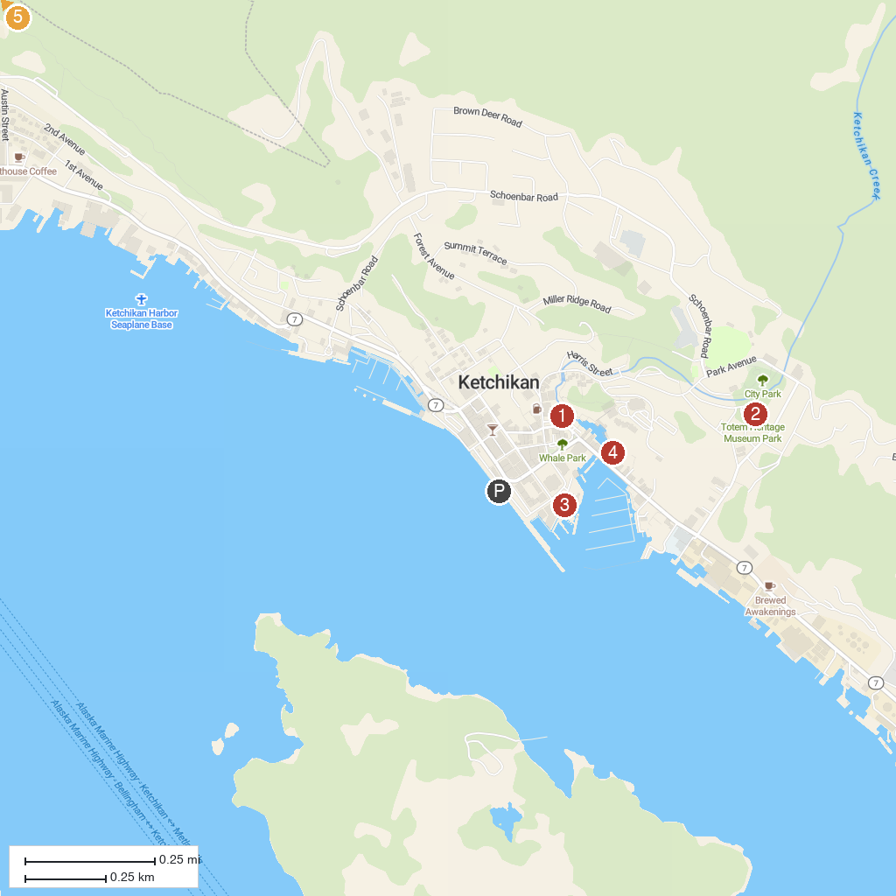
MAP KEY
1. Tongass Historical Museum | 4. Dolly's House
2. Totem Heritage Center | 5. Totem Bight State Historical Park
3. Great Alaskan Lumberjack Show
P. Cruise port / terminal
Map © MapTiler © OpenStreetMap contributors · cruiseports.org

