Kefalonia Island, Ionian Islands, Greece
Greece's largest Ionian island rewards cruise visitors with electric-blue cave lakes, white-pebble beaches plunging into turquoise water, and a lush, pine-forested interior unlike any other stop in the Aegean.
⚓ Pier (occasional tender if berth occupied) · 🕒 Typical call: 7-9 hrs · 💶 Euro (€) · 🗣️ Greek
✍️ MY DAY IN PORT (FILL IN)
Ship / Date
In port | arrive ______ · all aboard ______
Booked excursion
Notes / meeting point
GETTING ASHORE
- Docking: Single cruise berth at Argostoli quay; most ships dock directly. If berth is occupied by a larger vessel, passengers tender to the old harbor.
- Walk to center: 5-10 min to harbor promenade; 15 min to Lithostroto shopping street; 20 min to Plateia Vallianou (main square)
- Best For: Beaches, caves, scenic drives, sea turtles, Greek island dining
- Don't Miss: Loggerhead sea turtles at the fishing dock (morning), Melissani Cave boat tour, clifftop view over Myrtos Beach
GETTING AROUND
- 🚕 Taxi: €8–€12 — Taxis wait at the port and around Argostoli's central square. Fares for short hops around town are €8–€12; confirm the f
- 📱 Rideshare: ❌ not available
TOP THINGS TO DO
- Melissani Cave & Lake — An underground lake inside a collapsed cave near Sami, 40 minutes east of port.
- Myrtos Beach — Consistently ranked one of the world's most beautiful beaches — sheer white limestone cliffs drop to smooth white pebbles and…
- Drogarati Cave — A 150-million-year-old cave near Sami with towering stalactites and remarkable acoustics — opera performers have staged concerts…
- Assos Village & Venetian Castle — A painterly village on a horse-shoe peninsula on the northwest coast, its pastel houses mostly rebuilt after the 1953 earthquake…
- Makris Gialos & Platis Gialos Beaches — The most convenient beaches for cruise passengers — golden sand, calm clear water, sunbeds, beach bars, and water sports, just 10…
BEST WALKS
- Argostoli Waterfront & Sea Turtle Loop: 3 km · 45-60 min · Flat · Free — Walk the harbor promenade north from the cruise quay to the fishing dock to spot Caretta-caretta…
- Fanari Lighthouse Stroll: 2.5 km one-way · 35 min · Easy · Free — Head north along the coastal path from Argostoli center to the distinctive circular Fanari (Saint…
WEATHER · DAYLIGHT · MONEY
Month | High °F | Low °F | Rainy days
May | 71 | 62 | 6
Jul | 84 | 74 | 1
Sep | 80 | 71 | 6
Daylight: May 6:27AM–8:41PM · Jul 6:27AM–9:00PM · Sep 7:20AM–7:45PM
cruiseports.org/kefalonia-island · Confirm terminal & all-aboard time with your ship

Kefalonia Island, Ionian Islands, Greece — Port Map
Red = walkable sights · Amber = excursions farther out · P = cruise terminal
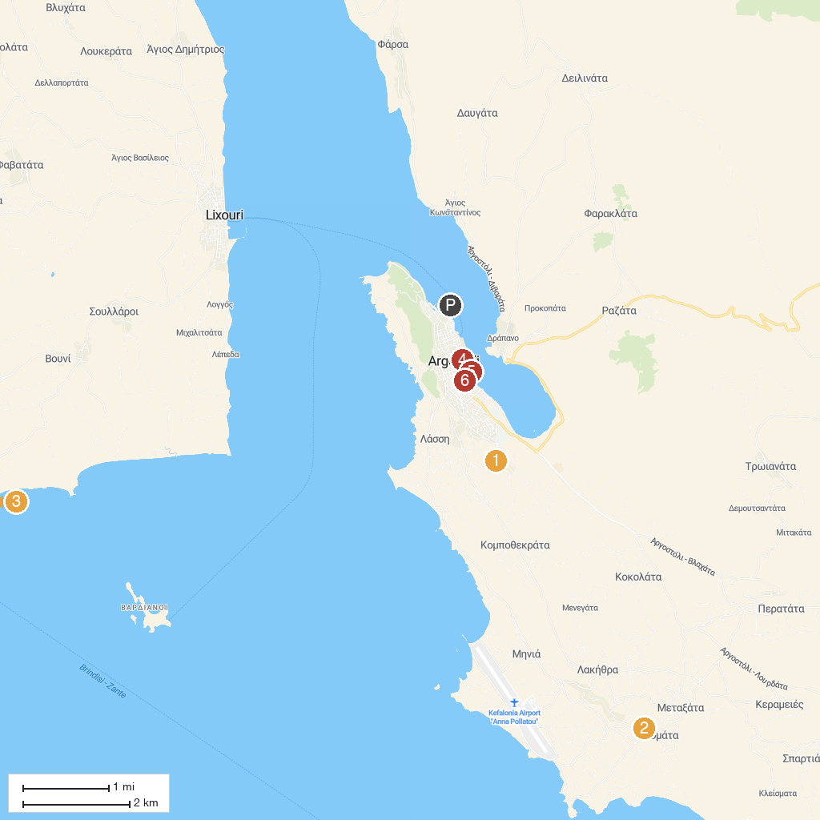
MAP KEY
1. Βοτανικός Κήπος Κεφαλονιάς | 5. I Love Kefalonia
2. Dias Apiary Bijen Boerderij | 6. Sea Turtle Viewpoint
3. Kounopetra Beach | 7. Platia Kampanas
4. Melissani Cave Lake
P. Cruise port / terminal
Map © MapTiler © OpenStreetMap contributors · cruiseports.org

