Kawaihae Harbor, Big Island, Hawaii, USA
A raw, working harbor on the Big Island's sun-baked Kohala Coast — your gateway to sacred Hawaiian history, famous white-sand beaches, and the cool paniolo hill town of Waimea.
⚓ Pier (industrial commercial wharf) · 🕒 Typical call: 7-9 hrs · 💵 USD · 🗣️ English / Hawaiian · ☀️ Hot & dry — bring sunscreen
✍️ MY DAY IN PORT (FILL IN)
Ship / Date
In port | arrive ______ · all aboard ______
Booked excursion
Notes / meeting point
GETTING ASHORE
- Docking: Pier (commercial wharf) — shuttle to port gate
- Walk to center: 10–15 min to Kawaihae shops; Puʻukoholā Heiau 15–20 min
- Best For: Beaches, Hawaiian history, Waimea day trip, snorkeling
- Don't Miss: Puʻukoholā Heiau & Hāpuna Beach
GETTING AROUND
- 🚕 Taxi: $35–$55 — Hawaii County regulated taxis ($3.20/mile) serve the harbor. Waikoloa Beach Resorts run ~$35–45; Waimea (Kamuela) ~$45–5
- 📱 Rideshare: ✅ Uber, Lyft, holoholo
TOP THINGS TO DO
- Puʻukoholā Heiau National Historic Site — Walk to this immense stone temple built by King Kamehameha the Great in 1790–91 as he unified the Hawaiian islands.
- Hāpuna Beach — Consistently ranked one of Hawaii's finest beaches — a long sweep of powdery white sand with brilliant turquoise water…
- Spencer Beach Park (Samuel M. Spencer) — A calm, reef-protected beach just 1.5 miles south of the harbor — great for swimming, snorkeling, and families.
- Waimea (Kamuela) Town & Parker Ranch — Drive 15 minutes uphill into Hawaii's paniolo cowboy country.
- Pololū Valley Lookout — Drive north to the end of Highway 270 for a stunning panorama of dramatic windward sea cliffs and the green Pololū Valley.
BEST WALKS
- Port Gate to Puʻukoholā Heiau: 1 mile · 20 min · Easy · Flat highway shoulder — Head south from the port gate along Akoni Pule Highway (Route 270) to reach Puʻukoholā Heiau…
- Port Gate to Kawaihae Shopping Center: 0.5 mile · 10 min · Easy — Walk north along the highway to the Kawaihae Shopping Center for local restaurants (Kohala Burger &…
WEATHER · DAYLIGHT · MONEY
Month | High °F | Low °F | Rainy days
May | 83 | 70 | 11
Jul | 86 | 73 | 10
Sep | 87 | 73 | 11
Daylight: May 5:47AM–6:52PM · Jul 5:52AM–7:05PM · Sep 6:11AM–6:25PM
cruiseports.org/kawaihae-harbor · Confirm terminal & all-aboard time with your ship

Kawaihae Harbor, Big Island, Hawaii, USA — Port Map
Red = walkable sights · Amber = excursions farther out · P = cruise terminal
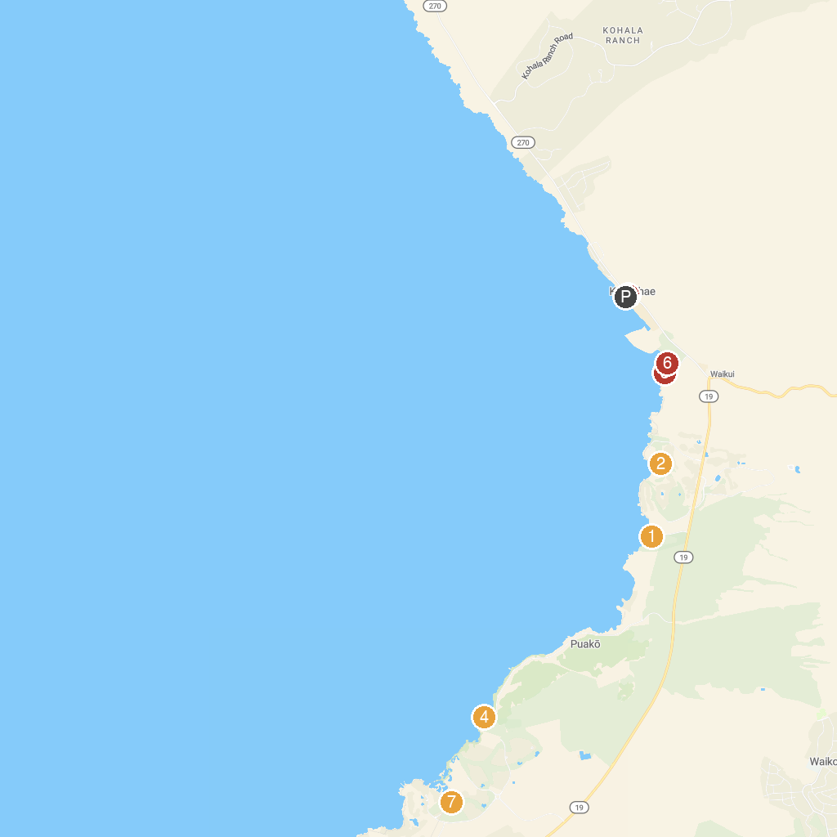
MAP KEY
1. Hapuna Beach State Recreation Area | 5. Buddha Point
2. Mauna Kea Golf Course | 6. Harbor Gallery
3. Spencer Beach Park | 7. Puʻukoholā Heiau National Historic Site
4. Holoholokai Beach Park | 8. Mauna Lani Golf
P. Cruise port / terminal
Map © MapTiler © OpenStreetMap contributors · cruiseports.org

