Kavala, Macedonia, Greece
Where Roman history meets Ottoman grandeur on the Aegean. Kavala stacks a Byzantine castle, a 16th-century aqueduct, and the UNESCO site of Ancient Philippi into a single, very walkable city call.
⚓ Pier port (docked) · 🕒 Typical call: 7–10 hrs · 💶 Currency: Euro (€) · 🗣️ Language: Greek · 🏛️ UNESCO site nearby: Ancient Philippi
✍️ MY DAY IN PORT (FILL IN)
Ship / Date
In port | arrive ______ · all aboard ______
Booked excursion
Notes / meeting point
GETTING ASHORE
- Docking: Pier — Apostolos Pavlos terminal, central waterfront
- Walk to Old Town: 10 min to Panagia; 25 min to the castle (steep)
- Best For: History buffs, walkers, day-trippers to Philippi
- Don't Miss: The Kamares aqueduct and the view from the Byzantine fortress
GETTING AROUND
- 🚕 Taxi: €6–10 — Taxis wait near the terminal. Base fare is €3.50 plus ~€1/km; a short city-center ride runs about €6–8.50. Agree on the
TOP THINGS TO DO
- Ancient Philippi (UNESCO) — Just 15 km away, Philippi is where Julius Caesar's assassins met their end and where St.
- Panagia Old Town & Byzantine Castle — Wander Ottoman-era alleyways, the birthplace of Egypt's founder Mehmet Ali, and climb to the Byzantine fortress for 360° views…
- Tobacco Museum & Kapnapothikes — Kavala was once the world's top tobacco exporter.
- Kalamitsa Beach — A wide sandy free beach 3 km west of the port — the best quick beach option for cruise passengers.
- Kamares Aqueduct Walk — The 280-meter double-tiered Ottoman aqueduct built by Suleiman the Magnificent is Kavala's most photographed monument.
BEST WALKS
- Waterfront to Castle Loop: 2–3 km · 1.5–2 hrs · Moderate (steep finish) — Walk east along the promenade past the Apostle Paul mosaic monument, enter Panagia at the aqueduct…
- Harbor Promenade Stroll: 1 km · 20–30 min · Easy, flat — Head west from the port along the palm-lined waterfront to the Archaeological Museum and Rapsani…
WEATHER · DAYLIGHT · MONEY
Month | High °F | Low °F | Rainy days
May | 71 | 57 | 9
Jul | 84 | 70 | 4
Sep | 78 | 64 | 5
Daylight: May 6:04AM–8:33PM · Jul 6:03AM–8:52PM · Sep 7:03AM–7:31PM
cruiseports.org/kavala · Confirm terminal & all-aboard time with your ship

Kavala, Macedonia, Greece — Port Map
Red = walkable sights · Amber = excursions farther out · P = cruise terminal
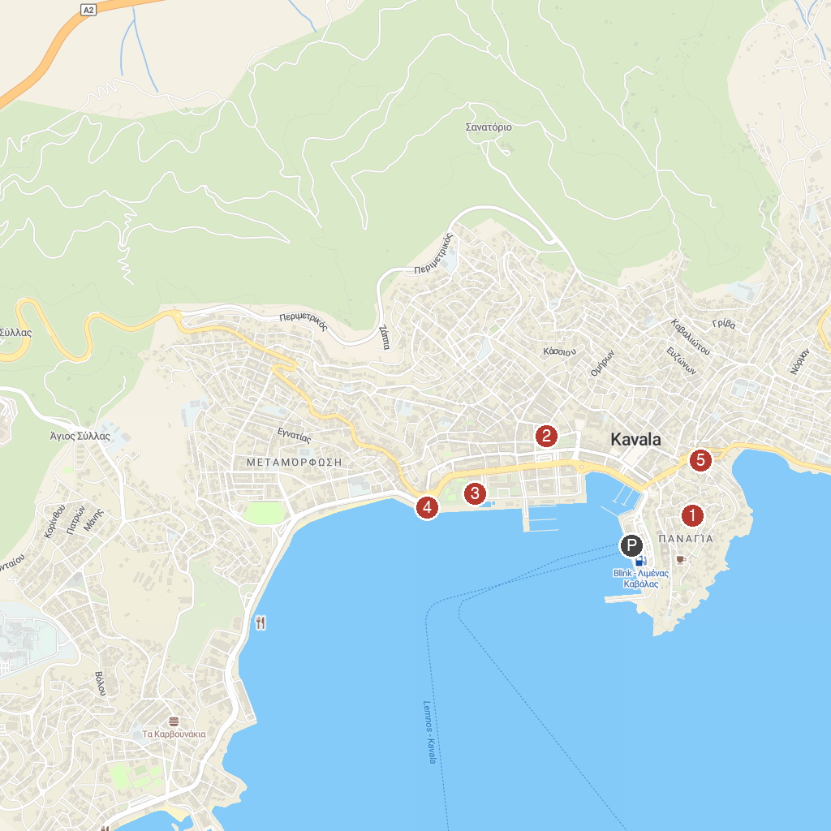
MAP KEY
1. Kavala Fortress | 5. Kavala Archaeological Museum
2. Ancient Theatre of Philippi | 6. Faliro
3. Saint Lydia Philippisia Sacred Baptistery | 7. Kamares
4. Great Club Kavala
P. Cruise port / terminal
Map © MapTiler © OpenStreetMap contributors · cruiseports.org

