Katakolon, Elis, Greece
A tiny fishing village on the Ionian Sea, Katakolon is the jumping-off point for one of the ancient world's most sacred sites — Olympia, where the Olympic Games were born 3,000 years ago.
⚓ Docked (pier at village) · 🕒 Typical call: 7-9 hrs · 💶 Currency: Euro (€) · 🗣️ Language: Greek
✍️ MY DAY IN PORT (FILL IN)
Ship / Date
In port | arrive ______ · all aboard ______
Booked excursion
Notes / meeting point
GETTING ASHORE
- Docking: Alongside at the Katakolon cruise pier — village shops are steps away
- Walk to center: 2 min from ship to the waterfront promenade
- Best For: Ancient Olympia, history lovers, easy village strolls
- Don't Miss: The Temple of Zeus and the original Olympic Stadium at Ancient Olympia
GETTING AROUND
- 🚕 Taxi: €80–€150 per vehicle (round trip) — Taxis wait at the port and can take up to 4 passengers to Ancient Olympia (~30 min). Agree on the fare before departing;
- 📱 Rideshare: ❌ not available
TOP THINGS TO DO
- Ancient Olympia & the Archaeological Museum — Walk the original Olympic Stadium, see the ruins of the Temple of Zeus and the Altis sanctuary, then explore the museum housing…
- Museum of the History of the Olympic Games in Antiquity — Smaller and less crowded than the main archaeological museum, this museum in Olympia village focuses specifically on the ancient…
- Agios Andreas Beach — A sandy beach a few kilometres outside Katakolon village.
- Waterfront Lunch in Katakolon — Katakolon's promenade has a handful of tavernas serving fresh seafood, Greek salads, and local wine.
- Ancient Olympia & Foloi Oak Forest Combo — Some excursions pair Olympia with a stop at the Foloi oak forest, one of Europe's largest and oldest oak forests — mythological…
BEST WALKS
- Katakolon Waterfront Promenade: 30 min · Flat · Scenic — Walk the entire length of the Katakolon waterfront from the cruise pier to the old lighthouse.
- Village Center & Market Street: 20 min · Flat · Shopping — Katakolon's main street behind the waterfront has a cluster of Greek jewelry boutiques (the town is…
WEATHER · DAYLIGHT · MONEY
Month | High °F | Low °F | Rainy days
May | 75 | 59 | 7
Jul | 90 | 72 | 1
Sep | 83 | 68 | 6
Daylight: May 6:25AM–8:37PM · Jul 6:25AM–8:55PM · Sep 7:16AM–7:42PM
cruiseports.org/katakolon · Confirm terminal & all-aboard time with your ship

Katakolon, Elis, Greece — Port Map
Red = walkable sights · Amber = excursions farther out · P = cruise terminal
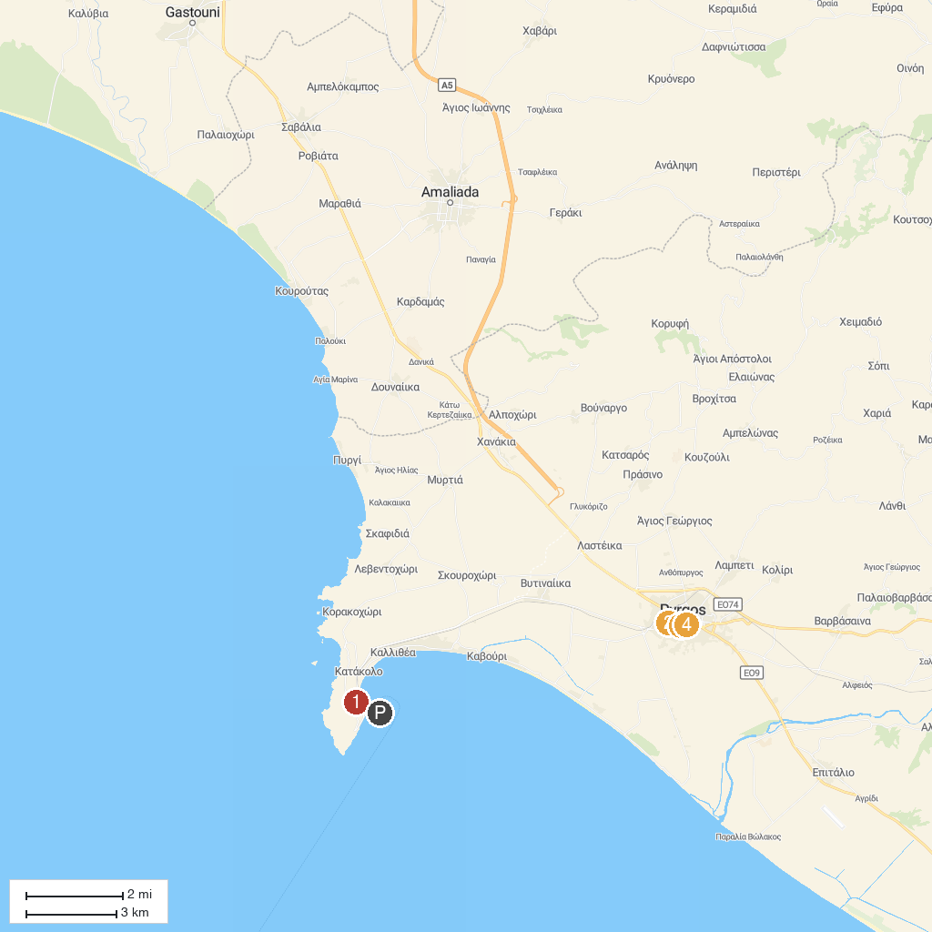
MAP KEY
1. "Kostas Kotsanas" Museum of Ancient Greek Technology | 3. Sakis Karagiorgas Square
2. ΙΕΡΑ ΜΗΤΡΟΠΟΛΙΣ ΗΛΕΙΑΣ | 4. Archaeological Museum of Pyrgos
P. Cruise port / terminal
Map © MapTiler © OpenStreetMap contributors · cruiseports.org

