Kastellorizo Island, Dodecanese, Greece
Kastellorizo (Megisti) is Greece's most remote island — a car-free gem of pastel neoclassical mansions, piercing blue water, and a Blue Grotto so vivid it almost doesn't look real. Small ships only, and an experience unlike anywhere else in the Aegean.
⚓ Tender port · 🕒 Typical call: 5–8 hrs · 💶 Euro (€) · 🗣️ Greek (Turkish nearby) · 🐢 Sea turtles in the harbour
✍️ MY DAY IN PORT (FILL IN)
Ship / Date
In port | arrive ______ · all aboard ______
Booked excursion
Notes / meeting point
GETTING ASHORE
- Docking: Tender — ships anchor in Megisti Bay; tender to the harbour front
- Walk to Centre: 0 min — tender lands you directly on the waterfront promenade
- Best For: Blue Grotto, harbour photography, slow taverna lunches, history
- Don't Miss: Boat to the Blue Grotto (€10–20 pp) and resident sea turtles at the quay
GETTING AROUND
- 🚕 Taxi: €15 (village ↔ airport) — There is one taxi on the island. It primarily serves the airport run (~3.5 km); not needed for port-to-village transfers
TOP THINGS TO DO
- Blue Grotto (Galazio Spilaio) — One of the Mediterranean's most spectacular sea caves.
- Castle of the Knights (Castello Rosso) — The 14th-century castle of the Knights of St.
- Lycian Rock Tomb — The only Lycian-style monumental rock tomb in Greece, carved into the clifface near the castle entrance.
- Mosque Museum — A beautifully restored Ottoman mosque at the harbour entrance now serves as a small museum showcasing local costumes…
- St. George Islet Water Taxi — A 5-minute water taxi (€5–10 return) takes you to this tiny islet just outside the harbour, complete with a whitewashed chapel…
BEST WALKS
- Harbour Promenade & Town Loop: 1.5 km · 20–25 min · Flat — Walk the full crescent of the pastel neoclassical waterfront from the tender quay, past the Lycian…
- Castle & Mandraki Cove: 2 km · 45–60 min · Some steep steps — From the harbour, climb the steps to Castello Rosso for harbour views, then descend the other side…
WEATHER · DAYLIGHT · MONEY
Month | High °F | Low °F | Rainy days
May | 74 | 60 | 5
Jul | 89 | 74 | 1
Sep | 84 | 70 | 3
Daylight: May 5:55AM–8:00PM · Jul 5:56AM–8:18PM · Sep 6:44AM–7:08PM
cruiseports.org/kastellorizo-island · Confirm terminal & all-aboard time with your ship

Kastellorizo Island, Dodecanese, Greece — Port Map
Red = walkable sights · Amber = excursions farther out · P = cruise terminal
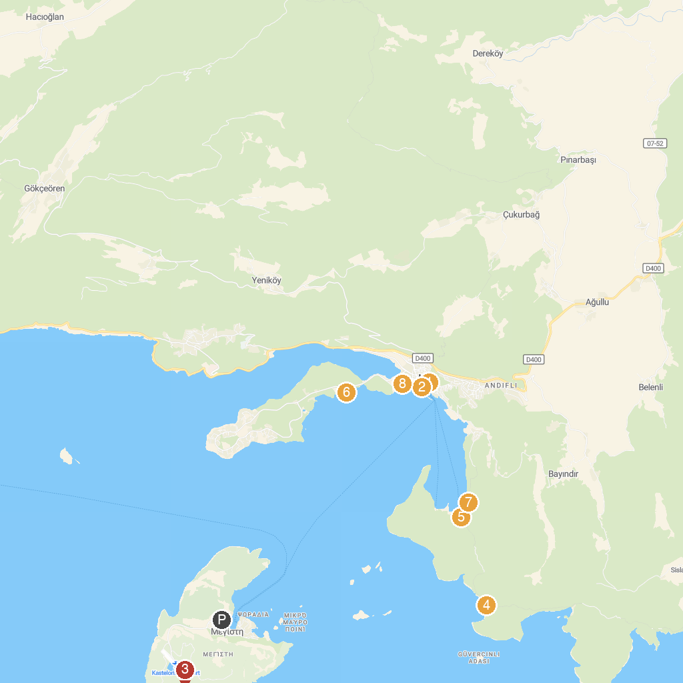
MAP KEY
1. Tuğra Art Gallery | 5. Limanağzı Plajı
2. Boat Trips by Captain Ergun | Kekova Tekne Turu | Kaş Tekne Turu | Кекова прогулка на лодке | Tekne Kiralama | 6. Kaş Belediyesi Kadınlar Plajı
3. Blue Cave (Fókiali) | 7. Saba in Ancient Sites
4. Çoban sahili | 8. Hellenistic theatre
P. Cruise port / terminal
Map © MapTiler © OpenStreetMap contributors · cruiseports.org

