Kasane, Chobe, Botswana
Where the Chobe River meets one of Africa's greatest wildlife spectacles. Kasane puts you on the water alongside elephants, hippos, and crocodiles — or on a 4x4 chasing lions through the park.
⚓ Riverfront jetty (no cruise terminal) · 🕒 Typical call: full day or homeport · 💵 Botswana Pula / USD widely accepted · 🗣️ English (official) · 🐘 Wildlife safari destination
✍️ MY DAY IN PORT (FILL IN)
Ship / Date
In port | arrive ______ · all aboard ______
Booked excursion
Notes / meeting point
GETTING ASHORE
- Docking: Lodge jetties & informal riverfront landings — no dedicated cruise terminal
- Walk to Centre: Kasane town is compact; river lodges are 5–15 min walk to shops
- Best For: Wildlife safaris, Chobe River boat cruises, day trip to Victoria Falls
- Don't Miss: Chobe River sunset cruise with elephant herds coming to drink
GETTING AROUND
- 🚕 Taxi: BWP 30–50 (~$2–4 USD) — Yellow-sign taxis are available near the waterfront for short hops around town. Agree on a fare before you get in.
- 📱 Rideshare: ❌ not available
TOP THINGS TO DO
- Chobe River Boat Safari — The signature Kasane experience.
- Chobe National Park Game Drive — Open 4x4 drives through the park's floodplain and riverine woodland in search of lions, leopards, buffalo, and the park's famous…
- Full-Day Chobe Safari (Game Drive + River Cruise) — The classic combo: morning land game drive followed by an afternoon river cruise, with lunch at a riverside lodge.
- Victoria Falls Day Trip — Eighty kilometres from Kasane, Victoria Falls on the Zimbabwe/Zambia border is one of the world's greatest natural wonders.
- Sunset River Cruise — Short, photogenic sunset cruise on the Chobe River.
BEST WALKS
- Kasane Riverfront Stroll: 1–2 km · Easy · 20–30 min — A flat walk along the Chobe Riverfront past lodge grounds, boat landings, and riverside viewpoints.
- Kasane Town Centre Loop: 1 km · Easy · 15–20 min — A short walk from the riverfront lodges into town takes you past Kazungula Road shops, the Chobe…
WEATHER · DAYLIGHT · MONEY
Month | High °F | Low °F | Rainy days
May | 81 | 58 | 0
Jul | 77 | 53 | 0
Sep | 92 | 64 | 0
Daylight: May 6:37AM–5:53PM · Jul 6:50AM–6:00PM · Sep 6:15AM–6:14PM
cruiseports.org/kasane · Confirm terminal & all-aboard time with your ship

Kasane, Chobe, Botswana — Port Map
Red = walkable sights · Amber = excursions farther out · P = cruise terminal
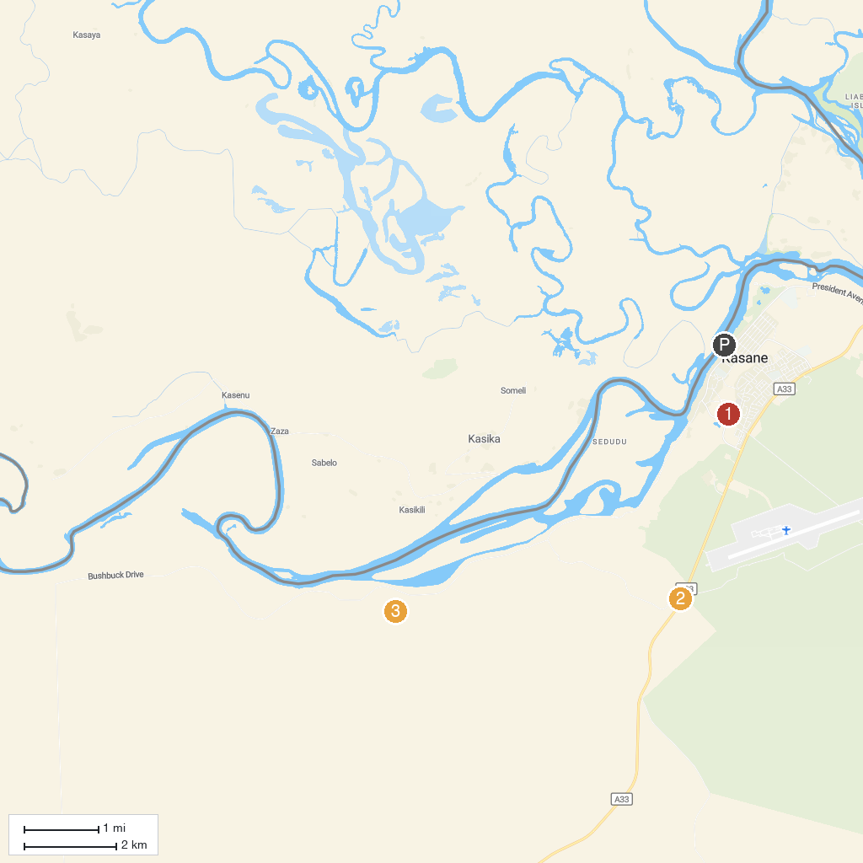
MAP KEY
1. CARACAL | 3. Chobe National Park Stretch Point
2. Sedudu Gate
P. Cruise port / terminal
Map © MapTiler © OpenStreetMap contributors · cruiseports.org

