Kaş, Antalya, Turkey
Where Lycian sarcophagi share the street with bougainvillea-draped cafes — Kaş is Turkey's most characterful small port, with ancient ruins, gem-clear seas, and a Greek island just 20 minutes away.
⚓ Tender port (no cruise pier) · 🕒 Typical call: 6–8 hrs · 💵 Turkish Lira (TRY); EUR/USD widely accepted · 🗣️ Turkish · 🤿 Turkey's top dive destination
✍️ MY DAY IN PORT (FILL IN)
Ship / Date
In port | arrive ______ · all aboard ______
Booked excursion
Notes / meeting point
GETTING ASHORE
- Docking: Tender — ships anchor in the bay, boats land at the Old Harbor (Yat Limanı)
- Walk to Center: You step off the tender into the town square — everything is walkable
- Best For: History, diving, scenic wandering, day trip to Greece
- Don't Miss: Kekova Sunken City boat trip or the free Antiphellos Theater
GETTING AROUND
- 🚕 Taxi: ₺500–₺800 (~€15–€25) short ride — Metered taxis and Uber Taxi (app-booked licensed cabs) are available for rides within and around Kaş. Confirm the fare b
- 📱 Rideshare: ✅ Uber
TOP THINGS TO DO
- Kekova Sunken City Boat Trip — Glide over the ruins of an ancient Lycian city submerged by a 2nd-century earthquake.
- Antiphellos Ancient Theater (Free) — A beautifully preserved Hellenistic theater on a peninsula cliff, facing the open sea and Kastellorizo island.
- Scuba Diving — Kaş is Turkey's diving capital — with exceptional visibility, underwater caves, amphora fields, and WWII wrecks.
- Ferry to Kastellorizo (Meis), Greece — A 20-minute ferry crosses to this tiny, photogenic Greek island.
- Kaputaş Beach & Saklıkent Gorge — Turkey's most photographed beach — turquoise water at the mouth of a gorge, reached via 180 steps.
BEST WALKS
- Old Town & Lycian Sarcophagus Stroll: 30–45 min · Flat to gentle uphill · Free — From the harbor, walk up Uzun Çarşı (the Long Bazaar) past bougainvillea-draped Ottoman balconies…
- Peninsula Walk to Antiphellos Theater: 25 min each way · Flat · Free — Follow the road west along the peninsula past the small yacht harbor to the ancient theater.
- Küçük Çakıl Beach: 10 min walk · Easy · Pebble beach — A short walk east of the tender dock brings you to this tiny cove with astonishingly cold, clear…
WEATHER · DAYLIGHT · MONEY
Month | High °F | Low °F | Rainy days
May | 77 | 63 | 5
Jul | 91 | 77 | 1
Sep | 87 | 73 | 3
Daylight: May 5:56AM–7:59PM · Jul 5:55AM–8:19PM · Sep 6:43AM–7:11PM
cruiseports.org/kas · Confirm terminal & all-aboard time with your ship

Kaş, Antalya, Turkey — Port Map
Red = walkable sights · Amber = excursions farther out · P = cruise terminal
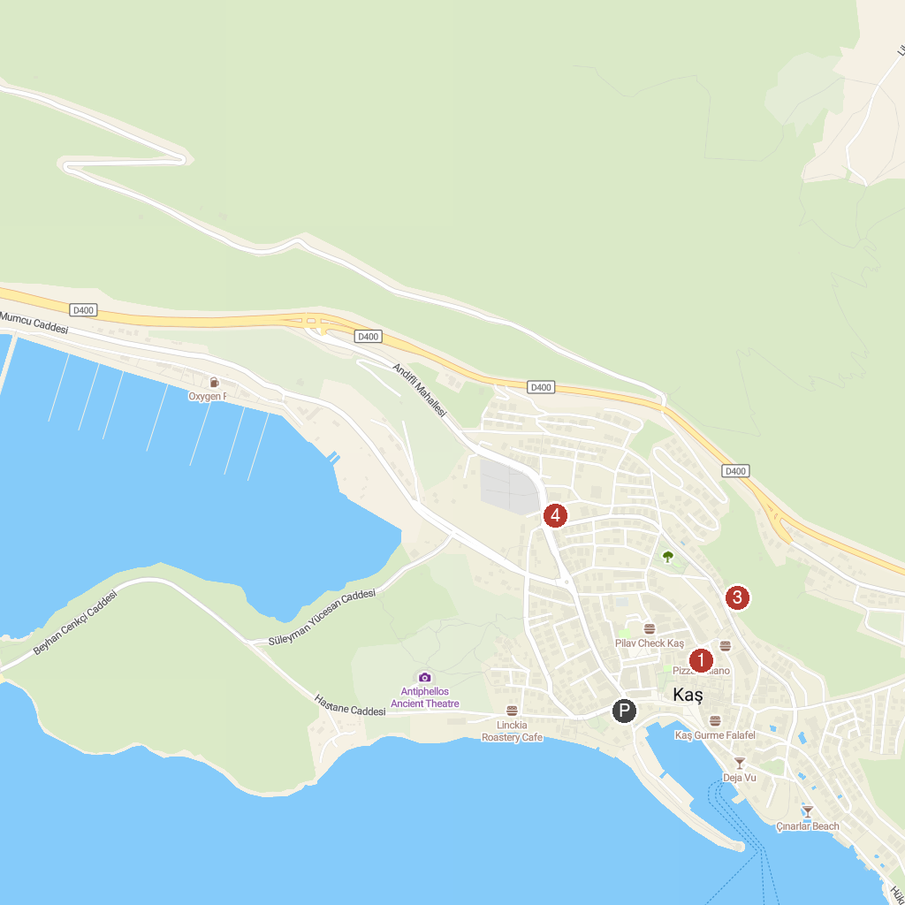
MAP KEY
1. Tuğra Art Gallery | 3. Lycia Rock Tombs
2. Boat Trips by Captain Ergun | Kekova Tekne Turu | Kaş Tekne Turu | Кекова прогулка на лодке | Tekne Kiralama | 4. Kas Merkez Mosque
P. Cruise port / terminal
Map © MapTiler © OpenStreetMap contributors · cruiseports.org

