Karpathos, Dodecanese, Greece
One of Greece's last unspoiled islands, Karpathos rewards curious cruisers with world-class beaches, a medieval mountain village where women still wear traditional embroidered dress daily, and the kind of taverna seafood that belongs on a postcard.
⚓ Pier (small ships) / Tender (large ships) · 🕒 Typical call: 6-8 hrs · 💶 Euro (€) · 🗣️ Greek (English spoken in town)
✍️ MY DAY IN PORT (FILL IN)
Ship / Date
In port | arrive ______ · all aboard ______
Booked excursion
Notes / meeting point
GETTING ASHORE
- Docking: Small/mid ships dock at Pigadia pier; large ships anchor and tender ashore
- Walk to center: 2-5 min flat walk from pier to Pigadia harbor promenade
- Best For: Authentic Greek culture, dramatic beaches, village exploration
- Don't Miss: Olympos village (1 hr north) and a plate of local makarounes pasta
GETTING AROUND
- 🚕 Taxi: €7–€15 — Taxis are available at Pigadia port, which is essentially the town center. Short rides within Pigadia cost around €7; lo
TOP THINGS TO DO
- Olympos Living Village — Drive 43 km north on scenic mountain roads to Olympos, a village that time forgot.
- Apella Beach — Consistently rated one of the best beaches in Europe.
- Kyra Panagia Beach — A stunning cove of fine pebbles and emerald water flanked by steep cliffs, crowned by the iconic red-domed church of Kyra Panagia.
- Menetes Village & Acropolis — The whitewashed medieval village of Menetes clings dramatically to a clifftop just 15 minutes from port.
- Pigadia Harbor Lunch — The harbor promenade is lined with traditional tavernas serving Karpathos specialties: makarounes (handmade pasta with…
BEST WALKS
- Harbor Promenade Stroll: 30-45 min · Flat · Walkable from pier — Exit the port and walk the pedestrian harbor front lined with cafes, tavernas, and souvenir shops.
- Pigadia Beach Walk: 20 min walk · Flat · Free beach — Turn right out of the port and follow the coastal path 15-20 minutes to Pigadia Town Beach — a long…
WEATHER · DAYLIGHT · MONEY
Month | High °F | Low °F | Rainy days
May | 69 | 48 | 14
Jul | 85 | 60 | 6
Sep | 75 | 54 | 9
Daylight: May 6:22AM–8:43PM · Jul 6:21AM–9:02PM · Sep 7:17AM–7:44PM
cruiseports.org/karpathos-island · Confirm terminal & all-aboard time with your ship

Karpathos, Dodecanese, Greece — Port Map
Red = walkable sights · Amber = excursions farther out · P = cruise terminal
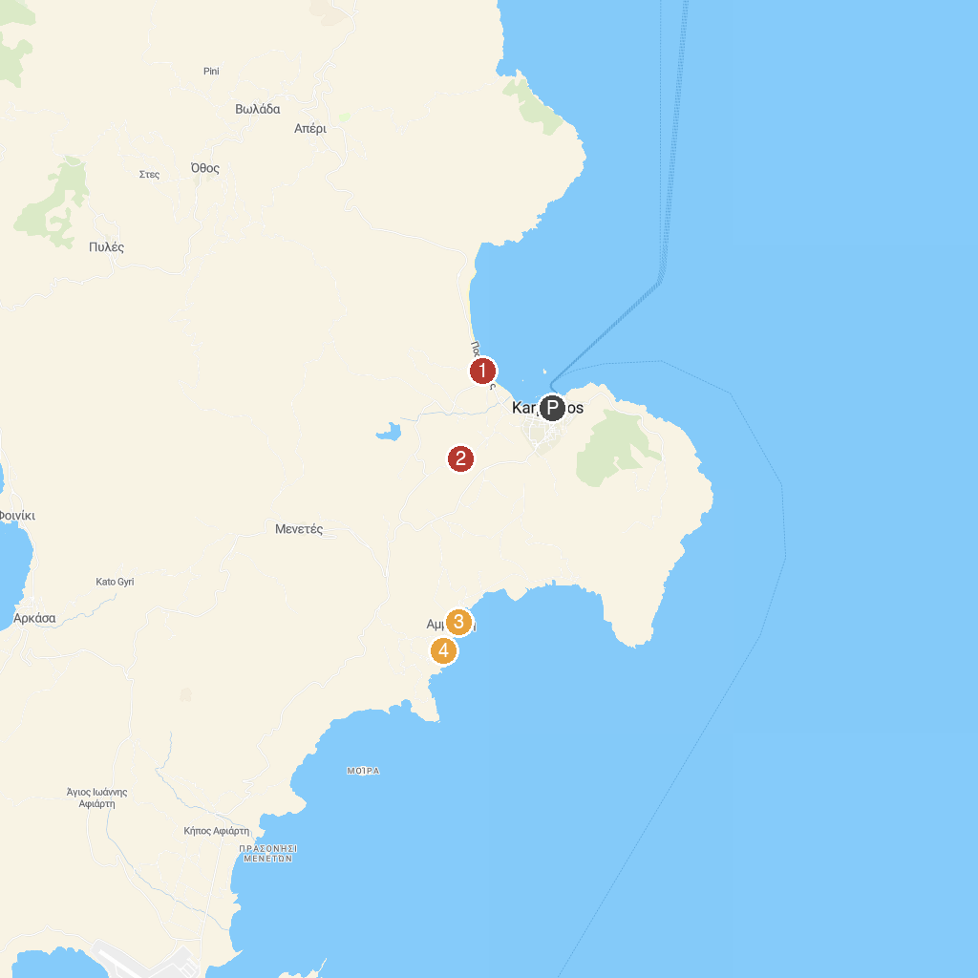
MAP KEY
1. Chapel Of Agia Fotini | 3. Παραλία Μεγάλη Αμμοωπή
2. Poseidon's Temple | 4. Kastelia Beach
P. Cruise port / terminal
Map © MapTiler © OpenStreetMap contributors · cruiseports.org

