Karlsruhe, Baden-Württemberg, Germany
Planned from scratch in 1715 with 32 streets radiating from a baroque palace, Karlsruhe is the Rhine's geometry lesson — part royal fan city, part digital art capital, and one of Germany's warmest corners.
⚓ Docked (river pier) · 🕒 Typical call: 8–10 hrs · 💶 Currency: Euro (€) · 🗣️ Language: German · 🚃 Tram to center: ~18 min
✍️ MY DAY IN PORT (FILL IN)
Ship / Date
In port | arrive ______ · all aboard ______
Booked excursion
Notes / meeting point
GETTING ASHORE
- Docking: Rheinhafen Karlsruhe — working river port, ~7 km from city center
- Walk to center: Not walkable — take Tram 5 or cruise shuttle (~18 min)
- Best For: Palace & gardens, interactive digital art (ZKM), Baden cuisine
- Don't Miss: Palace Tower for the fan-street panorama; Flammkuchen and local Baden wine
GETTING AROUND
- 🚕 Taxi: €25–€40 — Metered taxis available citywide. Base fare ~€3.30–€5.00, then ~€1.80–€3.60/km depending on time of day. Reliable option
- 📱 Rideshare: ✅ Uber, Bolt
- 🚌 Hop-on hop-off: ✅ Citytour Karlsruhe
TOP THINGS TO DO
- Karlsruhe Palace & Tower — The 18th-century baroque Schloss sits at the hub of the fan city.
- ZKM — Center for Art and Media — Housed in a converted munitions factory, ZKM is one of the world's most important digital and interactive art institutions.
- Schlossgarten & Botanical Garden — Behind the Palace stretch English-style gardens with ponds, sculptures, and a charming miniature steam railway (Schlossgartenbahn).
- Durlach & the Turmberg — Karlsruhe's historic predecessor town, Durlach, is a 15-minute tram ride away.
- Baden Wine & Flammkuchen Tasting — Karlsruhe sits in the heart of Baden wine country, heavily influenced by French Alsace.
BEST WALKS
- Marktplatz to Palace & Gardens Loop: 3 km · ~1 hr · Easy · Flat — Start at Marktplatz (the central pyramid tomb), walk north up Kaiserstraße to the Palace, tour the…
- Kaiserstraße Shopping Stroll: 1.5 km · 30 min · Easy — The main pedestrian shopping street runs straight south from the Palace.
WEATHER · DAYLIGHT · MONEY
Month | High °F | Low °F | Rainy days
May | 67 | 50 | 12
Jul | 80 | 61 | 11
Sep | 71 | 55 | 8
Daylight: May 5:44AM–9:02PM · Jul 5:38AM–9:25PM · Sep 7:03AM–7:38PM
cruiseports.org/karlsruhe · Confirm terminal & all-aboard time with your ship

Karlsruhe, Baden-Württemberg, Germany — Port Map
Red = walkable sights · Amber = excursions farther out · P = cruise terminal
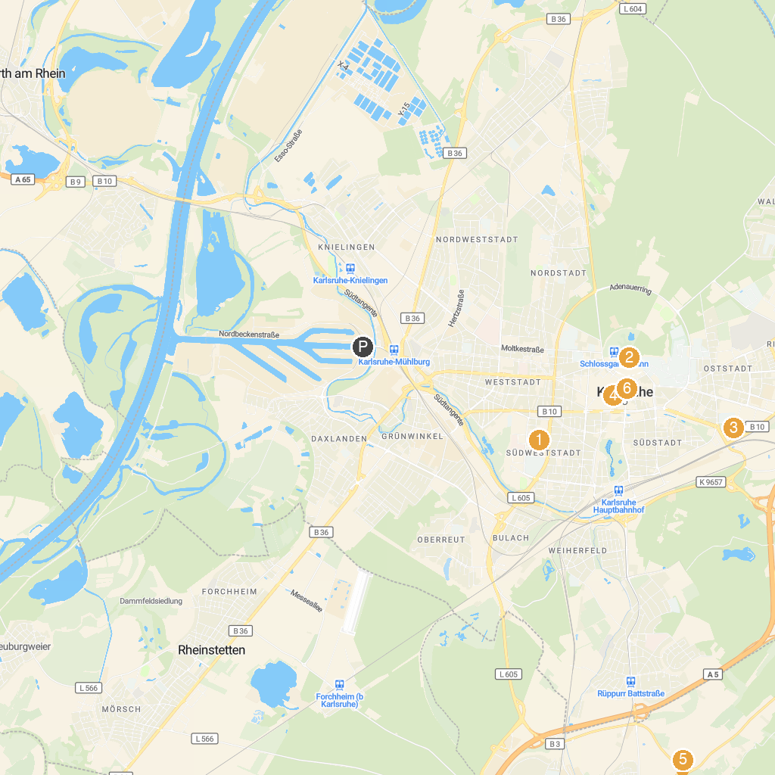
MAP KEY
1. ZKM | Center for Art and Media Karlsruhe | 4. Friedrichsplatz
2. Karlsruhe Palace | 5. Watthalden Park
3. Otto-Dullenkopf Park | 6. Marktplatz Karlsruhe
P. Cruise port / terminal
Map © MapTiler © OpenStreetMap contributors · cruiseports.org

