Karlskrona, Blekinge, Sweden
Founded in 1680 as Sweden's strategic naval fortress, Karlskrona is a UNESCO World Heritage baroque city spread across 33 archipelago islands — with a free world-class naval museum, wooden cottages straight out of a fairy tale, and the Baltic Sea on every horizon.
⚓ Pier (Verkö) or City Dock · 🕒 Typical call: 8–10 hrs · 💳 Cashless (card only, SEK) · 🗣️ Swedish (English widely spoken) · 🏛️ UNESCO World Heritage Site
✍️ MY DAY IN PORT (FILL IN)
Ship / Date
In port | arrive ______ · all aboard ______
Booked excursion
Notes / meeting point
GETTING ASHORE
- Docking: Large ships dock at Verkö (10 km east); smaller ships berth at Handelshamnen in the city center; some anchor and tender to Fisktorget
- Walk to center: 5–10 min from Handelshamnen; shuttle/bus required from Verkö
- Best For: Naval history, baroque architecture, archipelago walks, Scandinavian food
- Don't Miss: Naval Museum on Stumholmen — submarine hall and 18th-century figureheads (adults ~170 SEK summer; free for under-18)
GETTING AROUND
- 🚕 Taxi: 170–210 SEK (~–20 USD) — Taxis are available from Verkö port terminal to the city center, a roughly 10-minute ride. May need pre-arrangement; cre
TOP THINGS TO DO
- Naval Museum & Submarine Hall — The Marinmuseum on Stumholmen island is world-class.
- Baroque Old Town & Stortorget — Stroll the grand baroque main square — one of the largest in Sweden — flanked by Fredrikskyrkan and Trefaldighetskyrkan, both…
- Kungsholms Fort Boat Tour — This 300-year-old active military fortification guards the entrance to the Blekinge archipelago with a unique circular harbour.
- Aspö Island & Drottningskär Citadel — Take the free yellow car ferry from Handelshamnen to Aspö island (25 min), then walk 15 min to the remarkably preserved…
- Björkholmen Wooden Cottage Quarter — Wander the narrow lanes of this 18th-century neighbourhood of tiny colourful wooden cottages, built for early naval shipyard…
BEST WALKS
- City Centre Loop: Stortorget to Naval Museum: 3 km · 60–90 min · Easy, mostly flat — Start at Stortorget (the main baroque square), walk past Fredrikskyrkan, head down to Fisktorget on…
- Admiralty Church & Harbour Walk: 1.5 km · 30–45 min · Easy — Visit Amiralitetskyrkan — Sweden's largest wooden church — and toss a coin in the famous Gubben…
WEATHER · DAYLIGHT · MONEY
Month | High °F | Low °F | Rainy days
May | 59 | 46 | 9
Jul | 70 | 58 | 12
Sep | 63 | 53 | 10
Daylight: May 4:44AM–9:05PM · Jul 4:32AM–9:34PM · Sep 6:29AM–7:14PM
cruiseports.org/karlskrona · Confirm terminal & all-aboard time with your ship

Karlskrona, Blekinge, Sweden — Port Map
Red = walkable sights · Amber = excursions farther out · P = cruise terminal
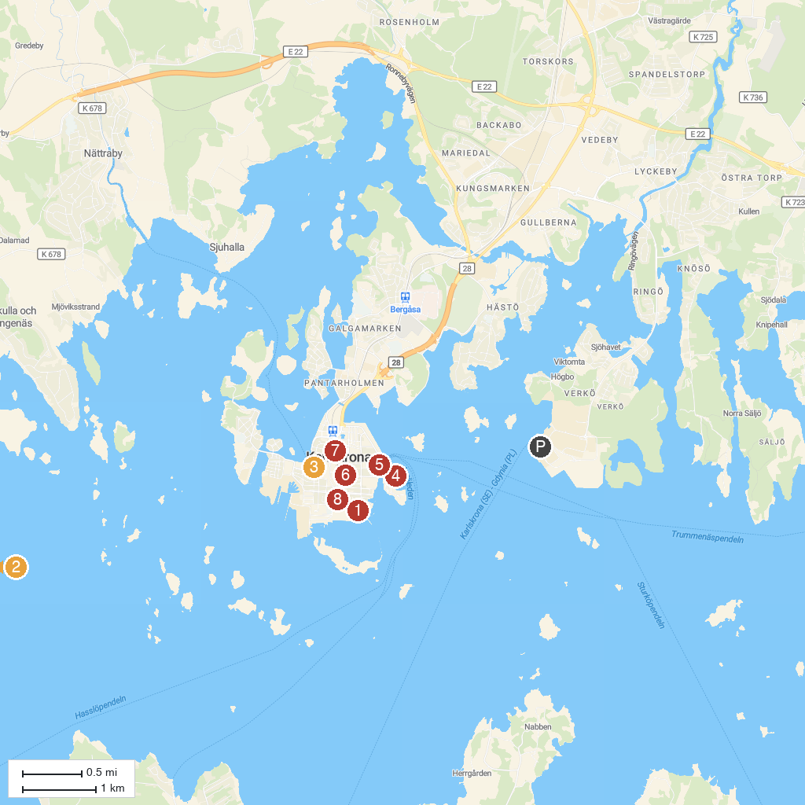
MAP KEY
1. Rosenbom, statue | 5. Car Museum - Albinsson & Sjöberg
2. Almö natural reserve | 6. Fredrikskyrkan
3. Blekinge museum | 7. Hoglands park
4. Karlskrona Naval Museum (Marinmuseum) | 8. Amiralitetsklockstapeln
P. Cruise port / terminal
Map © MapTiler © OpenStreetMap contributors · cruiseports.org

