Karatsu, Saga, Japan
A feudal castle town on Kyushu's northwestern coast, Karatsu rewards curious cruisers with centuries-old ceramic traditions, a million-pine coastal forest, and some of the freshest squid sashimi in Japan.
⚓ Pier (docked) · 🕒 Typical call: 8-10 hrs · 💴 Currency: Japanese Yen (JPY) · 🗣️ Language: Japanese · 🚐 Shuttle to center recommended
✍️ MY DAY IN PORT (FILL IN)
Ship / Date
In port | arrive ______ · all aboard ______
Booked excursion
Notes / meeting point
GETTING ASHORE
- Docking: Pier — Nishitaku Wharf (West Port) or Tobu Wharf (East Port)
- Walk to center: ~3.5 km to Karatsu Station — taxi or free shuttle recommended
- Best For: History, ceramics shopping, coastal scenery, seafood
- Don't Miss: Karatsu Castle keep, Niji-no-Matsubara pine grove, live squid sashimi
GETTING AROUND
- 🚕 Taxi: ¥1,000–¥2,000 — Local taxis (Karatsu Kanko Taxi, Showa Taxi) are available at the port. The ride to Karatsu city center is roughly 10 mi
TOP THINGS TO DO
- Karatsu Castle (Maizuru Castle) — The 17th-century 'Dancing Crane Castle' sits on a hill above the bay.
- Niji-no-Matsubara Pine Grove — One million black pine trees stretching 4.5 km along the arc of Karatsu Bay — planted 400 years ago as a windbreak.
- Yobuko Morning Market & Live Squid — Japan's most famous morning market runs daily 7:30 AM–noon in the fishing village of Yobuko, 30 minutes by taxi.
- Hikiyama Exhibition Hall — Festival Floats — Karatsu Kunchi (Nov 2–4) is a UNESCO Intangible Cultural Heritage festival.
- Former Takatori Residence — The palatial late 19th-century home of coal-mining baron Koreyoshi Takatori blends Japanese and Western architecture with a…
BEST WALKS
- Castle Hill to West Beach: ~1.5 km | Easy | 30–45 min — From Karatsu Castle, descend the stone steps (or slope elevator) and stroll west along the coast to…
- Karatsu Station Ceramics Walk: ~1 km loop | Easy | 45 min — From Karatsu Station, browse Gallery Arpino, then follow the Katamachi and Gofukumachi shopping…
WEATHER · DAYLIGHT · MONEY
Month | High °F | Low °F | Rainy days
May | 73 | 59 | 11
Jul | 85 | 74 | 17
Sep | 80 | 70 | 16
Daylight: May 5:20AM–7:13PM · Jul 5:21AM–7:30PM · Sep 6:03AM–6:26PM
cruiseports.org/karatsu · Confirm terminal & all-aboard time with your ship

Karatsu, Saga, Japan — Port Map
Red = walkable sights · Amber = excursions farther out · P = cruise terminal
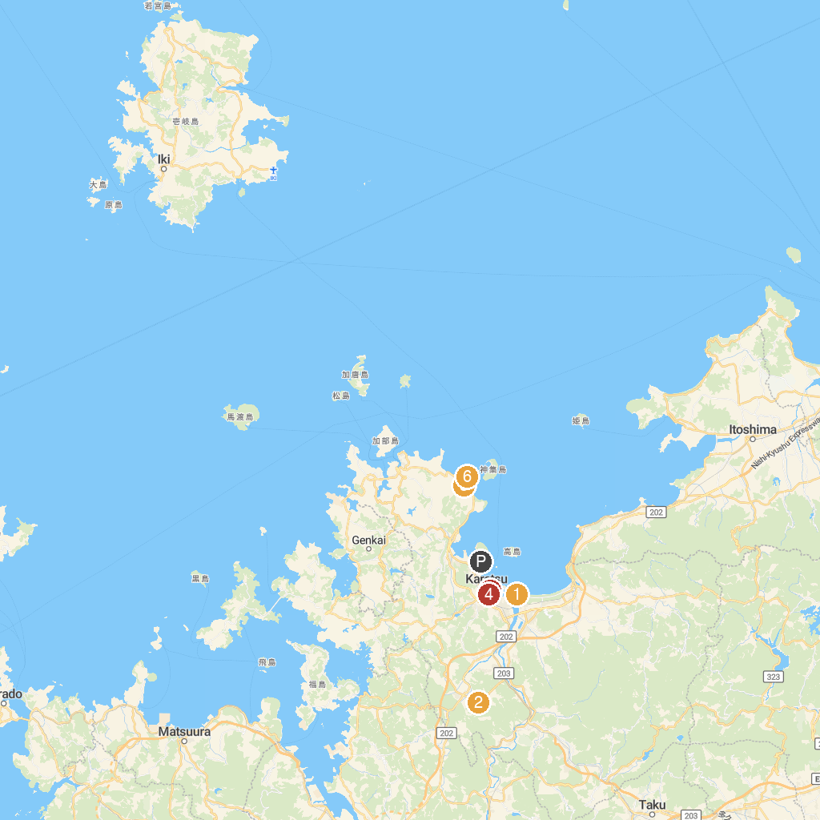
MAP KEY
1. Nanatsugama | 5. Hikiyama Exhibition Hall
2. Niji No Matsubara Pine Grove | 6. Minatoeki Shrine
3. Shikinooka Park | 7. Tategami Rock of Minato
4. Former Karatsu Bank | 8. Nanatsugama Park
P. Cruise port / terminal
Map © MapTiler © OpenStreetMap contributors · cruiseports.org

