Kapellskär, Stockholm Archipelago, Sweden
A tranquil gateway into the Stockholm archipelago, Kapellskär drops you straight into Sweden's wild Roslagen coast — a biosphere of rocky islands, birch forests, and glassy inlets, with Stockholm reachable in 90 minutes.
⚓ Pier (docked) · 🕒 Typical call: 8-10 hrs · 💳 Cashless (SEK — cards only) · 🗣️ Swedish (English spoken widely) · 🌿 Archipelago & nature
✍️ MY DAY IN PORT (FILL IN)
Ship / Date
In port | arrive ______ · all aboard ______
Booked excursion
Notes / meeting point
GETTING ASHORE
- Docking: Pier — cruise ships dock directly at the ferry quay
- Walk to center: Port area only; Norrtälje is 20 km, Stockholm ~90 km
- Best For: Archipelago nature walks, day trips to Stockholm or Norrtälje
- Don't Miss: Riddersholm Nature Reserve trails, Sladdstycket heritage museum
GETTING AROUND
- 🚕 Taxi: 1,300–1,600 SEK (~$120–$150 USD) — Pre-booked private transfers (Kiwitaxi, TransferAirport24) or local taxis to Stockholm city center. The ~89km drive take
TOP THINGS TO DO
- Riddersholm Nature Reserve — Right next to the port, Riddersholm offers 20 km of marked trails through coastal forest, rocky outcrops, and meadows.
- Sladdstycket Heritage Museum — A tiny but charming local museum in a restored fishing cottage on the edge of Riddersholm Reserve, showcasing Baltic Sea shore…
- Day Trip to Stockholm — Sweden's capital is 90 km south and reachable by cruise line transfer bus or SL public bus.
- Norrtälje Town Stroll — Just 20 km away, Norrtälje is a handsome small town with a historic center, harbor-side cafés, local shops, and the Norrtälje…
- Archipelago Kayaking — The Roslagen coast is one of Sweden's best sea-kayaking destinations.
BEST WALKS
- Riddersholm Coastal Loop: 3-6 km | 1-2 hrs | Easy | Free — From the port, follow the signed path into Riddersholm Nature Reserve along the rocky shoreline…
- Harbor & Lighthouse Stroll: 1-2 km | 30 min | Easy | Free — A short loop around the working harbor past the old steam-boat pier (Ångbåtsbryggan), the small…
WEATHER · DAYLIGHT · MONEY
Month | High °F | Low °F | Rainy days
May | 54 | 42 | 9
Jul | 68 | 57 | 10
Sep | 60 | 51 | 9
Daylight: May 4:08AM–9:13PM · Jul 3:50AM–9:47PM · Sep 6:12AM–7:03PM
cruiseports.org/kapellskar · Confirm terminal & all-aboard time with your ship

Kapellskär, Stockholm Archipelago, Sweden — Port Map
Red = walkable sights · Amber = excursions farther out · P = cruise terminal
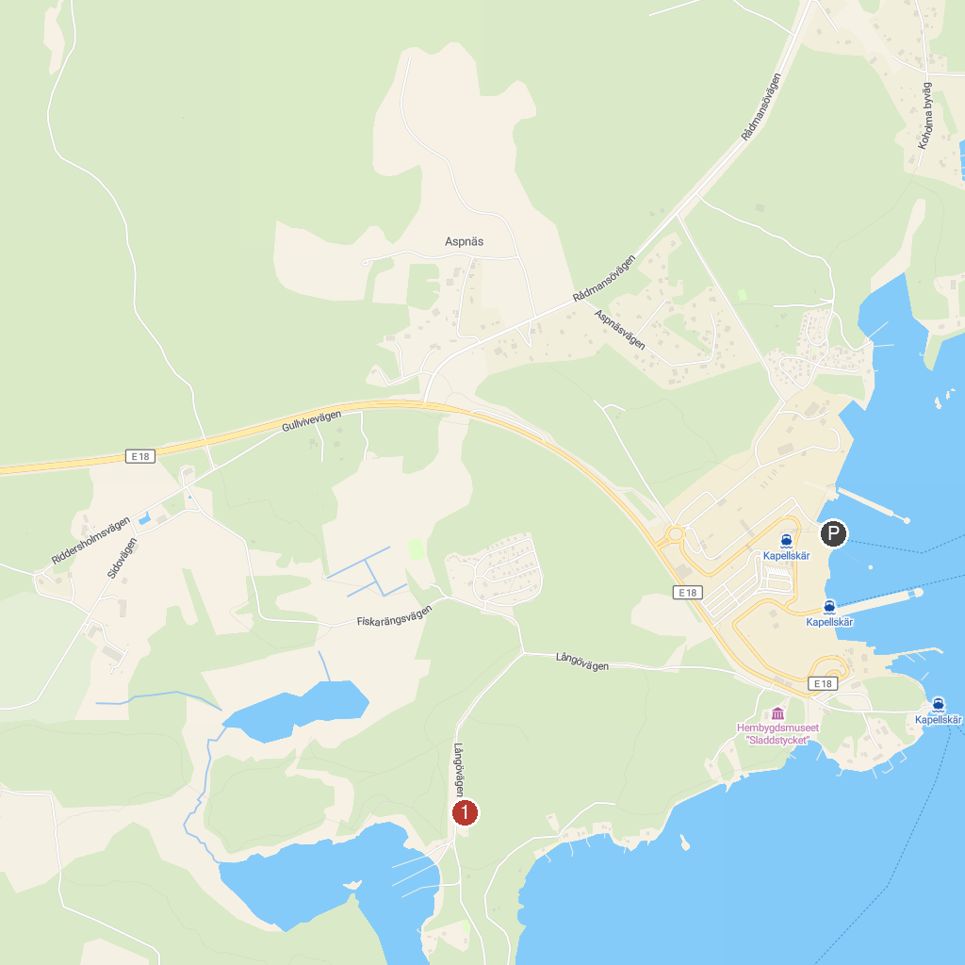
MAP KEY
1. Norrtälje Luftvärnsmuseum | 5. Eriks Kulle, Söderby Karl
2. Själbottna-Östra Lagnö naturreservat | 6. Ängsö National Park
3. Länna kyrka | 7. Riddersholm
4. Vikingabyn Storholmen
P. Cruise port / terminal
Map © MapTiler © OpenStreetMap contributors · cruiseports.org

