Kanazawa, Ishikawa, Japan
Japan's 'Little Kyoto' without the crowds — a castle town of samurai streets, geisha districts, and gold-leaf culture, all wrapped around one of Japan's three great gardens.
⚓ Pier (cruise terminal) · 🕒 Typical call: 8-10 hrs · 💴 Currency: Japanese Yen (JPY) · 🗣️ Language: Japanese · 🏯 Best for: History & culture
✍️ MY DAY IN PORT (FILL IN)
Ship / Date
In port | arrive ______ · all aboard ______
Booked excursion
Notes / meeting point
GETTING ASHORE
- Docking: Pier — Kanazawa Port Cruise Terminal (opened 2020)
- Port to center: ~6 km, not walkable — shuttle, taxi or bus required
- Best For: Kenroku-en garden, samurai & geisha districts, gold leaf, market seafood
- Don't Miss: Gold leaf soft-serve ice cream in Higashi Chaya District
GETTING AROUND
- 🚕 Taxi: ¥1,500–¥3,000 — Taxis queue at the port terminal when ships are in. The 15–20 min ride to central Kanazawa or Kenroku-en costs roughly ¥
- 📱 Rideshare: ✅ Uber
TOP THINGS TO DO
- Kenroku-en Garden & Kanazawa Castle — Stroll one of Japan's three great landscape gardens, then cross into the free castle park to see the massive Ishikawa-mon Gate…
- Higashi Chaya Geisha District — Walk the dark-wood teahouse streets of Kanazawa's best-preserved geisha quarter.
- Nagamachi Samurai District — Wander cobblestone lanes flanked by earthen walls and visit the Nomura Samurai House — an immaculately preserved residence with…
- Omicho Market Seafood Crawl — Kanazawa's covered market 'kitchen' has 180+ stalls of fresh Sea of Japan seafood.
- 21st Century Museum of Contemporary Art — A striking circular glass building housing permanent and temporary works.
BEST WALKS
- Kenroku-en to Higashi Chaya Loop: 3.5 km · 1-1.5 hrs · Easy — Start at Kenroku-en, cross through Kanazawa Castle Park via Ishikawa-mon Gate, then walk down…
- Kanazawa Station to Omicho Market: 1.5 km · 20 min · Easy — An easy flat walk from the iconic Tsuzumi-mon Gate at Kanazawa Station through the city center to…
WEATHER · DAYLIGHT · MONEY
Month | High °F | Low °F | Rainy days
May | 71 | 54 | 12
Jul | 83 | 71 | 16
Sep | 79 | 66 | 16
Daylight: May 4:46AM–6:53PM · Jul 4:46AM–7:11PM · Sep 5:35AM–6:01PM
cruiseports.org/kanazawa · Confirm terminal & all-aboard time with your ship

Kanazawa, Ishikawa, Japan — Port Map
Red = walkable sights · Amber = excursions farther out · P = cruise terminal
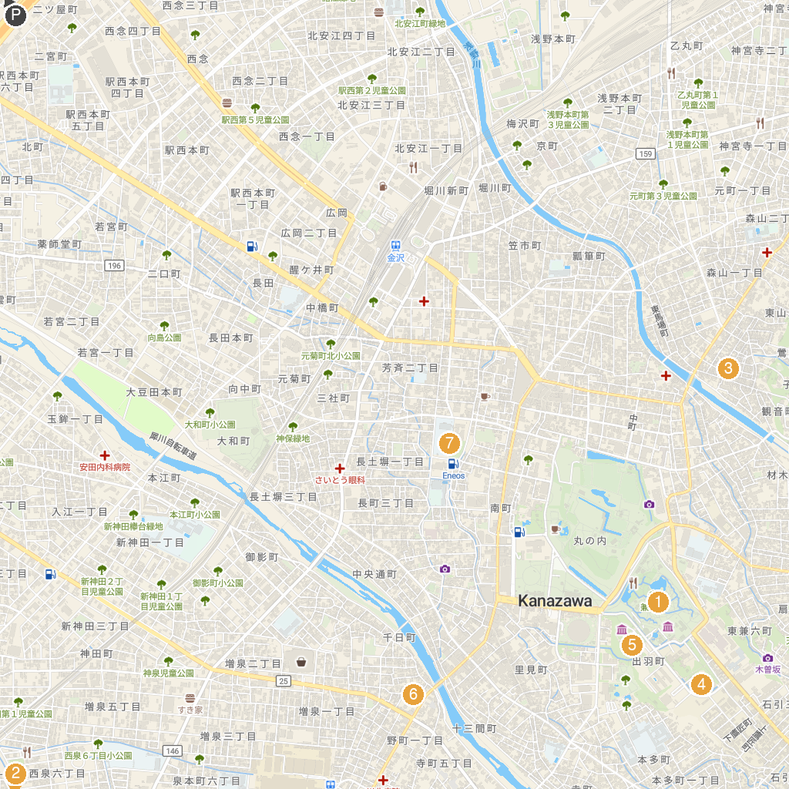
MAP KEY
1. Kenroku-en | 5. Hondanomori Hokuden Hall
2. ROUND1 Stadium Kanazawa | 6. Ishikawa Prefectural Museum of Art
3. Higashi Chaya District | 7. Shinmeigu (Kanazawa-shi)
4. Sumiyoshi Park | 8. Tamagawa Park
P. Cruise port / terminal
Map © MapTiler © OpenStreetMap contributors · cruiseports.org

