Kampot, Kampot Province, Cambodia
Where pepper is king and time slows to a river's pace. Kampot's faded colonial streets, firefly-lit waterways, and world-famous pepper farms make for one of Southeast Asia's most unexpectedly rewarding port days.
⚓ Docked — Kampot Tourism Port or Container Port · 🕒 Typical call: 8-10 hrs · 💵 USD widely accepted / Cambodian Riel · 🗣️ Khmer (English common in tourist areas) · 🌶️ World-famous Kampot pepper
✍️ MY DAY IN PORT (FILL IN)
Ship / Date
In port | arrive ______ · all aboard ______
Booked excursion
Notes / meeting point
GETTING ASHORE
- Docking: Kampot International Tourism Port (opened 2025) or Container Port, both ~6 km southeast of town
- Walk to center: Not walkable from port — $3-5 tuk-tuk to the riverside (~15 min)
- Best For: Pepper farm visits, French colonial architecture, cave temples, and day trips to Kep
- Don't Miss: La Plantation pepper farm, Phnom Chhngok Cave Temple, and green pepper crab in Kep
GETTING AROUND
- 📱 Rideshare: ✅ Grab, PassApp
TOP THINGS TO DO
- La Plantation Pepper Farm — Kampot pepper holds GI status (like Champagne) and La Plantation is the most visitor-friendly farm.
- Phnom Chhngok Cave Temple — A pre-Angkorian Hindu brick temple dating to the 7th century, dedicated to Shiva, sits inside a limestone cave about 8-12 km from…
- Kep Crab Market & Beach — The fishing village of Kep, 30 minutes away, is famous for its open-air Crab Market.
- Bokor Mountain (Bokor National Park) — A highland road climbs to the eerie abandoned Bokor Palace Hotel — a French colonial ruin wrapped in cloud forest — plus a giant…
- Kampot Colonial Town Walk — Stroll the riverside French Quarter past faded yellow colonial buildings, the Old Market (Phsar Chas), and the iconic Giant…
BEST WALKS
- Riverside French Quarter Loop: 1.5-2 km · 30-45 min · Easy — A relaxed circuit through Kampot's most atmospheric streets.
- Salt Fields Walk: Easy · Best Nov-Apr — Cross the Entanou Bridge to the island opposite downtown Kampot to see the gleaming salt pans.
WEATHER · DAYLIGHT · MONEY
Month | High °F | Low °F | Rainy days
May | 88 | 79 | 23
Jul | 85 | 78 | 25
Sep | 84 | 77 | 25
Daylight: May 5:41AM–6:17PM · Jul 5:48AM–6:29PM · Sep 5:53AM–6:03PM
cruiseports.org/kampot · Confirm terminal & all-aboard time with your ship

Kampot, Kampot Province, Cambodia — Port Map
Red = walkable sights · Amber = excursions farther out · P = cruise terminal
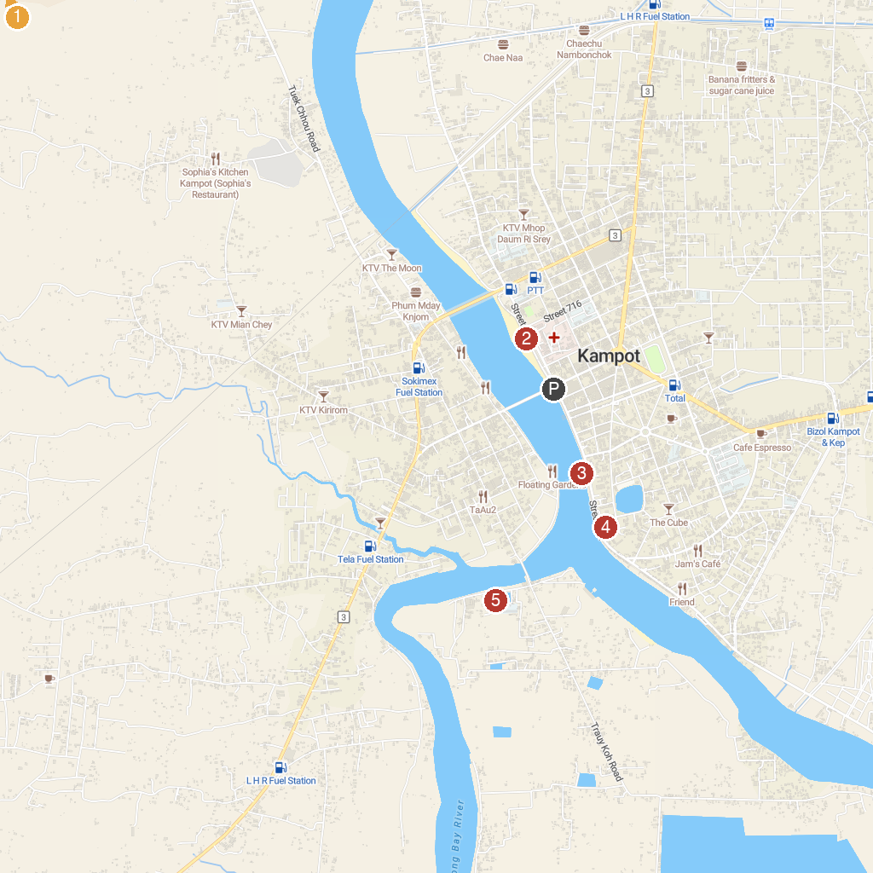
MAP KEY
1. Teuk Chhou Rapids | 4. Kampot Provincial Museum
2. Kampot Beach | 5. Wat Traeuy Kaoh
3. Seahorse Statue
P. Cruise port / terminal
Map © MapTiler © OpenStreetMap contributors · cruiseports.org

