Kampong Chhnang, Kampong Chhnang Province, Cambodia
Where Cambodia's 'Port of Pottery' meets the Tonle Sap — floating villages of Khmer, Vietnamese, and Cham families spread across the water while artisans on shore hand-shape terracotta using techniques unchanged for centuries.
⚓ Tendered (skiff transfer) · 🕒 Typical call: 6-8 hrs · 💵 USD & Cambodian Riel · 🗣️ Khmer
✍️ MY DAY IN PORT (FILL IN)
Ship / Date
In port | arrive ______ · all aboard ______
Booked excursion
Notes / meeting point
GETTING ASHORE
- Docking: Tender — small wooden skiffs from ship to shore
- Walk to centre: 10-15 min from landing to central market
- Best For: Floating village boat tours, traditional pottery villages
- Don't Miss: Ondong Rossey pottery village; floating school at Phoum Kandal
GETTING AROUND
- 🚕 Taxi: $2–5 in town — Metered taxis are scarce here — most car rides are negotiated on the spot. Agree on a price before setting off for town
- 📱 Rideshare: ✅ Grab
TOP THINGS TO DO
- Floating Village Skiff Tour — Glide through Phoum Kandal and Chong Kos aboard a small wooden boat.
- Ondong Rossey Pottery Village — Watch Khmer women shape unglazed terracotta using the ancient 'walking' technique — no wheel, just hands and feet circling the…
- Oudong Ancient Capital — Drive 45 minutes south to the former royal capital (1618–1866).
- Phsar Leu Central Market Walk — Step into one of Cambodia's least-touristy provincial markets — fresh river fish, aromatic spices, piles of palm sugar, and live…
- Phnom Neang Kang Rey — A forested hill across the river wrapped in Khmer folklore about a faithful maiden who turned to stone.
BEST WALKS
- Waterfront to Central Market: 800 m · 15 min · Easy — From the landing pier, follow the river road north past boat repair yards and roadside food stalls…
WEATHER · DAYLIGHT · MONEY
Month | High °F | Low °F | Rainy days
May | 93 | 79 | 23
Jul | 90 | 77 | 27
Sep | 88 | 76 | 27
Daylight: May 5:37AM–6:18PM · Jul 5:44AM–6:30PM · Sep 5:50AM–6:02PM
cruiseports.org/kampong-chhnang · Confirm terminal & all-aboard time with your ship

Kampong Chhnang, Kampong Chhnang Province, Cambodia — Port Map
Red = walkable sights · Amber = excursions farther out · P = cruise terminal
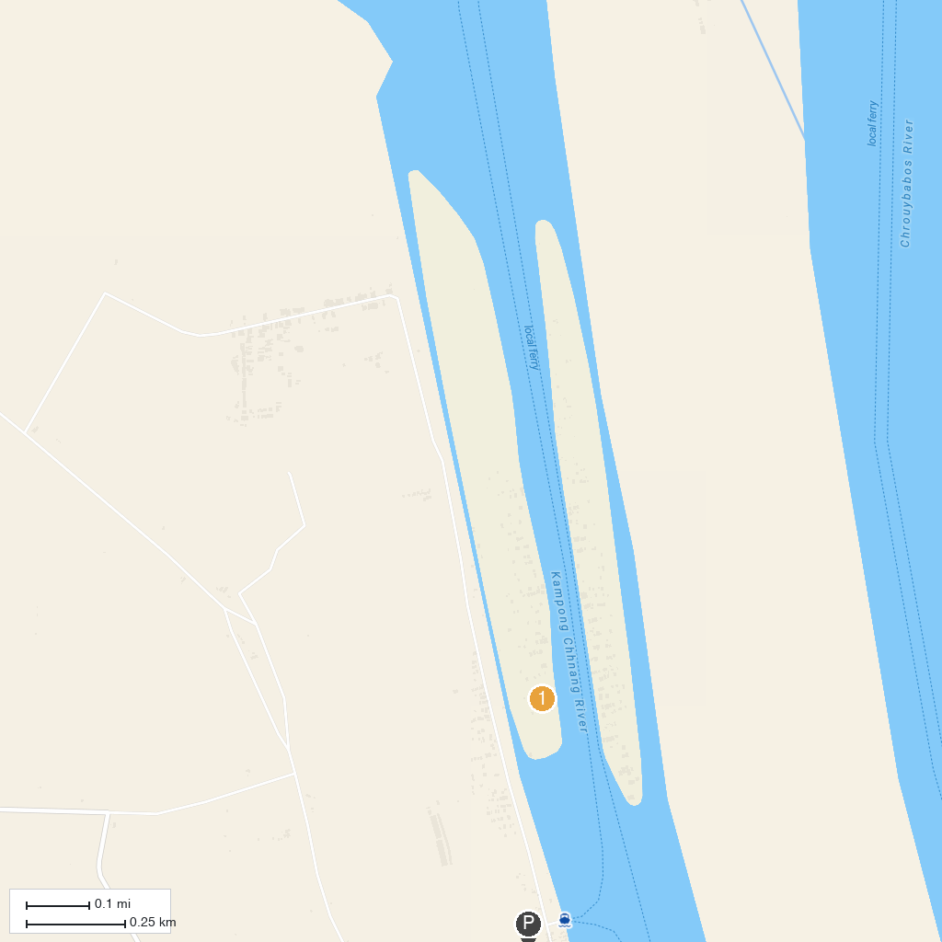
MAP KEY
1. หมู่บ้านจมน้ำ กำปงจันฑาล | 2. Kongkea Resort
P. Cruise port / terminal
Map © MapTiler © OpenStreetMap contributors · cruiseports.org

