Kampong Cham, Kampong Cham Province, Cambodia
Cambodia's third city feels like its best-kept secret — French-colonial facades, a 1,000-year-old temple wearing modern Buddhist robes, and a Mekong riverfront where life moves at the pace of the river.
⚓ River pier (gangway to bank) · 🕒 Typical call: 6-8 hrs · 💵 USD & Cambodian Riel · 🗣️ Khmer · 🚲 Bicycle-friendly
✍️ MY DAY IN PORT (FILL IN)
Ship / Date
In port | arrive ______ · all aboard ______
Booked excursion
Notes / meeting point
GETTING ASHORE
- Docking: River gangway direct to Preah Sihanouk Boulevard promenade
- Walk to center: 5 min flat to Central Market and main dining
- Best For: Angkorian ruins, island cycling, authentic Cambodian town life
- Don't Miss: Wat Nokor Bachey — ancient black-sandstone temple with a pagoda built inside it
GETTING AROUND
- 🚕 Taxi: $0.50–2 USD — Motorcycle taxis are the cheapest option for solo passengers making short hops within town.
- 📱 Rideshare: ✅ Grab, PassApp
TOP THINGS TO DO
- Wat Nokor Bachey — A 12th-century Angkorian temple built in sandstone and laterite — with a vibrant modern Buddhist pagoda (built in the 1930s)…
- Koh Pen Island Bicycle Loop — Cross to this large Mekong island — by the concrete bridge (dry season bamboo bridge version sometimes rebuilt for tourists)…
- Phnom Pros & Phnom Srei (Man & Woman Hills) — Two facing hills wrapped in Khmer legend about a competition between men and women.
- Chup Rubber Plantation — One of Southeast Asia's largest rubber plantations, established by the French Compagnie du Cambodge in the 1920s.
- Riverside Café & Market Walk — Start at Phsar Thom (Central Market) for an unfiltered wet-market experience, then work your way to the riverfront for lunch at…
BEST WALKS
- Riverside Promenade & Central Market: 1.5 km · 30-40 min · Flat · Free — A simple stroll from the ship landing along Preah Sihanouk Boulevard, past French colonial facades…
- Koh Pen Island Walk: 2-4 km on island · 1-2 hrs · Flat · Free (bridge crossing) — Cross the bridge to Koh Pen Island and walk the dirt paths through the stilt-house village.
WEATHER · DAYLIGHT · MONEY
Month | High °F | Low °F | Rainy days
May | 92 | 79 | 23
Jul | 89 | 78 | 27
Sep | 87 | 77 | 28
Daylight: May 5:34AM–6:14PM · Jul 5:41AM–6:26PM · Sep 5:47AM–5:58PM
cruiseports.org/kampong-cham · Confirm terminal & all-aboard time with your ship

Kampong Cham, Kampong Cham Province, Cambodia — Port Map
Red = walkable sights · Amber = excursions farther out · P = cruise terminal
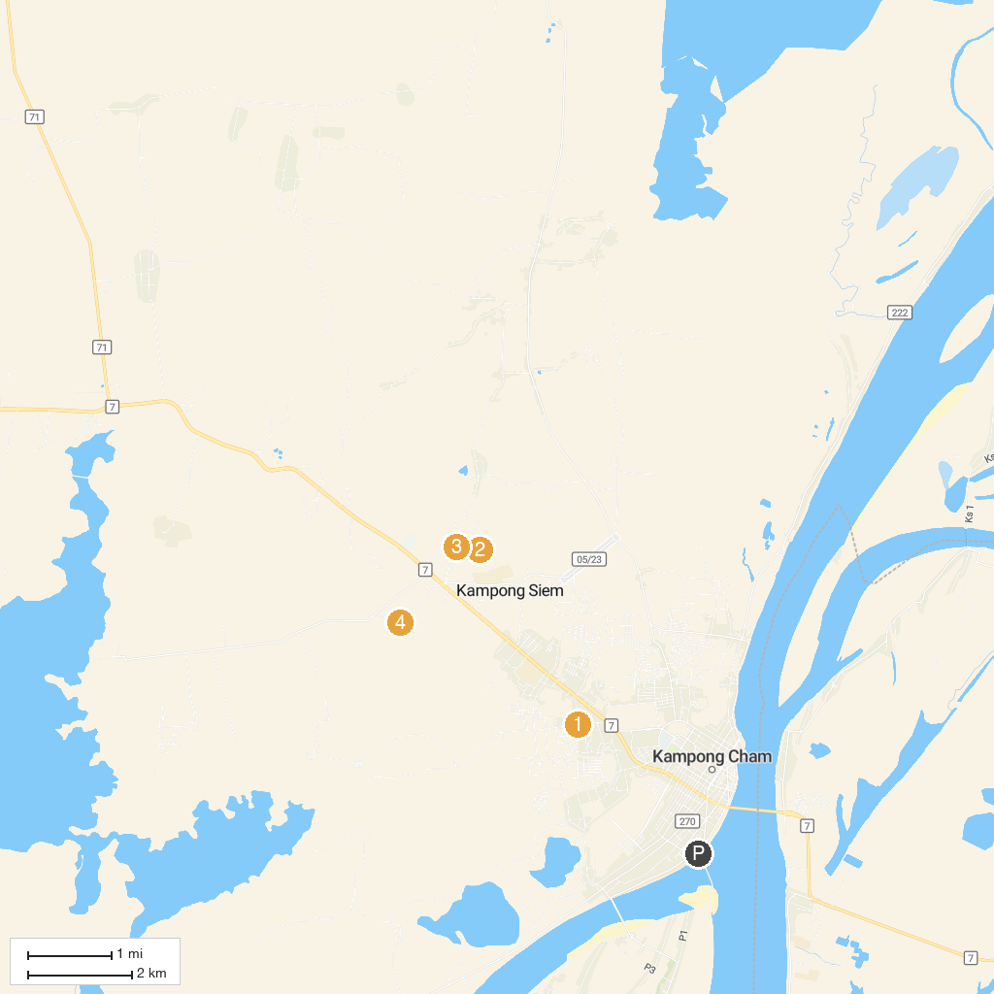
MAP KEY
1. Nokor BaChey temple | 3. Phnom Bros Library
2. Phnom Srei | 4. Cheung Kok Ecotourism Village
P. Cruise port / terminal
Map © MapTiler © OpenStreetMap contributors · cruiseports.org

