Kampen, Overijssel, Netherlands
One of the best-preserved Hanseatic cities in the Netherlands, Kampen packs medieval gates, a soaring Gothic church, and centuries of IJssel River heritage into a compact, walkable old town — all just steps from the quay.
⚓ Pier dock (IJsselkade quay) · 🕒 Typical call: 6–8 hrs · 💶 Euro (€) · 🗣️ Dutch (English widely spoken)
✍️ MY DAY IN PORT (FILL IN)
Ship / Date
In port | arrive ______ · all aboard ______
Booked excursion
Notes / meeting point
GETTING ASHORE
- Docking: Pier — ships dock directly on the IJsselkade riverfront quay
- Walk to center: 2 minutes — old town begins immediately behind the quay
- Best For: Medieval architecture, Hanseatic history, Gothic churches, leisurely cycling
- Don't Miss: Koornmarktspoort gate, Bovenkerk organ, the Kamper Kogge cog ship replica
GETTING AROUND
- 🚕 Taxi: €5–€15 — Local taxis are available (e.g., Taxi Brink Kampen, +31 38 444 1111). Fares within the city are short and inexpensive gi
- 📱 Rideshare: ✅ Uber
TOP THINGS TO DO
- Medieval Gates & Hanseatic Old Town Walk — Kampen once had twenty city gates; three magnificent ones survive.
- Bovenkerk — Gothic Cathedral & Hinsz Organ — The massive 14th-century St.
- Koggewerf — Hanseatic Cog Ship Yard — On the riverbank, the Koggewerf is a working historic shipyard where craftspeople build and maintain the Kamper Kogge — a…
- Ikonenmuseum — Orthodox Icon Collection — Housed in a former monastery, this is one of Western Europe's most prestigious collections of Eastern Orthodox Christian art.
- Cycling the IJssel Dikes — Kampen's flat river landscape is ideal for cycling.
BEST WALKS
- IJsselkade to the Three City Gates: 2.5 km loop · 45–60 min · Easy — Start on the IJsselkade promenade, walk to the Koornmarktspoort gate on the waterfront, head into…
- Stadsbrug Panorama Stroll: 1 km out-and-back · 20 min · Easy — Walk from the quay to the Stadsbrug (city bridge) for the classic Kampen skyline photo with the…
WEATHER · DAYLIGHT · MONEY
Month | High °F | Low °F | Rainy days
May | 63 | 48 | 12
Jul | 72 | 58 | 15
Sep | 67 | 54 | 11
Daylight: May 5:40AM–9:26PM · Jul 5:32AM–9:51PM · Sep 7:11AM–7:50PM
cruiseports.org/kampen · Confirm terminal & all-aboard time with your ship

Kampen, Overijssel, Netherlands — Port Map
Red = walkable sights · Amber = excursions farther out · P = cruise terminal
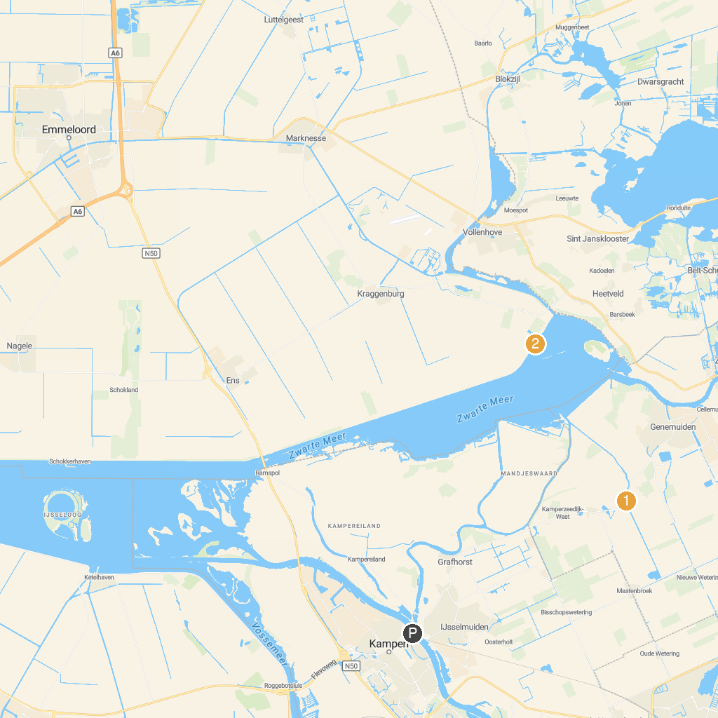
MAP KEY
1. Stoomgemaal Mastenbroek | 5. Museum Sjoel Elburg
2. PIER+HORIZON - Paul de Kort | 6. The Great Escape
3. Eekhout | 7. Zwaluwenburg
4. Botterstichting Elburg | 8. Culture Historical Center Land of Vollenhove
P. Cruise port / terminal
Map © MapTiler © OpenStreetMap contributors · cruiseports.org

