Kalymnos Island, Dodecanese, Greece
The rugged Dodecanese island that built its wealth on deep-sea sponge diving and reinvented itself as one of the world's great rock-climbing destinations — all wrapped around a vibrant harbor town with excellent seafood.
⚓ Tender (large ships) / Docked (small ships) · 🕒 Typical call: 6–8 hrs · 💶 Currency: Euro (€) · 🗣️ Language: Greek (English widely spoken)
✍️ MY DAY IN PORT (FILL IN)
Ship / Date
In port | arrive ______ · all aboard ______
Booked excursion
Notes / meeting point
GETTING ASHORE
- Docking: Small/expedition ships dock at Pothia quay; large cruise ships tender to the main harbor
- Walk to center: You step ashore directly into Pothia — town center is immediate
- Best For: Sponge diving history, rock climbing, authentic Greek island atmosphere, beaches
- Don't Miss: Lady of Kalymnos bronze statue at the Archaeological Museum and a sponge-factory tour on the waterfront
GETTING AROUND
- 🚕 Taxi: €5–€15 — Taxis wait near the port in Pothia. Short rides within town are inexpensive; trips to beach villages like Myrties or Mas
TOP THINGS TO DO
- Pothia Sponge Diving Walking Tour — Trace Kalymnos's seafaring past through the neoclassical mansions built on sponge wealth, a waterfront sponge workshop…
- Rock Climbing at Massouri & Grande Grotta — Kalymnos has over 4,000 sport climbing routes on solid limestone cliffs above the west-coast villages.
- Massouri & Telendos Island Beach Day — Kalymnos's best beaches line the west coast near Massouri and Myrties, with clear turquoise water and dramatic cliff backdrops.
- Vathy Fjord Village — On Kalymnos's east coast, a dramatic gorge opens onto the tiny fishing village of Vathy, sitting at the head of a narrow fjord.
- Agios Savvas Monastery & Castle Views — The stone monastery of Agios Savvas clings above Pothia and delivers the best panoramic shot of the harbor, your ship, and the…
BEST WALKS
- Pothia Harbourfront & Old Town: 1–2 hrs · Easy · All on foot — From the quay, follow the waterfront road past sponge workshops and tavernas, then duck into the…
- Castle of Chrysocheria & Windmills: 1.5 hrs · Moderate · Uphill walk — A 20-minute uphill walk from the port brings you to the ruined Knights of St.
WEATHER · DAYLIGHT · MONEY
Month | High °F | Low °F | Rainy days
May | 73 | 65 | 3
Jul | 84 | 76 | 0
Sep | 81 | 73 | 2
Daylight: May 6:04AM–8:12PM · Jul 6:04AM–8:31PM · Sep 6:54AM–7:19PM
cruiseports.org/kalymnos-island · Confirm terminal & all-aboard time with your ship

Kalymnos Island, Dodecanese, Greece — Port Map
Red = walkable sights · Amber = excursions farther out · P = cruise terminal
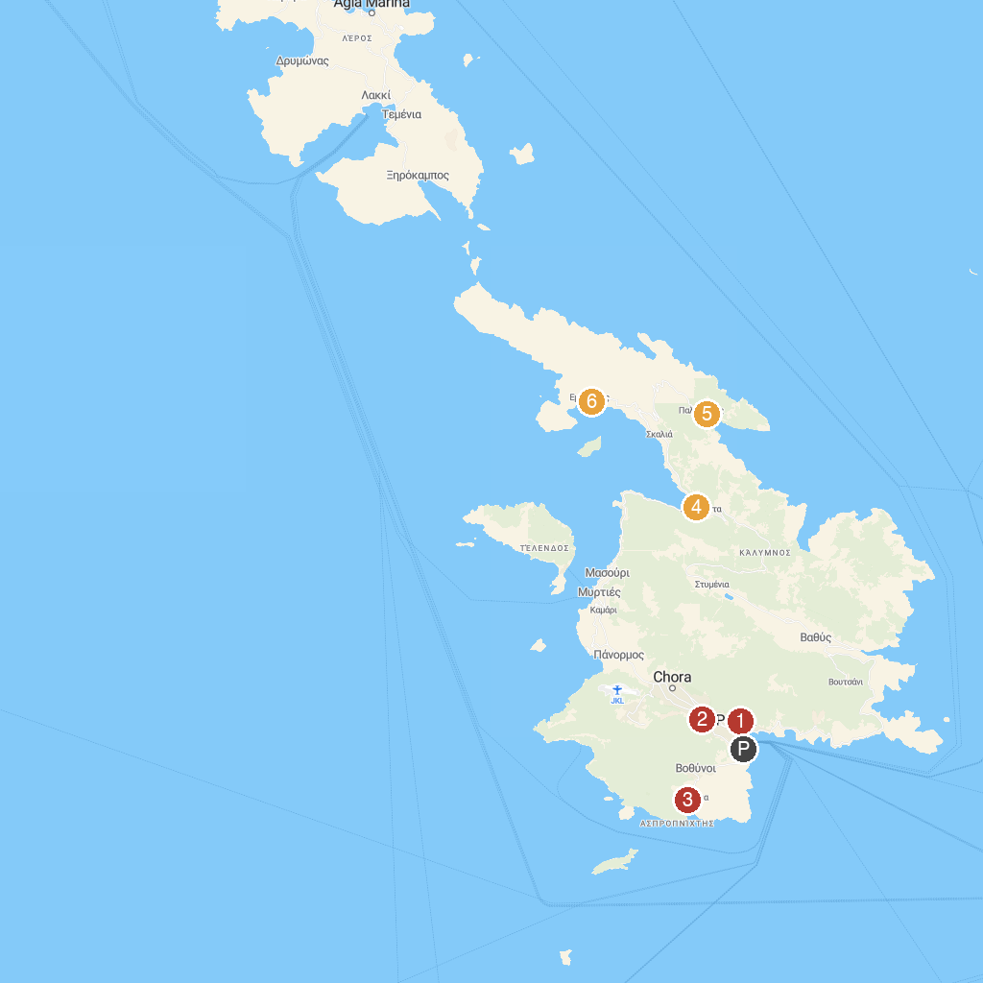
MAP KEY
1. Kalymnos Archaeological Museum | 4. Arginonta Beach
2. Chrysocheria Castle | 5. Palionisos Kalimnou
3. Vlychadia Beach | 6. Emporios Beach
P. Cruise port / terminal
Map © MapTiler © OpenStreetMap contributors · cruiseports.org

