Kalamata, Peloponnese, Greece
Capital of Messinia and birthplace of the world's most famous olive, Kalamata blends Byzantine churches, a hilltop Frankish fortress, and easy access to some of the Peloponnese's finest ancient sites.
⚓ Pier (docked) · 🕒 Typical call: 7-9 hrs · 💶 Euro (€) · 🗣️ Greek
✍️ MY DAY IN PORT (FILL IN)
Ship / Date
In port | arrive ______ · all aboard ______
Booked excursion
Notes / meeting point
GETTING ASHORE
- Docking: Pier — ships dock at the main quay
- Walk to center: 15-20 min along the waterfront promenade
- Best For: Ancient ruins, olive culture, Peloponnese day trips
- Don't Miss: Ancient Messene — one of Greece's best-preserved ancient cities
GETTING AROUND
- 🚕 Taxi: €5–€10 — Taxis are readily available at the port. The short ride to the city center typically costs €5–€10; surcharges may apply
TOP THINGS TO DO
- Ancient Messene — One of Greece's most remarkably preserved Hellenistic cities, just 40 minutes from port.
- Mystras & Sparta — Drive through the scenic Langada Pass to visit legendary Ancient Sparta and the nearby Byzantine ruins of Mystras — a UNESCO…
- Methoni Venetian Castle — A dramatic Venetian sea fortress at the tip of the Messinian peninsula, connected to a tiny island by a causeway.
- Kalamata Olive & Food Tour — Kalamata olives are arguably the world's most famous variety — visit an olive grove and mill, learn the production process, and…
- Voidokilia Beach & Gialova Lagoon — A perfectly circular sandy bay framed by dunes — one of Greece's most photogenic beaches — paired with the Gialova Lagoon, the…
BEST WALKS
- Waterfront to Old Town & Castle: 4 km round trip · 1.5-2 hrs · Easy-moderate — From the pier, walk the Navarinou promenade past cafés and the beach to the city centre.
- Market & Archaeological Museum Loop: 2 km · 45 min · Easy — A flat city walk taking in the Municipal Market — heaving with olives, olive oil, fresh produce…
WEATHER · DAYLIGHT · MONEY
Month | High °F | Low °F | Rainy days
May | 76 | 59 | 6
Jul | 91 | 71 | 2
Sep | 84 | 67 | 5
Daylight: May 6:23AM–8:32PM · Jul 6:23AM–8:50PM · Sep 7:13AM–7:38PM
cruiseports.org/kalamata · Confirm terminal & all-aboard time with your ship

Kalamata, Peloponnese, Greece — Port Map
Red = walkable sights · Amber = excursions farther out · P = cruise terminal
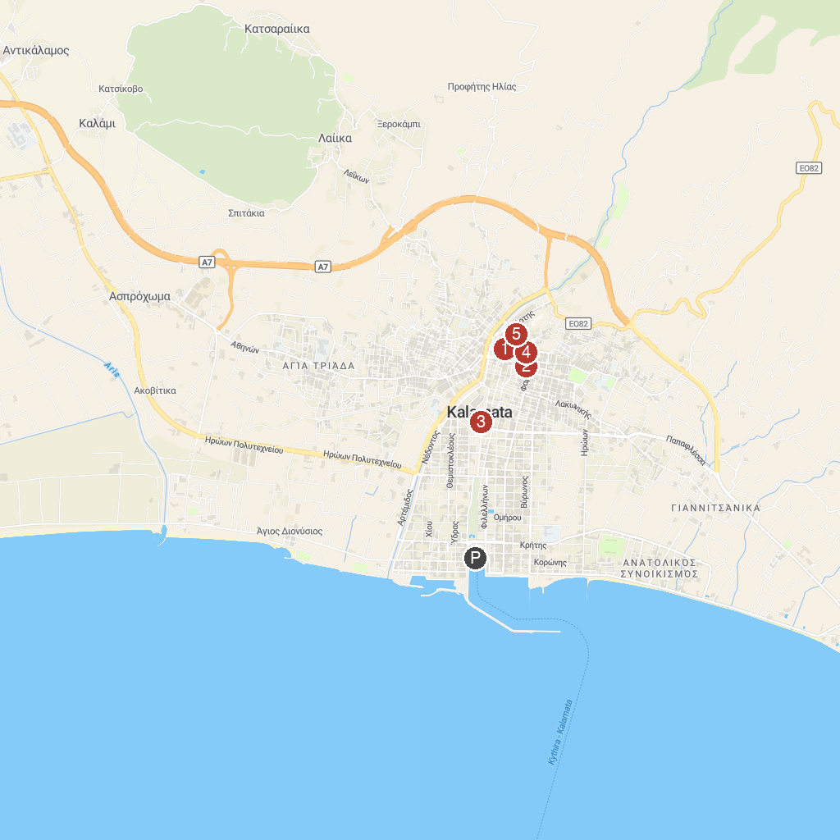
MAP KEY
1. Archaeological Museum of Messinia | 4. Πολεμικό Μουσείο Καλαμάτας
2. Victoria Karelias Collection of Traditional Greek Costumes | 5. Historical and Folklore Museum of Kalamata
3. Central Square of Kalamata
P. Cruise port / terminal
Map © MapTiler © OpenStreetMap contributors · cruiseports.org

