Kaikoura, Canterbury, New Zealand
Where the Southern Alps plunge straight into a whale-rich ocean canyon. Kaikoura delivers world-class wildlife encounters and some of New Zealand's most dramatic coastal scenery — all within a few hours ashore.
⚓ Tender port (South Bay Marina) · 🕒 Typical call: 7–9 hrs · 💵 NZD — cards accepted everywhere · 🗣️ English / Te Reo Māori · 🐋 Wildlife destination
✍️ MY DAY IN PORT (FILL IN)
Ship / Date
In port | arrive ______ · all aboard ______
Booked excursion
Notes / meeting point
GETTING ASHORE
- Docking: Tender — ships anchor offshore; tenders to South Bay Marina (~2.5 km from town)
- Walk to Town: ~45 min on flat road from South Bay Marina, or take the free/cheap cruise shuttle
- Best For: Whale watching, dolphin swims, fur seals, dramatic coastal walks
- Don't Miss: Fresh crayfish at the roadside Kaikoura Seafood BBQ near Point Kean
GETTING AROUND
- 🚕 Taxi: Contact for quote — Kaikoura Shuttles and Taxis (+64 3 319 6166) offers transfers and a 3-hour sightseeing tour (NZ$140/adult, NZ$90/child,
- 📱 Rideshare: ✅ Uber
TOP THINGS TO DO
- Sperm Whale Watching by Boat — Whale Watch Kaikoura runs 3-hour catamaran trips over the Hikurangi Trench, where giant sperm whales feed year-round.
- Swim with Dusky Dolphins — Dolphin Encounter takes small groups out to swim alongside pods of hundreds of dusky dolphins in the open ocean — one of New…
- Kaikoura Peninsula Walkway — A dramatic cliff-top trail with views of the ocean, fur seals on the rocks below, seabirds nesting on ledges, and snow-capped…
- Albatross & Seabird Encounter — A short boat trip to encounter royal albatrosses, giant petrels, and shearwaters feeding just offshore — a must for birders and…
- Scenic Whale Watch Flight — Air Kaikoura offers 30-minute fixed-wing flights over the coast — spot sperm whales from above, framed by the Seaward Kaikoura…
BEST WALKS
- Town to Point Kean Seal Colony: 4 km one-way · ~50 min · flat · free — A flat, scenic walkway along the waterfront from the town center past Fyffe House to the Point Kean…
- Peninsula Walkway Clifftop Loop (South Bay section): 2 km · 45 min · easy-moderate · free — From South Bay Marina, follow the Peninsula Walkway up onto the clifftops for sweeping ocean and…
WEATHER · DAYLIGHT · MONEY
Month | High °F | Low °F | Rainy days
May | 59 | 46 | 11
Jul | 52 | 39 | 13
Sep | 56 | 43 | 12
Daylight: May 7:29AM–5:13PM · Jul 7:50AM–5:11PM · Sep 6:27AM–6:14PM
cruiseports.org/kaikoura · Confirm terminal & all-aboard time with your ship

Kaikoura, Canterbury, New Zealand — Port Map
Red = walkable sights · Amber = excursions farther out · P = cruise terminal
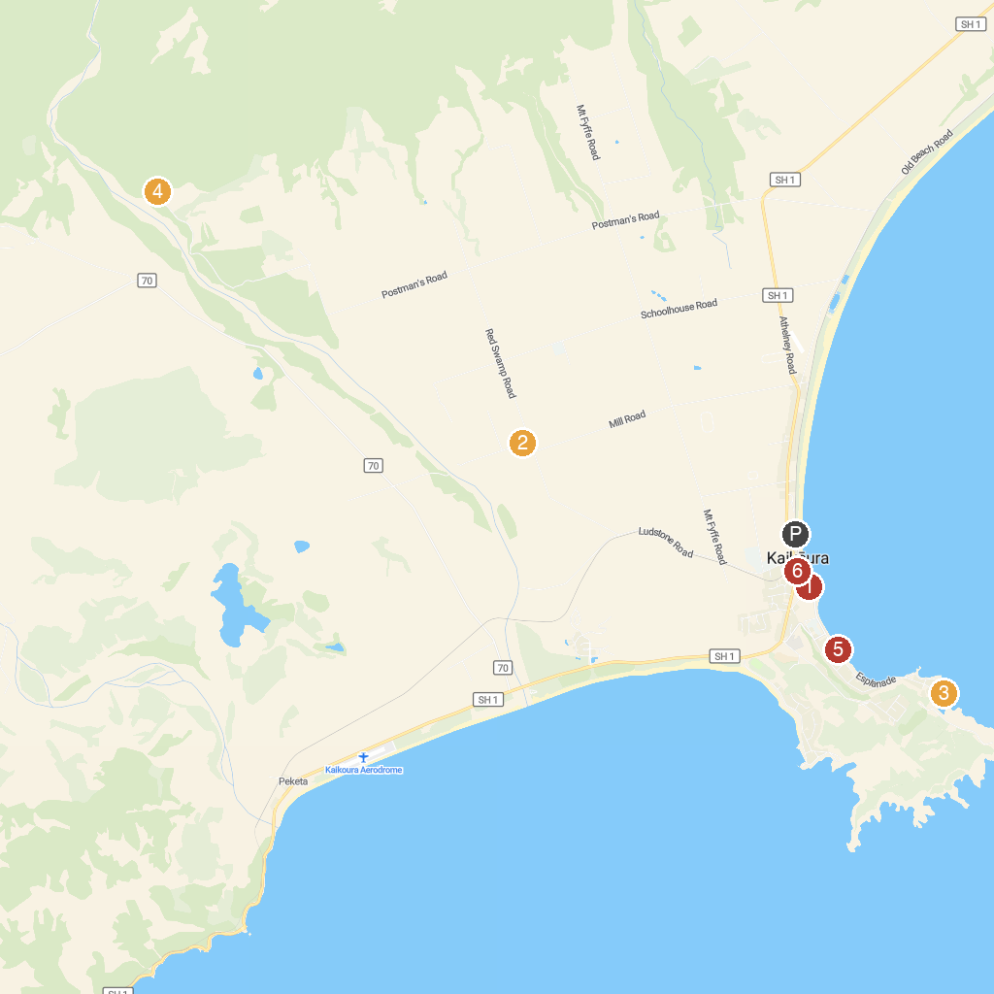
MAP KEY
1. Kaikoura Visitor Information Centre | 4. Mt Fyffe Carpark
2. Kaikoura Llama Trekking | 5. Kaikoura Beach
3. Fyffe House | 6. Daves' Diving Kaikoura
P. Cruise port / terminal
Map © MapTiler © OpenStreetMap contributors · cruiseports.org

