Kahului, Maui, Hawaii, USA
Maui's only active cruise terminal sits in a workaday harbor, but step off the ship and the whole island opens up — volcanic summits, jungle waterfalls, and snorkel-perfect craters await.
⚓ Docked (pier) · 🕒 Typical call: 8-10 hrs · 💵 USD · 🗣️ English / Hawaiian
✍️ MY DAY IN PORT (FILL IN)
Ship / Date
In port | arrive ______ · all aboard ______
Booked excursion
Notes / meeting point
GETTING ASHORE
- Docking: Direct alongside berth at Kahului Harbor — no tender required
- Walk to center: Queen Ka'ahumanu Center ~1.5 mi (20-30 min); not scenic — take a shuttle or rideshare
- Best For: Haleakalā volcano, Road to Hana, Molokini snorkel, Iao Valley
- Don't Miss: Molokini Crater snorkel or a sunrise/day summit at Haleakalā National Park
GETTING AROUND
- 🚕 Taxi: ~$20 flat rate — County-regulated flat rate of $20 for trips under 3 miles covers the 1–2 mile ride to Kahului town center. Taxis availab
- 📱 Rideshare: ✅ Uber, Lyft
- 🚌 Hop-on hop-off: ✅ Hula Hula Hopper
TOP THINGS TO DO
- Road to Hana — Maui's legendary 64-mile coastal highway winds through rainforest, past waterfalls, and black-sand beaches.
- Haleakalā National Park Summit — Drive to the 10,023-ft summit of a dormant shield volcano for sweeping crater views above the clouds.
- Molokini Crater Snorkel — This partially submerged volcanic crater off Maui's south coast is ranked among the world's best snorkel sites — visibility often…
- Iao Valley State Monument — A lush valley with the iconic Iao Needle — a 1,200-ft green basalt spire rising from the valley floor.
- Whale Watch Cruise (Dec–Apr) — Kahului Harbor is right in the middle of North Pacific humpback whale winter grounds.
BEST WALKS
- Iao Valley Loop: 1.2 miles | Easy | Paved paths — Short paved loop through lush Iao Valley with views of the Iao Needle spire.
- Paia Town Stroll: 0.5 miles | Easy | Flat — Walk the main strip of Paia town from the iconic Paia Fish Market along Baldwin Avenue's galleries…
WEATHER · DAYLIGHT · MONEY
Month | High °F | Low °F | Rainy days
May | 82 | 72 | 4
Jul | 85 | 75 | 3
Sep | 85 | 75 | 4
Daylight: May 5:48AM–6:56PM · Jul 5:53AM–7:09PM · Sep 6:13AM–6:28PM
cruiseports.org/kahului · Confirm terminal & all-aboard time with your ship

Kahului, Maui, Hawaii, USA — Port Map
Red = walkable sights · Amber = excursions farther out · P = cruise terminal
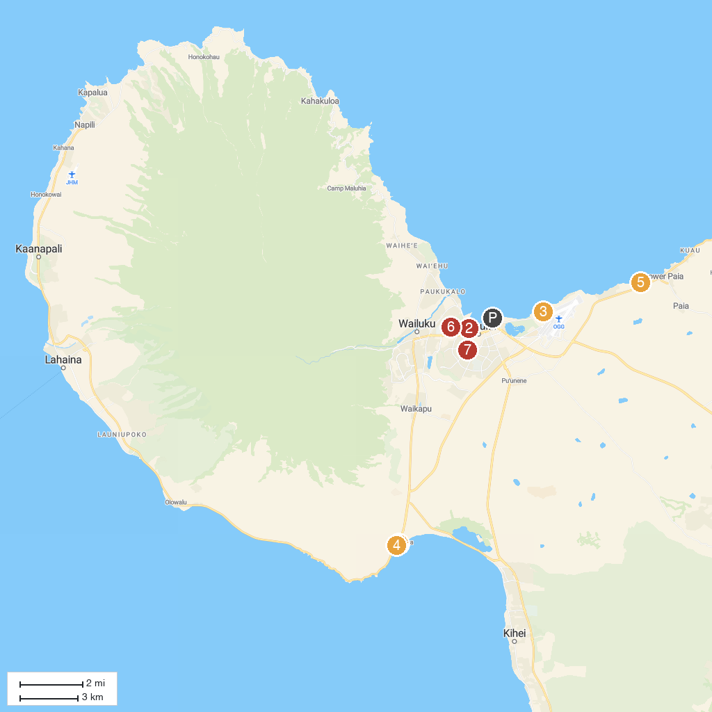
MAP KEY
1. Maui Ocean Center, The Aquarium of Hawaii | 5. Ho'okipa Beach Park
2. Maui Exposition | 6. Baldwin Beach Park
3. Kanaha Beach Park | 7. Maui Nui Botanical Gardens
4. PacWhale Eco-Adventures | 8. Kahului Community Center Park
P. Cruise port / terminal
Map © MapTiler © OpenStreetMap contributors · cruiseports.org

