Jekyll Island, Georgia, USA
Once the exclusive winter retreat of Rockefellers and Vanderbilts, Jekyll Island is now a preserved Georgia barrier island with 10 miles of beaches, a National Historic Landmark district, and wild sea turtle nesting grounds.
⚓ Pier docked (Jekyll Harbor Marina) · 🕒 Typical call: 6-8 hrs · 💵 USD · 🗣️ English · 🚲 Bike-friendly island
✍️ MY DAY IN PORT (FILL IN)
Ship / Date
In port | arrive ______ · all aboard ______
Booked excursion
Notes / meeting point
GETTING ASHORE
- Docking: Direct pier at Jekyll Harbor Marina — no tender
- Walk to Historic District: ~1.5 miles from marina; bikes or shuttle recommended
- Best For: History, beaches, nature, cycling
- Don't Miss: Driftwood Beach and the Millionaires' Village trolley tour
GETTING AROUND
- 🚕 Taxi: $35–$45 — Metro Cab of Brunswick serves Jekyll Island. Expect $35–$45 from Brunswick (~12 miles). A $8–$10 island entrance fee per
TOP THINGS TO DO
- Millionaires' Village Trolley Tour — A 60-minute guided trolley ride through the 240-acre Jekyll Island Historic District, a National Historic Landmark.
- Driftwood Beach Walk — Jekyll Island's most photographed spot — a hauntingly beautiful stretch of ancient, bleached oak and cedar trees standing…
- Georgia Sea Turtle Center — A working sea turtle rehabilitation hospital and education center.
- Island Bike Tour — Over 20 miles of paved multi-use trails crisscross the island, connecting the marina, Historic District, all six beach parks, and…
- Beaches & Beach Parks — Jekyll has seven beach access parks along 10 miles of undeveloped coastline.
BEST WALKS
- Marina to Historic District: 1.5 miles one-way · Flat · 30 min walk — Walk or bike east from Jekyll Harbor Marina through the maritime forest to the Jekyll Island…
- Driftwood Beach to Great Dunes Park: ~3.5 miles one-way · Flat · bike recommended (~25 min ride) — Start at Driftwood Beach (N.
WEATHER · DAYLIGHT · MONEY
Month | High °F | Low °F | Rainy days
May | 82 | 69 | 10
Jul | 89 | 77 | 17
Sep | 84 | 74 | 16
Daylight: May 6:30AM–8:14PM · Jul 6:32AM–8:30PM · Sep 7:10AM–7:30PM
cruiseports.org/jekyll-island-ga · Confirm terminal & all-aboard time with your ship

Jekyll Island, Georgia, USA — Port Map
Red = walkable sights · Amber = excursions farther out · P = cruise terminal
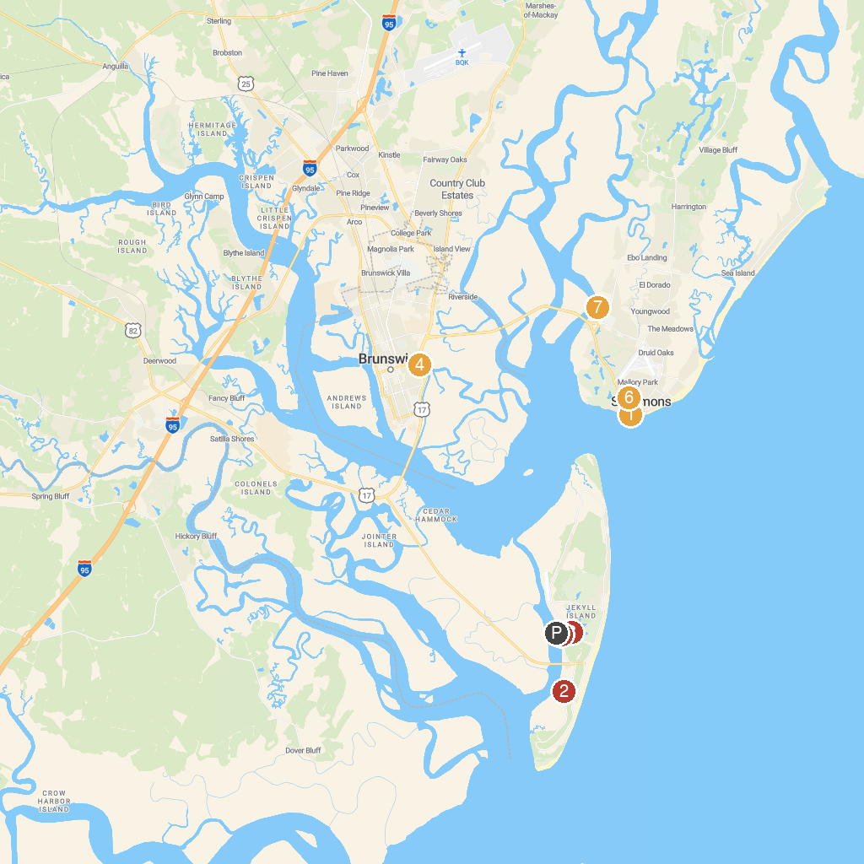
MAP KEY
1. St. Simons Island Lighthouse Museum | 5. City of Brunswick
2. Summer Waves Water Park | 6. Indian Mound Cottage
3. Mosaic, Jekyll Island Museum | 7. Mallery Park
4. Blythe Island Regional Park | 8. Hamilton Plantation Slave Cabins
P. Cruise port / terminal
Map © MapTiler © OpenStreetMap contributors · cruiseports.org

