Jeju Island, Jeju Province, South Korea
South Korea's volcanic island delivers UNESCO lava tubes, a sunrise-crater hike, diving women who free-dive for seafood, and black-pork bibimbap — all within a single shore day.
⚓ Docked (two ports) · 🕒 Typical call: 8-10 hrs · 💵 Korean Won (KRW) · 🗣️ Korean (English signage at key sites)
✍️ MY DAY IN PORT (FILL IN)
Ship / Date
In port | arrive ______ · all aboard ______
Booked excursion
Notes / meeting point
GETTING ASHORE
- Docking: Jeju City Port (north) or Seogwipo Gangjeong Port (south) — both pier berths, no tendering
- Walk to center: Jeju City Port: ~2 km to Dongmun Market; Gangjeong: free shuttle to Seogwipo
- Best For: Volcanic landscapes, UNESCO hikes, Korean culture & markets
- Don't Miss: Seongsan Ilchulbong sunrise crater and haenyeo (women diver) demonstration
GETTING AROUND
- 🚕 Taxi: ₩8,000–₩10,000 (~$6–$8 USD) to city center — Taxis are metered, plentiful at the port, and an easy option. The terminal is ~2–3 km from Jeju City center. Jumbo taxis
- 📱 Rideshare: ✅ Uber, Kakao T
- 🚌 Hop-on hop-off: ✅ Jeju City Tour Bus
TOP THINGS TO DO
- Seongsan Ilchulbong (Sunrise Peak) — Climb this ~5,000-year-old volcanic tuff cone for sweeping views of the coast and crater.
- Manjanggul Lava Tube — Walk through one of the world's longest lava tubes — a 7.4 km UNESCO-listed underground passage formed by ancient volcanic flows.
- Haenyeo Experience & Seongeup Folk Village — Watch Jeju's legendary women free-divers (haenyeo) harvest seafood without oxygen equipment — a UNESCO Intangible Heritage…
- Cheonjiyeon & Jeongbang Waterfalls — Two of Jeju's most celebrated waterfalls, both near Seogwipo.
- Dongmun & Olle Market Food Tour — Dongmun Traditional Market (Jeju City) and Maeil Olle Market (Seogwipo) are the island's top food hubs.
BEST WALKS
- Jeju City Waterfront & Yongduam Rock: 2 km · 45 min · Easy — From Jeju City Port, walk west along the coastline to Yongduam (Dragon Head Rock) — a dramatic lava…
- Seopjikoji Coastal Path: 2 km loop · 1 hr · Easy — On the eastern tip of the island near Seongsan, this clifftop coastal trail offers dramatic ocean…
WEATHER · DAYLIGHT · MONEY
Month | High °F | Low °F | Rainy days
May | 71 | 60 | 11
Jul | 83 | 76 | 16
Sep | 78 | 71 | 16
Daylight: May 5:33AM–7:27PM · Jul 5:35AM–7:44PM · Sep 6:17AM–6:40PM
cruiseports.org/jeju-island · Confirm terminal & all-aboard time with your ship

Jeju Island, Jeju Province, South Korea — Port Map
Red = walkable sights · Amber = excursions farther out · P = cruise terminal
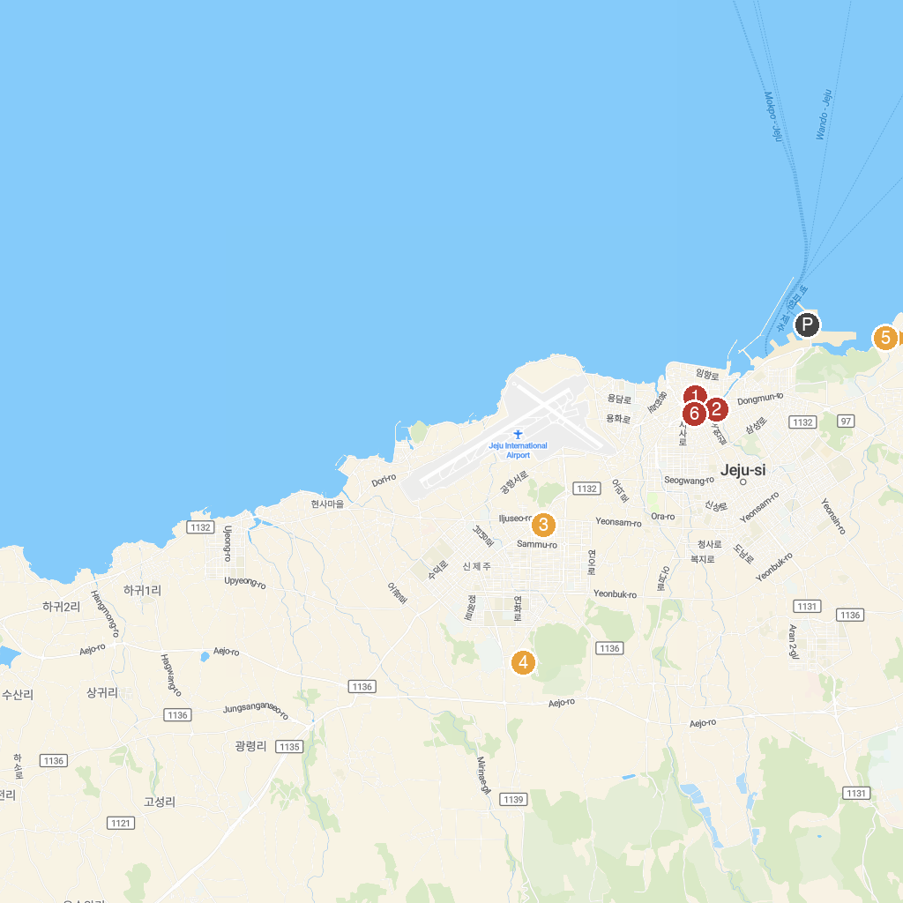
MAP KEY
1. 함덕서우봉해변종합관리센터 | 5. Sinjeju Catholic Church
2. 용진각대피소 옛터 | 6. Sumokwon theme park
3. Jejumok Gwana | 7. Jeju Samyang-dong Prehistoric Site
4. Dongmun Traditional Market | 8. Art Space IAa
P. Cruise port / terminal
Map © MapTiler © OpenStreetMap contributors · cruiseports.org

