Jeddah, Hejaz, Saudi Arabia
Gateway to the Holy Cities and the Red Sea, Jeddah blends thousand-year-old coral architecture with a modern waterfront skyline — and Saudi Arabia's wildly beloved fried chicken.
⚓ Pier (Jeddah Islamic Port) · 🕒 Typical call: 8-10 hrs · 💵 Saudi Riyal (SAR) · 🗣️ Arabic (English widely spoken) · 🕌 Conservative dress required
✍️ MY DAY IN PORT (FILL IN)
Ship / Date
In port | arrive ______ · all aboard ______
Booked excursion
Notes / meeting point
GETTING ASHORE
- Docking: Pier — Jeddah Islamic Port passenger terminal, no tender
- Walk to Center: Not walkable — port is industrial; 15-20 min by taxi/shuttle to Al-Balad
- Best For: UNESCO coral architecture, Red Sea history, vibrant souqs, iconic fountain
- Don't Miss: Al-Balad historic district and a stop at Al Baik for legendary Saudi fried chicken
GETTING AROUND
- 🚕 Taxi: SAR 20–50 (~$5–14) negotiated — Official taxis do not use meters; fares are negotiated. Port taxis are generally available but agree on a price before g
- 📱 Rideshare: ✅ Uber, Careem
TOP THINGS TO DO
- Al-Balad UNESCO Walking Tour — Explore Jeddah's 1,400-year-old walled city, renowned for its rawashin — intricately carved wooden bay windows atop coral-stone…
- Red Sea Corniche & King Fahd Fountain — Stroll Jeddah's 30-km waterfront promenade past Henry Moore and Joan Miró sculptures, then watch King Fahd Fountain — the world's…
- Al-Tayebat City Museum — A multi-level palace replica showcasing thousands of artifacts spanning Islamic and Saudi history.
- Obhur Beach Club Day Pass — Private beach clubs north of Jeddah (Silver Sands, Oia Beach) offer pool, beach, and Red Sea access where Western swimwear is…
- Al-Rahmah Floating Mosque & Corniche Walk — Visit the iconic mosque built on stilts over the Red Sea — stunning at high tide when the structure appears to float.
BEST WALKS
- Al-Balad Historic Core Loop: 2–3 km | 2–3 hrs | Moderate (uneven surfaces) — Start at Bab Makkah gate, then weave through Souq Al Alawi to Nassif House Museum, Al-Shafei…
- Corniche Waterfront Stroll: 2–4 km | 1–2 hrs | Easy — Walk the paved Red Sea promenade from Al-Rahmah Floating Mosque south toward King Fahd Fountain.
WEATHER · DAYLIGHT · MONEY
Month | High °F | Low °F | Rainy days
May | 94 | 79 | 0
Jul | 97 | 82 | 0
Sep | 95 | 82 | 0
Daylight: May 5:45AM–6:54PM · Jul 5:49AM–7:08PM · Sep 6:10AM–6:26PM
cruiseports.org/jeddah · Confirm terminal & all-aboard time with your ship

Jeddah, Hejaz, Saudi Arabia — Port Map
Red = walkable sights · Amber = excursions farther out · P = cruise terminal
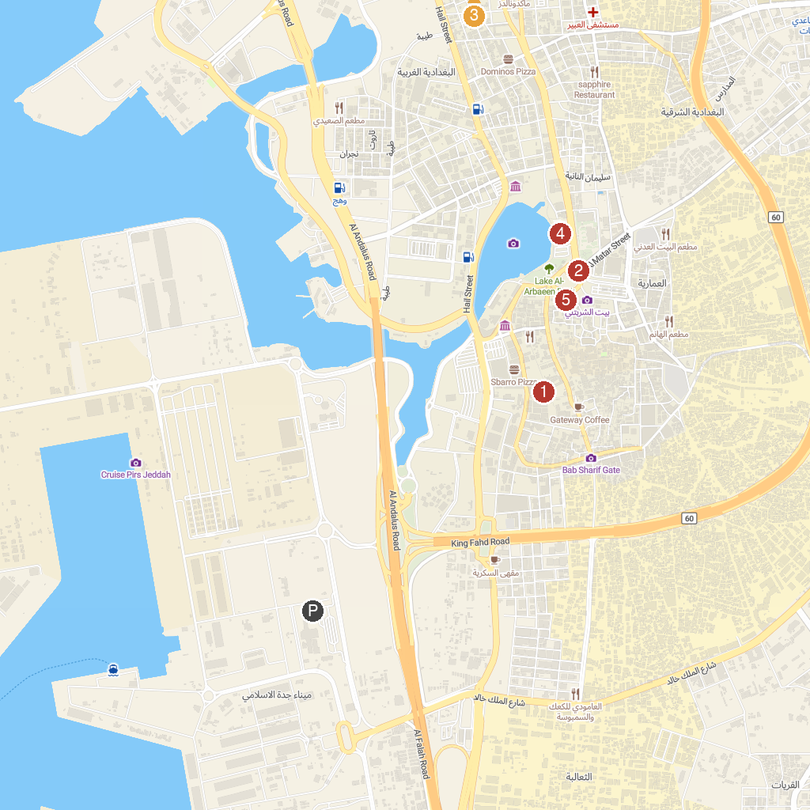
MAP KEY
1. Akkash Mosque | 4. Fakieh Aquarium
2. ‏Al-Bay'ah Square | 5. Jaffali Mosque
3. Darat Safeya Binzagr | 6. Barhat Bab Jadid
P. Cruise port / terminal
Map © MapTiler © OpenStreetMap contributors · cruiseports.org

