Jacksonville, Florida, USA
Florida's largest city keeps things refreshingly uncrowded — one ship at a time, a compact terminal, and a day's worth of beaches, history, and rivers in every direction.
⚓ Docked — JAXPORT Cruise Terminal · 🕒 Typical call: homeport (embark/debark) · 💵 USD · 🗣️ English
✍️ MY DAY IN PORT (FILL IN)
Ship / Date
In port | arrive ______ · all aboard ______
Booked excursion
Notes / meeting point
GETTING ASHORE
- Docking: Docked at JAXPORT Cruise Terminal, 9810 August Drive — no tendering
- Walk to center: Downtown Jacksonville is ~15 min by car; terminal is not walkable to city
- Best For: Day trips to St. Augustine, beach days, zoo, river views
- Don't Miss: Sailing under the Dames Point Bridge as you depart — a JAXPORT signature moment
GETTING AROUND
- 🚕 Taxi: $35–$50 — Taxis are available outside the terminal. The ride to downtown Jacksonville covers about 11–12 miles and takes roughly 1
- 📱 Rideshare: ✅ Uber, Lyft
TOP THINGS TO DO
- St. Augustine Day Trip — America's oldest city is just 35–60 min south.
- Jacksonville Zoo and Gardens — A 73-acre zoo home to thousands of animals including big cats, gorillas, and exotic birds, woven through botanical gardens.
- Jacksonville Beach & Atlantic Beach — Twenty miles of Atlantic coastline, 30–40 min from port.
- Catty Shack Ranch Wildlife Sanctuary — A nonprofit rescue for endangered big cats — lions, Siberian tigers, leopards, and bobcats.
- Riverside/Avondale & Cummer Museum — Jacksonville's most photogenic neighborhood — historic bungalows, oak-lined streets, independent shops, and the Cummer Museum of…
BEST WALKS
- Jacksonville Riverwalk: 1.5 miles | Easy | Downtown — A flat, paved riverfront promenade along the Southbank of the St.
- Riverside/Avondale Historic Neighborhood: 1–2 miles | Easy | Historic district — Stroll oak-canopied streets past Craftsman bungalows and Spanish Mediterranean mansions.
WEATHER · DAYLIGHT · MONEY
Month | High °F | Low °F | Rainy days
May | 84 | 67 | 10
Jul | 89 | 76 | 22
Sep | 85 | 73 | 17
Daylight: May 6:32AM–8:13PM · Jul 6:35AM–8:29PM · Sep 7:11AM–7:31PM
cruiseports.org/jacksonville · Confirm terminal & all-aboard time with your ship

Jacksonville, Florida, USA — Port Map
Red = walkable sights · Amber = excursions farther out · P = cruise terminal
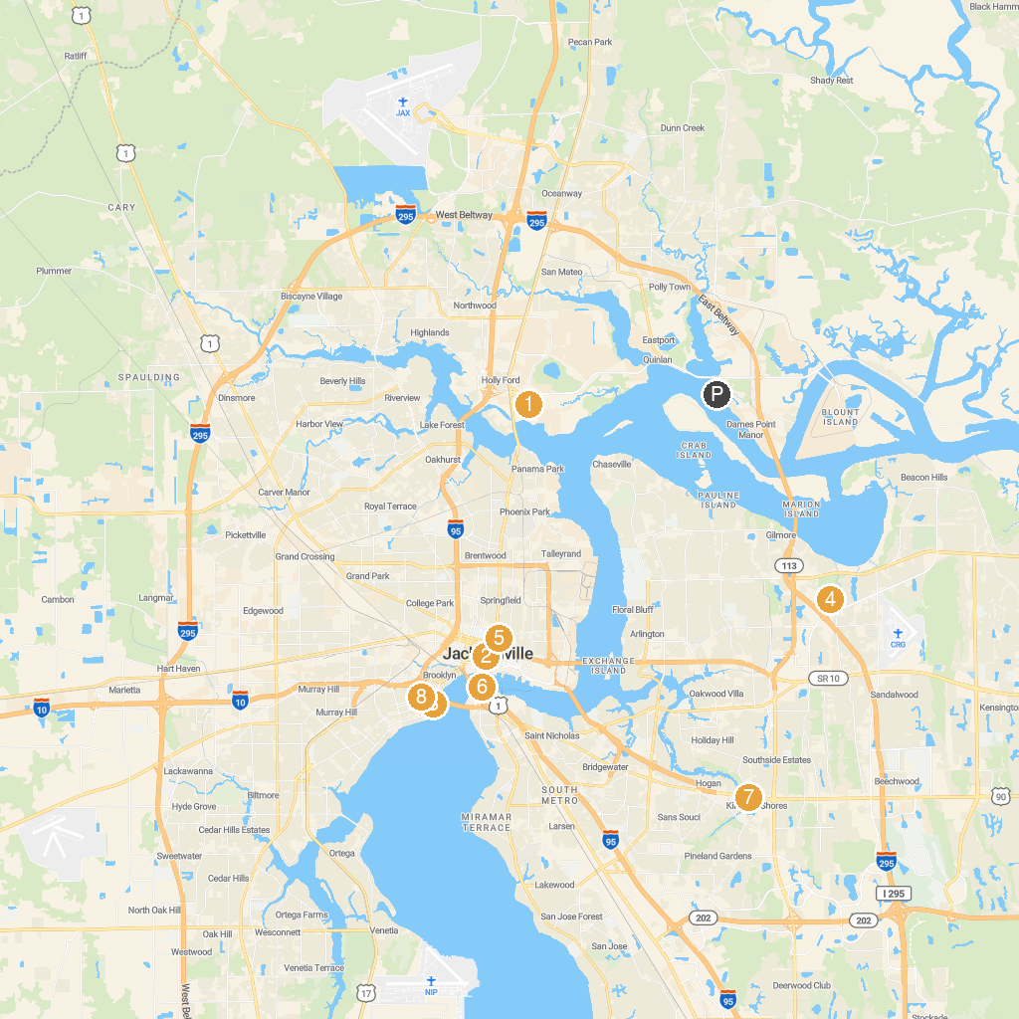
MAP KEY
1. Jacksonville Zoo and Botanical Gardens | 5. Springfield Park
2. MOCA (Museum Of Contemporary Art), Jacksonville | 6. Friendship Fountain
3. Cummer Museum of Art & Gardens | 7. Jacksonville's "Hands On" Children's Museum
4. Jacksonville Arboretum & Botanical Gardens | 8. Riverside Park
P. Cruise port / terminal
Map © MapTiler © OpenStreetMap contributors · cruiseports.org

