Ithaca Island, Ionian Islands, Greece
The legendary home of Odysseus rises from the Ionian Sea in a mosaic of emerald hills and electric-blue coves. Unspoiled by mass tourism, Ithaca rewards unhurried exploration with genuine Greek hospitality, mythic landscapes, and the quietest harbourfront you'll find on any Greek itinerary.
⚓ Tender port · 🕒 Typical call: 6–8 hrs · 💶 Currency: Euro (€) · 🗣️ Language: Greek
✍️ MY DAY IN PORT (FILL IN)
Ship / Date
In port | arrive ______ · all aboard ______
Booked excursion
Notes / meeting point
GETTING ASHORE
- Docking: Tender — ships anchor in Vathy Bay; 5–10 min tender ride
- Walk to centre: Immediate — tender drops at the Vathy waterfront
- Best For: Mythology, quiet beaches, authentic tavernas, scenic hikes
- Don't Miss: Water taxi to Gidaki Beach & the Statue of Odysseus
GETTING AROUND
- 🚕 Taxi: €5–€15 — Taxis wait at the Vathy port and are the easiest way to get around. Pre-arrange during peak summer (July–August) as dema
- 📱 Rideshare: ❌ not available
TOP THINGS TO DO
- Palace of Odysseus & School of Homer — Head to the northern village of Exogi to visit the Mycenaean ruins at Agios Athanasios, long associated with the legendary palace…
- Water Taxi to Gidaki Beach — The island's most stunning beach is accessible only by sea.
- Vathy Town & Archaeological Museum — Stroll the horseshoe harbour promenade, admire the rebuilt Venetian-style townhouses, and visit the small Archaeological Museum…
- Filiatro & Dexa Beach Half-Day — Dexa Beach (Odysseus's mythic landing spot) is a 25-minute walk or 5-minute taxi; Filiatro is 10 minutes by taxi with sunbeds and…
- Northern Villages: Kioni & Anogi — With 8+ hours in port, a tour to the postcard-perfect fishing village of Kioni and the Byzantine tower at Anogi reveals the…
BEST WALKS
- Vathy Waterfront & Town Stroll: 1.5 km · 20–30 min · Easy · Free — From the tender landing walk the full arc of the harbour promenade past the Statue of Odysseus, the…
- Vathy to Dexa Beach: 2.5 km one way · 25–30 min · Easy–Moderate · Free — Follow the coastal road south out of Vathy toward the bay entrance to reach Dexa Beach, where…
WEATHER · DAYLIGHT · MONEY
Month | High °F | Low °F | Rainy days
May | 75 | 63 | 5
Jul | 90 | 75 | 0
Sep | 83 | 71 | 2
Daylight: May 6:02AM–8:14PM · Jul 6:02AM–8:33PM · Sep 6:54AM–7:19PM
cruiseports.org/ithaca-island · Confirm terminal & all-aboard time with your ship

Ithaca Island, Ionian Islands, Greece — Port Map
Red = walkable sights · Amber = excursions farther out · P = cruise terminal
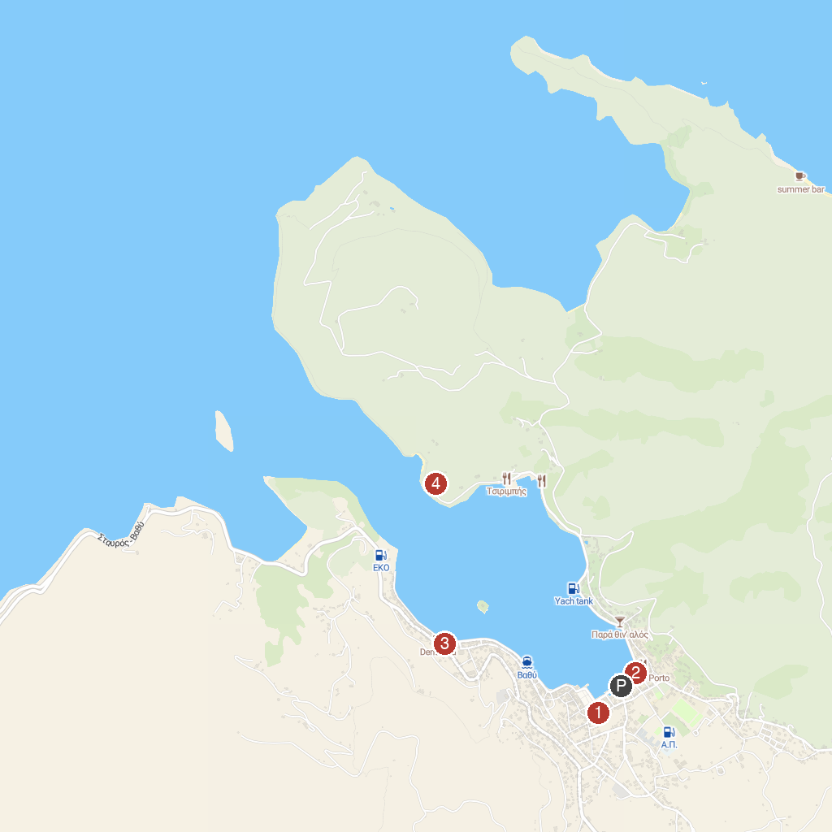
MAP KEY
1. Melissani Cave Lake | 4. Odyssey
2. Folklore and Nautical Museum of Ithaca | 5. Venetian cannons
3. Vathi Port viewpoint
P. Cruise port / terminal
Map © MapTiler © OpenStreetMap contributors · cruiseports.org

