Itea, Phocis, Greece
A quiet waterfront town on the Corinthian Gulf, Itea is the launchpad for Delphi — where the ancient Oracle spoke and Apollo's temple still commands the mountainside above a sea of a million olive trees.
⚓ Pier (small ships) / Tender (large ships) · 🕒 Typical call: 7-10 hrs · 💶 Currency: Euro (€) · 🗣️ Language: Greek · 🏛️ UNESCO World Heritage site nearby
✍️ MY DAY IN PORT (FILL IN)
Ship / Date
In port | arrive ______ · all aboard ______
Booked excursion
Notes / meeting point
GETTING ASHORE
- Docking: Pier for smaller ships; tender for large vessels
- Walk to center: 3–5 min from pier to promenade
- Best For: Ancient history, archaeology, olive-country scenery
- Don't Miss: Temple of Apollo and the Charioteer of Delphi museum
GETTING AROUND
- 🚕 Taxi: €13–€16 — Taxis queue at the port and can take you up the mountain to Delphi in about 15 minutes. Confirm the fare before departin
TOP THINGS TO DO
- Delphi Archaeological Site — Walk the Sacred Way past the Temple of Apollo, the ancient theater, and the stadium perched high on Mount Parnassus slopes.
- Delphi Archaeological Museum — Air-conditioned home of the bronze Charioteer of Delphi, the Sphinx of Naxos, and stunning statuary.
- Olive Grove of Amfissa — Over 1.2 million ancient olive trees — some more than 1,000 years old — blanket the valley between Itea and Delphi.
- Galaxidi Village — A perfectly preserved neoclassical sea captain's town 15 km west of Itea.
- Itea Waterfront & Beach — Stroll the Akti Poseidonos promenade, sip Greek coffee at a waterfront café, and dip into the calm, clear Corinthian Gulf.
BEST WALKS
- Waterfront Promenade Walk: 1 km · Flat · 20 min — Walk the Akti Poseidonos promenade from the pier westward past cafés, the Orthodox church, and the…
- Itea Town Center: 0.5 km · Flat · 15 min — From the waterfront, head one block inland to find local bakeries, kafeneions, and the small market…
WEATHER · DAYLIGHT · MONEY
Month | High °F | Low °F | Rainy days
May | 75 | 61 | 5
Jul | 90 | 75 | 2
Sep | 82 | 69 | 5
Daylight: May 6:19AM–8:34PM · Jul 6:18AM–8:53PM · Sep 7:12AM–7:38PM
cruiseports.org/itea · Confirm terminal & all-aboard time with your ship

Itea, Phocis, Greece — Port Map
Red = walkable sights · Amber = excursions farther out · P = cruise terminal
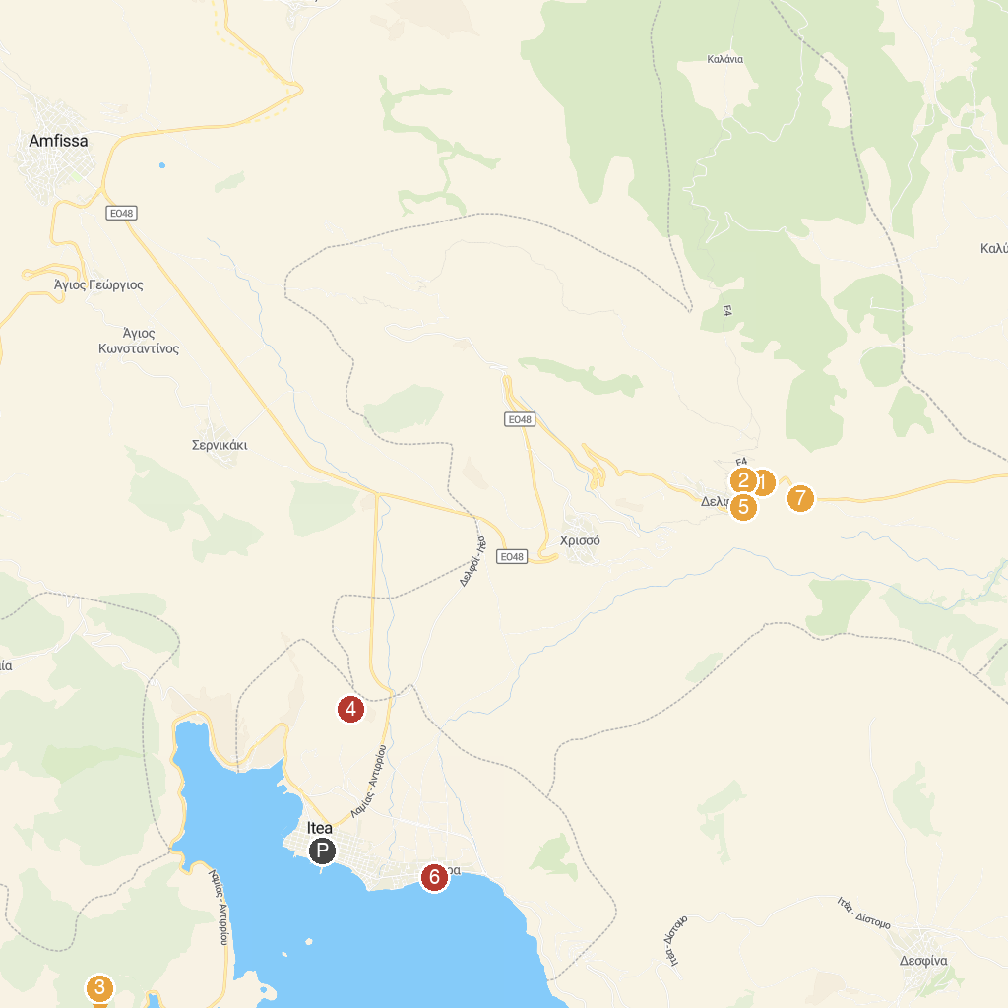
MAP KEY
1. Temple of Apollo | 5. Museum of Delphic Festivals
2. Ancient Stadium of Delphi | 6. Ancient Port Kirra
3. Maritime Museum of Galaxidi | 7. Tholos of Athena Pronaia
4. MoKa honey Stories tour
P. Cruise port / terminal
Map © MapTiler © OpenStreetMap contributors · cruiseports.org

