Istanbul, Turkey
Two continents, one shore day. Istanbul stacks 2,500 years of empire — Byzantine domes, Ottoman minarets, spice-scented bazaars, and a stunning Bosphorus approach — right outside the world's first underground cruise terminal.
⚓ Docked – Galataport, Karaköy · 🕒 Typical call: 10-14 hrs · 💵 Turkish Lira (cards widely accepted) · 🗣️ Turkish (English common in tourist areas)
✍️ MY DAY IN PORT (FILL IN)
Ship / Date
In port | arrive ______ · all aboard ______
Booked excursion
Notes / meeting point
GETTING ASHORE
- Docking: Galataport, Karaköy — underground terminal, steps from the city
- Walk to Old City: T1 tram from Karaköy to Sultanahmet (4 stops, ~10 min)
- Best For: History, mosques, bazaars, Bosphorus views, modern art
- Don't Miss: Hagia Sophia upper gallery (€25, go at 9 AM); fish sandwich at Eminönü
GETTING AROUND
- 🚕 Taxi: ~$5–$15 USD to nearby areas — Official yellow taxis are metered. Insist the driver uses the meter to avoid overcharging, a common issue near cruise te
- 📱 Rideshare: ✅ Uber
- 🚌 Hop-on hop-off: ✅
TOP THINGS TO DO
- Hagia Sophia & Blue Mosque — The two defining monuments of Istanbul face each other across Sultanahmet Square.
- Topkapi Palace — The Ottoman sultans' imperial palace overlooks the Bosphorus at the tip of the Old City.
- Grand Bazaar & Spice Market — The Grand Bazaar (Kapalıçarşı) is one of the world's oldest covered markets — 60 streets, 4,000+ shops.
- Bosphorus Cruise — A 90-minute public ferry from Eminönü runs up the Bosphorus past Ottoman yalı mansions, Rumeli Fortress, and the two suspension…
- Basilica Cistern — The 6th-century Byzantine underground cistern (Yerebatan Sarnıcı) was fully renovated and reopened in 2022 with improved lighting…
BEST WALKS
- Sultanahmet Heritage Walk: 2.5 km · 1.5–2 hrs · Easy (mostly flat with gentle rises) — The classic Old City loop.
- Galata & Karaköy Waterfront Walk: 2 km · 1 hr · Easy (one uphill stretch to tower) — Walk straight off the ship along the Galataport promenade, past the Istanbul Modern Museum, to the…
WEATHER · DAYLIGHT · MONEY
Month | High °F | Low °F | Rainy days
May | 70 | 57 | 8
Jul | 84 | 70 | 4
Sep | 78 | 66 | 7
Daylight: May 5:46AM–8:15PM · Jul 5:45AM–8:34PM · Sep 6:45AM–7:13PM
cruiseports.org/istanbul · Confirm terminal & all-aboard time with your ship

Istanbul, Turkey — Port Map
Red = walkable sights · Amber = excursions farther out · P = cruise terminal
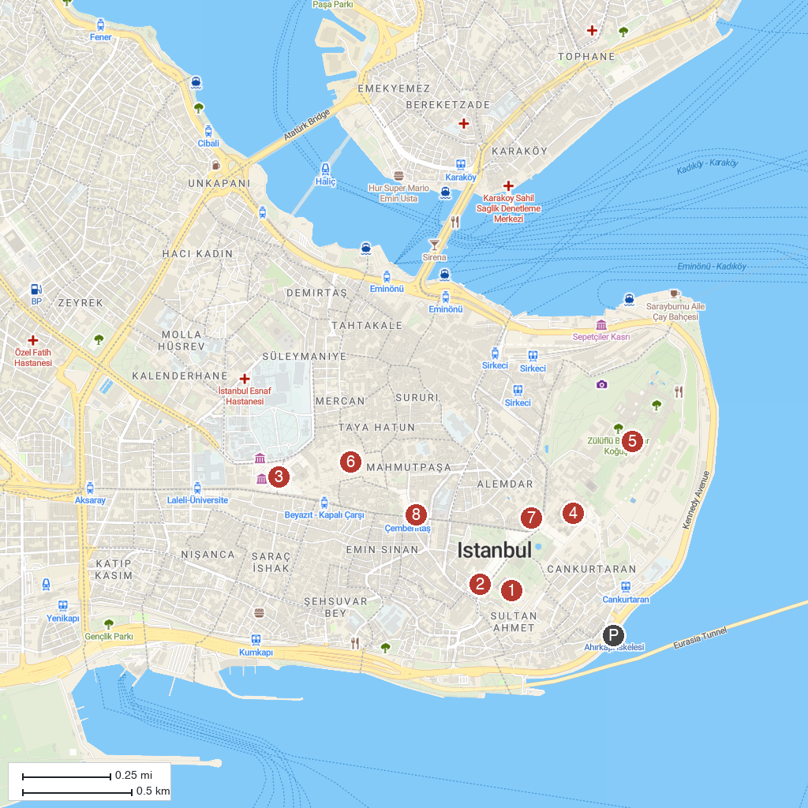
MAP KEY
1. The Blue Mosque | 5. Topkapi Palace Museum
2. Serpent Column | 6. Grand Bazaar
3. Beyazit Square | 7. Basilica Cistern
4. Hagia Sophia Grand Mosque | 8. Cemberlitas Hammam
P. Cruise port / terminal
Map © MapTiler © OpenStreetMap contributors · cruiseports.org

