Cowes, Isle of Wight, England
A royal retreat and sailor's paradise off England's south coast — tender into Cowes and discover chalk cliffs, Victorian palaces, and dinosaur footprints all on one diamond-shaped island.
⚓ Tender port (Trinity Landing, Cowes) · 🕒 Typical call: 8–10 hrs · 💷 Currency: British Pound (£) · 🗣️ Language: English · 🦖 UNESCO Biosphere Reserve
✍️ MY DAY IN PORT (FILL IN)
Ship / Date
In port | arrive ______ · all aboard ______
Booked excursion
Notes / meeting point
GETTING ASHORE
- Docking: Tender to Trinity Landing, West Cowes — 0 min walk to town
- Walk to centre: Steps from tender pier to Cowes High Street
- Best For: Royal history, coastal walks, cycling, yachting culture
- Don't Miss: Osborne House — Queen Victoria's beloved seaside palace
GETTING AROUND
- 🚕 Taxi: £2–£5 within Cowes; £15–£24 to Newport — Licensed taxis available at Trinity Landing. Cowes town center is a short walk, but cabs are handy for reaching Newport
TOP THINGS TO DO
- Osborne House — Queen Victoria's Palace — Victoria called this Italianate seaside villa her favourite home.
- The Needles & Alum Bay — Three towering white chalk stacks rise from the sea at the island's western tip, guarded by a striped lighthouse.
- Carisbrooke Castle — A classic Norman motte-and-bailey fortress near Newport where King Charles I was imprisoned before his execution.
- RIB Speedboat to the Needles — The most thrilling way to see the Needles — a high-speed rigid inflatable boat departs from Cowes waterfront and races along the…
- Tennyson Down & Needles Viewpoint Walk — Hike the chalk ridge from Freshwater Bay to the Tennyson Monument and onwards to the Needles viewpoint — all completely free.
BEST WALKS
- Cowes Waterfront & High Street: 1.5 km · flat · 30 min · free — From Trinity Landing walk south along the esplanade to the Royal Yacht Squadron and Cowes Castle…
- Osborne House Grounds Walk: 2 km within estate · easy · 45 min · included with entry — Once inside Osborne House, walk from the main palace down through Victoria's terraced gardens to…
- Tennyson Down Ridge: 7 km return · moderate · 2.5 hrs · free — From Freshwater Bay (reached by bus or taxi), climb the chalk ridge to the Tennyson Monument and…
WEATHER · DAYLIGHT · MONEY
Month | High °F | Low °F | Rainy days
May | 61 | 49 | 11
Jul | 70 | 59 | 10
Sep | 66 | 56 | 9
Daylight: May 5:16AM–8:47PM · Jul 5:09AM–9:11PM · Sep 6:41AM–7:18PM
cruiseports.org/isle-of-wight · Confirm terminal & all-aboard time with your ship

Cowes, Isle of Wight, England — Port Map
Red = walkable sights · Amber = excursions farther out · P = cruise terminal
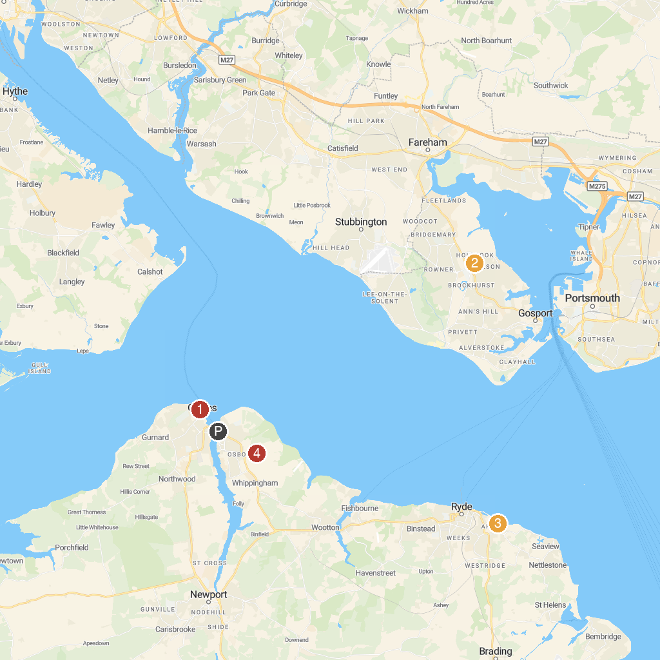
MAP KEY
1. Cowes Week | 5. Osborne
2. Fort Brockhurst | 6. Portsmouth Historic Dockyard
3. Appley Park | 7. Royal Navy Museums: HMS Victory
4. National Motor Museum, Beaulieu | 8. Spinnaker Tower
P. Cruise port / terminal
Map © MapTiler © OpenStreetMap contributors · cruiseports.org

