Portree, Isle of Skye, Scotland
Scotland's most dramatic island greets cruise passengers with a postcard harbour ringed by colourful houses — and wild Highland landscapes just minutes away. The Old Man of Storr, Dunvegan Castle, and the Quiraing are all within day-trip reach of the tender pier.
⚓ Tender port · 🕒 Typical call: 6–9 hrs · 💷 Currency: GBP · 🗣️ English / Scottish Gaelic
✍️ MY DAY IN PORT (FILL IN)
Ship / Date
In port | arrive ______ · all aboard ______
Booked excursion
Notes / meeting point
GETTING ASHORE
- Docking: Tender — ships anchor in Portree Bay; pontoon in the harbour
- Walk to centre: 2 min from tender pontoon to Portree town square
- Best for: Dramatic scenery, Highland hikes, castle history
- Don't miss: Old Man of Storr — 15 min by taxi, views across the Sound of Raasay
GETTING AROUND
- 🚕 Taxi: ~£60–£120 for a half-day — Several local operators (Portree Taxis, Skye Taxi Tours) offer flexible island tours and can pick up near the pier. Book
- 📱 Rideshare: ❌ not available
TOP THINGS TO DO
- Old Man of Storr Hike — A 4.5 km round-trip climb to the base of Skye's most famous rock pinnacle.
- Dunvegan Castle & Seal Colony — Scotland's oldest continuously inhabited castle — home of Clan MacLeod for 800 years — sits on Loch Dunvegan about 30 min…
- Quiraing Landscape — An otherworldly landslip plateau on the Trotternish Ridge, with craggy peaks, hidden plateaus, and jaw-dropping views.
- Fairy Pools, Glen Brittle — A series of crystal-clear turquoise pools and waterfalls at the foot of the Cuillin mountains — one of Skye's most photographed…
- Portree Town & Harbour Walk — Explore Portree's picturesque colourful harbour frontage, browse Highland woolens and whisky at independent shops, and have a…
BEST WALKS
- Portree Harbour & Town Centre: 1 km • 20 min • Easy • Free — Stroll from the tender pontoon along the harbour front past the colourful Bosville Terrace houses…
- Scorrybreac Circular: 5 km • 1.5–2 hrs • Moderate • Free — From the pier, follow the shore path north out of town onto the Scorrybreac headland.
WEATHER · DAYLIGHT · MONEY
Month | High °F | Low °F | Rainy days
May | 55 | 46 | 16
Jul | 62 | 53 | 22
Sep | 59 | 51 | 20
Daylight: May 5:04AM–9:39PM · Jul 4:50AM–10:09PM · Sep 6:55AM–7:42PM
cruiseports.org/isle-of-skye · Confirm terminal & all-aboard time with your ship

Portree, Isle of Skye, Scotland — Port Map
Red = walkable sights · Amber = excursions farther out · P = cruise terminal
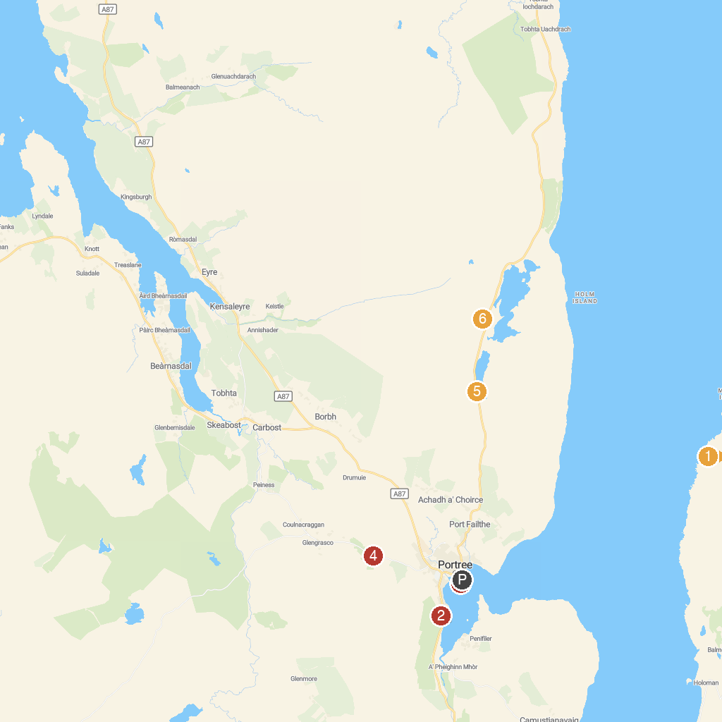
MAP KEY
1. Calum’s Road | 4. A.C.E Target Sports Skye
2. Isle of Skye Candle Co. Visitor Centre | 5. Loch Fada
3. The Lump | 6. Bride's Veil Falls
P. Cruise port / terminal
Map © MapTiler © OpenStreetMap contributors · cruiseports.org

