Isle of Rum, Inner Hebrides, Scotland
One of Scotland's wildest islands, Rum is a National Nature Reserve where red deer roam the glens, white-tailed eagles soar overhead, and a crumbling Edwardian castle stands as a monument to Victorian excess. This is expedition cruising at its most raw.
⚓ Tender (no pier) · 🕒 Typical call: 4–6 hrs · 💷 GBP (cash preferred) · 🗣️ English / Scottish Gaelic · 🦅 Wildlife & Wilderness
✍️ MY DAY IN PORT (FILL IN)
Ship / Date
In port | arrive ______ · all aboard ______
Booked excursion
Notes / meeting point
GETTING ASHORE
- Docking: Tender to Loch Scresort — small expedition ships only; no berth for large vessels
- Walk to village: 5 min from pier to Kinloch — the island's only settlement
- Best For: Wildlife watching, rugged hiking, Edwardian history, dark skies
- Don't Miss: Otter Hide trail, Kinloch Castle exterior, short Northside Nature Trail
GETTING AROUND
- 📱 Rideshare: ❌ not available
TOP THINGS TO DO
- Otter Hide Trail — A short 30-minute return walk along the south shore of Loch Scresort to a purpose-built hide overlooking the water.
- Kinloch Castle — The red sandstone Edwardian mansion built 1897–1900 for textile magnate Sir George Bullough is one of Scotland's most eccentric…
- Northside Nature Trail — A 1-hour circular walk from Kinloch into the NNR offering views across Loch Scresort and into the reserve's upland interior.
- Hallival & Askival Summit Walk — For fit hikers with sturdy boots, the peaks of Hallival (722m) and Askival (812m — Rum's highest point) form the classic walk…
- Kilmory Track Walk — An 8km track along the north coast to Kilmory beach — the best place on Rum to spot harbour porpoise, dolphins, and minke whales…
BEST WALKS
- Otter Hide & Loch Scresort Shore: 1.5 km return | 30–45 min | Easy — Follow the south shore of Loch Scresort from the pier to the NatureScot otter hide.
- Northside Nature Trail Loop: ~5 km circular | ~1 hr | Easy–moderate — Circular walk north from Kinloch through heather moorland with views back over Loch Scresort and…
- Kinloch to Kilmory Beach: 16 km return | 4–5 hrs | Moderate — Long walk along the north coast track to Rum's most remote accessible beach.
WEATHER · DAYLIGHT · MONEY
Month | High °F | Low °F | Rainy days
May | 52 | 45 | 17
Jul | 58 | 52 | 21
Sep | 56 | 51 | 19
Daylight: May 5:07AM–9:37PM · Jul 4:52AM–10:09PM · Sep 6:55AM–7:45PM
cruiseports.org/isle-of-rum · Confirm terminal & all-aboard time with your ship

Isle of Rum, Inner Hebrides, Scotland — Port Map
Red = walkable sights · Amber = excursions farther out · P = cruise terminal
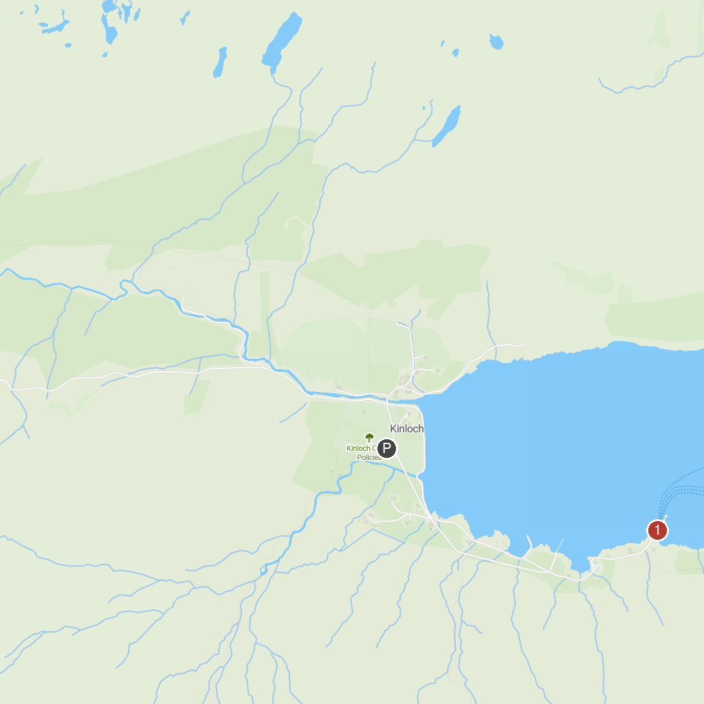
MAP KEY
1. Bella Jane Boat Trips | 4. Rum National Nature Reserve
2. Mallaig Heritage Centre | 5. Camas Daraich, Aird of Sleat, Skye
3. Fairy Pools | 6. Spar Cave
P. Cruise port / terminal
Map © MapTiler © OpenStreetMap contributors · cruiseports.org

