Isle of Raasay, Inner Hebrides, Scotland
Raasay is the quiet one next to Skye — a resilient Hebridean island where you can walk to a world-class whisky distillery, climb a flat-topped volcanic peak for views spanning a billion years of geology, and trace the poetry of the Highland Clearances across abandoned villages.
⚓ Tender (anchor off Inverarish) · 🕒 Typical call: 5–7 hrs · 💷 Currency: British Pounds (GBP) · 🗣️ English / Scottish Gaelic · 🦅 Wildlife: sea eagles, otters, red deer
✍️ MY DAY IN PORT (FILL IN)
Ship / Date
In port | arrive ______ · all aboard ______
Booked excursion
Notes / meeting point
GETTING ASHORE
- Docking: Anchor & tender — ships anchor off Inverarish; tender to the community pontoon or beach
- Walk to Centre: 5 min walk from tender landing to Inverarish village and distillery
- Best For: Whisky lovers, hikers, wildlife watchers, anyone wanting to escape Skye's crowds
- Don't Miss: Isle of Raasay Distillery tour & tasting, and the view from Dun Caan summit
GETTING AROUND
- 📱 Rideshare: ❌ not available
TOP THINGS TO DO
- Isle of Raasay Distillery Tour & Tasting — A five-minute walk from the tender landing, this award-winning distillery produces a distinctive lightly-peated single malt aged…
- Dun Caan Summit Hike — Raasay's flat-topped volcanic peak (443 m) offers a 360° panorama over Skye, the Torridon hills, and the Outer Hebrides.
- Hallaig Clearance Village & Sorley Maclean Trail — Walk to the ruins of Hallaig, one of the villages cleared in the 19th century and immortalised in Sorley Maclean's famous Gaelic…
- Raasay House Kayaking & RIB Trips — The Raasay House Outdoor Centre (1.5 km north of the tender landing) offers guided sea kayaking, wildlife RIB boat trips, and…
- Brochel Castle & Calum's Road — On the island's north-east coast, the crumbling 16th-century Brochel Castle perches on a volcanic plug above the sea.
BEST WALKS
- Distillery & Inverarish Village Loop: 1 hr | Easy | Free — From the tender landing, walk south through Inverarish to the distillery visitor centre (exterior…
- Temptation Hill Viewpoint: 1.5–2 hrs | Easy–moderate | Free — A short climb from Inverarish to the Temptation Hill viewpoint rewards with sweeping views across…
- Raasay House & Walled Garden: 45 min walk each way | Easy | Free to view — Head north along the track from Inverarish to reach Raasay House, a Georgian mansion that is now a…
WEATHER · DAYLIGHT · MONEY
Month | High °F | Low °F | Rainy days
May | 56 | 46 | 17
Jul | 62 | 53 | 21
Sep | 59 | 51 | 20
Daylight: May 5:03AM–9:38PM · Jul 4:50AM–10:08PM · Sep 6:55AM–7:42PM
cruiseports.org/isle-of-raasay · Confirm terminal & all-aboard time with your ship

Isle of Raasay, Inner Hebrides, Scotland — Port Map
Red = walkable sights · Amber = excursions farther out · P = cruise terminal
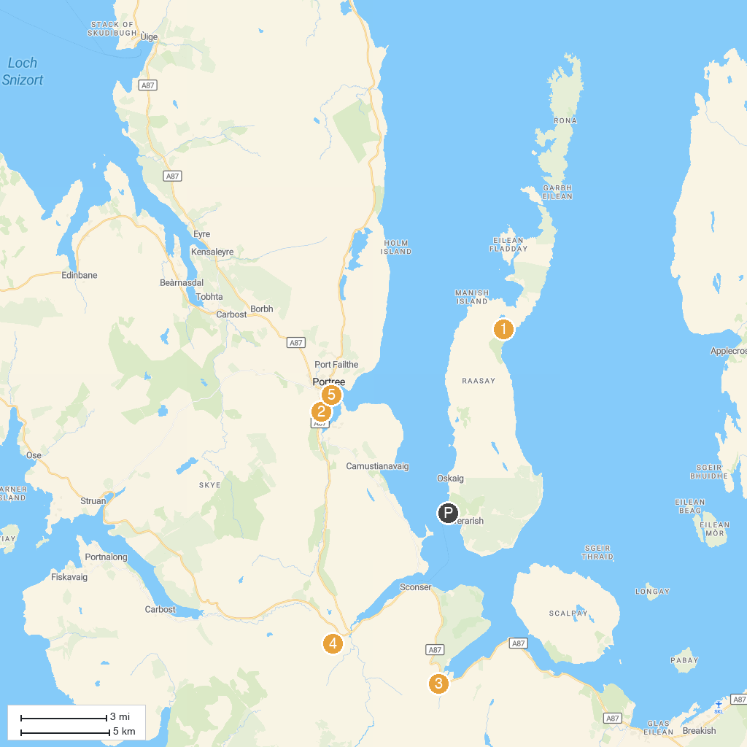
MAP KEY
1. Calum’s Road | 4. Sligachan Waterfalls
2. Isle of Skye Candle Co. Visitor Centre | 5. The Lump
3. Eas a' Bhradain
P. Cruise port / terminal
Map © MapTiler © OpenStreetMap contributors · cruiseports.org

